Dashboard and Notifications for RMS

Research Office instructions for setting up and managing subscriptions and the dashboard in RMS

Issued May 2019

Contents

**Overview 3**

**Dashboard 3**

Accessing the Dashboard 3

Editing the Dashboard screen 4

How to create a new selection for the Dashboard: 4

Accessing the data from the Dashboard 5

**Notifications** 6

How to subscribe to a Notification 6

Receiving Notifications 7

In RMS Notifications 7

Email Notifications 8

Unsubscribing to Notifications 9

**Additional information/FAQ's** 9

# **Overview**

The ARC has functionality within the Research Management System (RMS) to allow Research Office staff to set up an easy access dashboard to access pre-selected data and receive notifications to assist with the management of Post-award activities.

# **Dashboard**

The Dashboard in RMS provides Research Office staff the ability to pre-select search criteria in RMS, for easy accessibility to Post-award data. Users can personalise the dashboard to suit their own requirements and only show information they are interested in.

## **Accessing the Dashboard**

Click the ‘Dashboard’ link in the top right hand corner of the Action Centre to access the dashboard page in RMS.

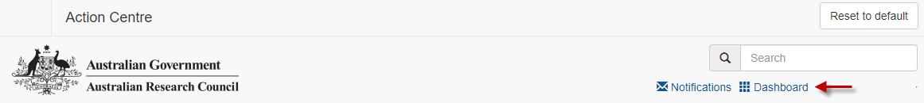

Once in the dashboard four tiles will appear - Variations, Final Reports, Partner Organisation Agreement Contributions Reports (POACRs) and End of Year Reports (EOYRs).

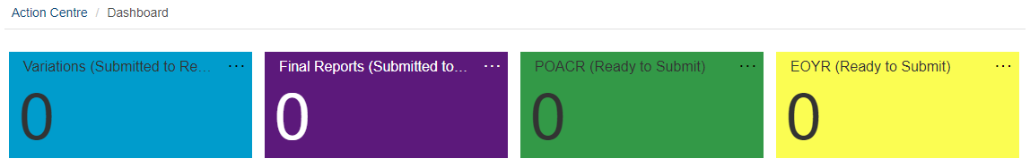

Each tile has defaulted selections to show the following default settings:

| Variations | Variations received by the Research Office in the last 30 Days and has the ‘Submitted to RO’ status |
| --- | --- |
| Final Reports | Final Reports received by the Research Office in the last 30 Days and has the ‘Submitted to RO Valid’ status |
| POACR | POACRs received by the Research Office in the last 30 Days and has the ‘Ready to Submit’ status |
| EOYR | EOYRs received by the Research Office in the last 30 Days and has the ‘Ready to Submit’ status |

## **Editing the Dashboard screen**

RMS allows users to customise the dashboard to display user’s preferences.

To edit the existing tiles select the … on the top right hand corner of each tile. This will provides the ability to edit, move or remove the individual tile.

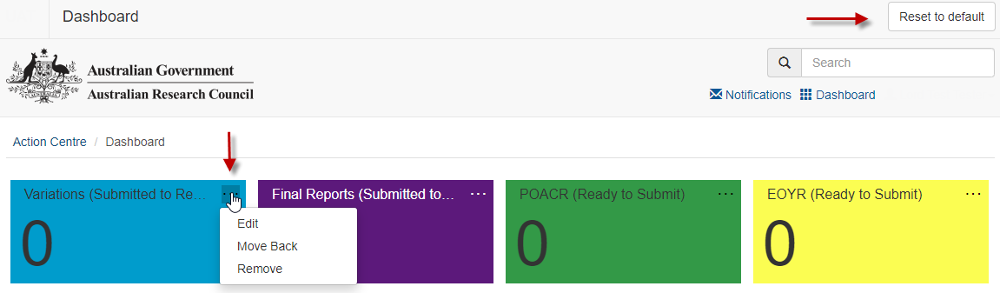

* Edit – provides the ability to re-name and/or re-colour the tile
* Move Forward/Back - changes where on the screen the tile is displayed
* Remove - will delete the tile

If users wish to return the dashboard to the original settings, this can be done by selecting the ‘Reset to default’ in the top right-hand corner of the screen. This will return the dashboard to the original four default tiles.

## **How to create a new selection for the Dashboard:**

Users can create multiple new dashboard tiles to suit their personal preferences. There is no limit on the amount of tiles that can be created or edited. Tiles can be created by doing the following steps:

* open to the relevant Post-award tab that holds the required data (Variations, Monitoring Reports or Final Reports)
* select the options from each of the relevant dropdown lists
* once all selections are made, click the ‘Add to Dashboard’ button in the top right-hand corner of the screen

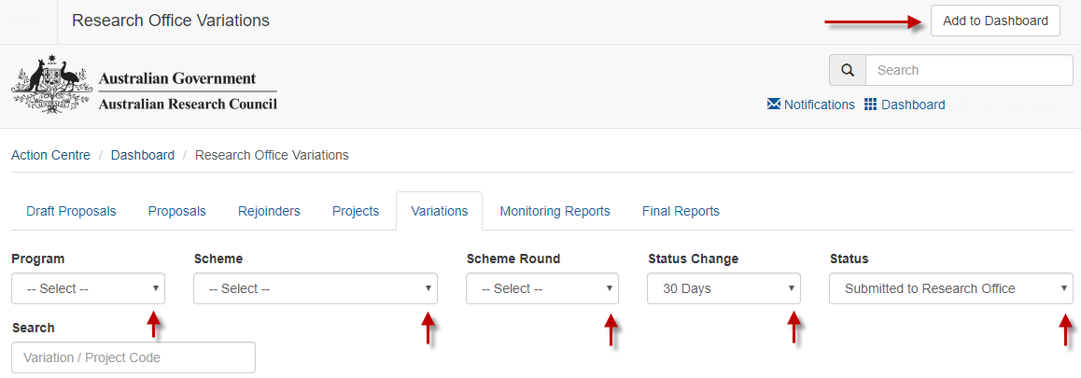

A new screen will appear and a default name of the original tab will appear. The name can then be edited and a colour selected as per user’s preference, as only the user will see it. Save the selection once it is made.

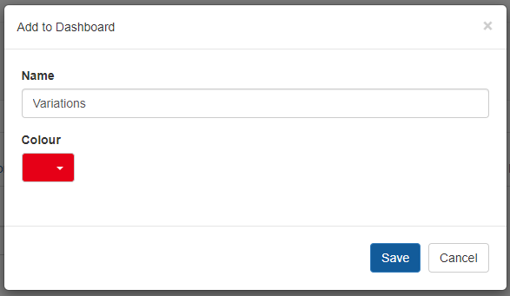

The new tile will then appear in the dashboard and is ready to be selected.

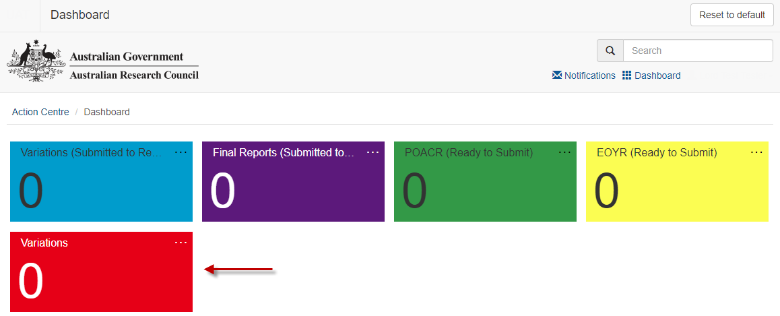

## **Accessing the data from the Dashboard**

To access any of the data from the dashboard click any of the coloured tiles that appear on the dashboard. RMS will then take you to the relevant page in RMS and display the information that has been pre-selected to appear. The variations/reports can then be actioned/viewed from this page.

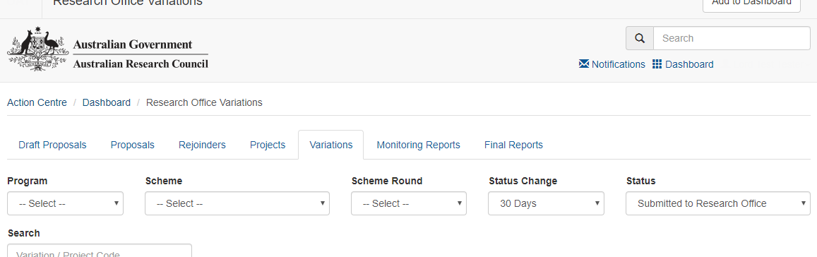

# **Notifications**

RMS has a subscription service that allows users to be notified when a Post-award action has been performed in RMS. Users can subscribe to be informed when a Variation, End of Year Report, POACR or Final Report have changed state (i.e. be submitted to ARC or returned from the ARC). Users can select to receive notifications either via email or within RMS and must be set up by each individual user.

## **How to subscribe to a Notification**

To access the notifications screen, select the ‘Notifications’ link in the top right hand corner of the Action Centre.

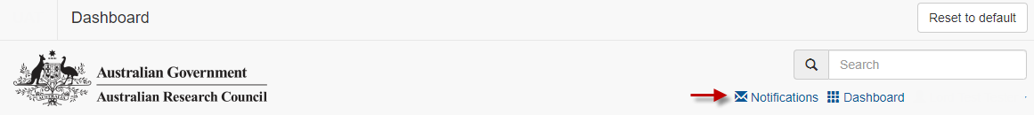

The first time notifications are created, the screen will appear with the statement ‘*You have no notifications*’. To create a notification, select the ‘Manage Notifications’ button in the top right hand side of the screen.

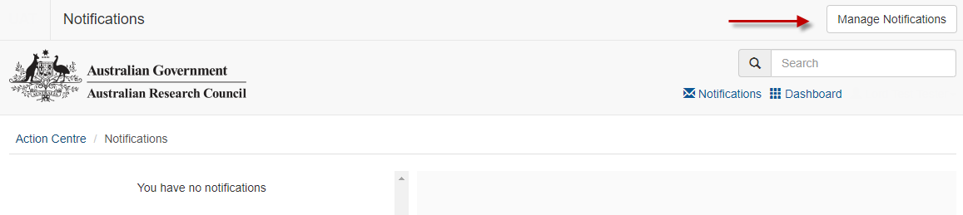

The ‘Add subscription’ page in RMS will appear and allow users to create a subscription. Multiple subscriptions can be made at any stage and can be created using the following steps.

To activate a subscription the following criteria must be completed:

* **RECEIVE**: the method to receive the notifications - this can be via email or RMS, or both. (This can be edited again after the subscription is created.)
* **TYPE**: the notification type that is being subscribed to (Variations, Final Reports, EOYRS or POACRs) from the drop down list.
* **STATE**: the state of the request/report such as returned to Research Office or accepted by ARC. If 'All States' is selected, a notification will be sent for every status change for the variation/report ‘type’ selected
* **FOR**: the funding program that the variation/report relates to. The program can be narrowed down to ‘Discovery’ or ‘Linkage’, which would result in only the schemes that fall under these programs appearing on the scheme list. Alternatively ‘All Programs’ will show both programs and all schemes under both programs

To refine the selections even further, additional non-mandatory selections can also be selected:

* **SCHEME**: (based on the program selected) a specific scheme can be selected or ‘All Schemes’ can be selected
* **SCHEME ROUND**: (based on the previous program/scheme selections) a specific scheme round can be selected or ‘All Scheme Rounds’ can be selected

Once the relevant criteria has been selected, click the ‘Subscribe’ button. The subscription will then appear in the ‘Current subscriptions’ list on the bottom of the page.

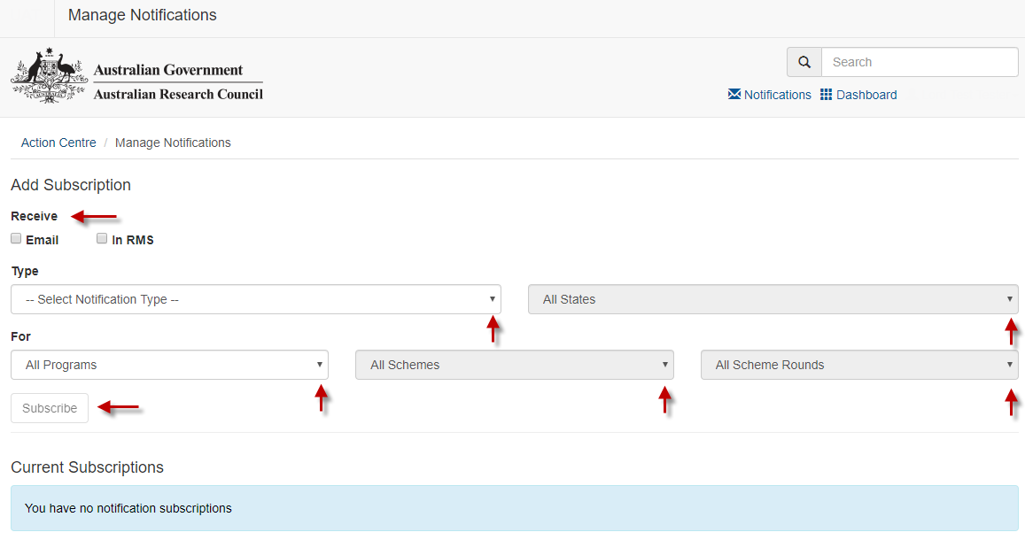

## **Receiving Notifications**

Depending on the selections made within each subscription, notifications will be received via one or both of the following methods.

### In RMS Notifications

If subscriptions are set up to receive notifications via ‘In RMS’ any new notifications will appear in RMS as a red badge against the notifications link and display the number of unread notifications.

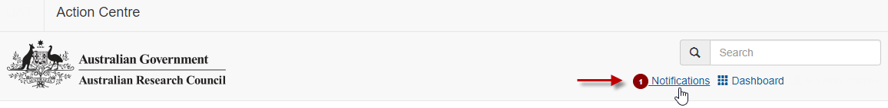

Select the notifications link to open the notifications page. All notifications will then appear on the left-hand side of the screen. Once a notification is selected, the details of the notification will be displayed on the right hand side of the screen. Each notification will inform the user of the Project ID and status change of the variation/report. The variation/report will open for review if the Project ID is selected.

Notifications can then be marked as read or deleted by clicking on the 'X' button in the top right-hand corner. Notifications can also be marked as read or deleted in bulk by selecting the 'Mark all as read' or 'Delete All' buttons.

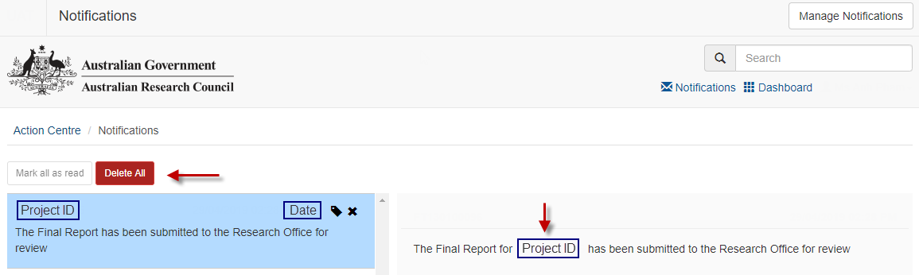

### Email Notifications

If subscriptions are set up to receive notifications via email, the notifications will be sent to the email address attached to the RMS account. The email will include details about the variation/report, the project ID and the status change. Clicking on the project ID link will open up the variation/report in RMS.

**Note:** Specific details and comments of the variation/report will not be sent within the email.

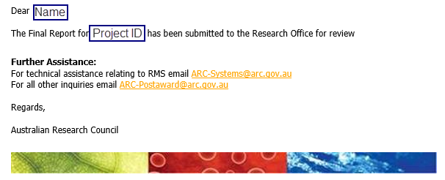

**Note:** Although the method of receiving subscriptions can be adjusted once created using the 'email' and 'In RMS' buttons, the details of the subscription cannot be edited. Subscriptions will have to be unsubscribed and re-added if changes are required.

## **Unsubscribing to Notifications**

Notifications can be unsubscribed, so they are no longer received. Once unsubscribed emails and RMS notifications will cease.

To unsubscribe to a specific subscription select the ‘Unsubscribe’ button on the right hand side of the relevant subscription.

To unsubscribe to all subscriptions select the ‘Unsubscribe All’ button on the right hand side of the screen above the 'Current Subscriptions' list.

Alternatively, if the subscription is to be kept but the method of receiving the subscription needs to be changed, then they can be adjusted by selecting the 'Email' and 'In RMS' buttons on the left side of the relevant subscriptions

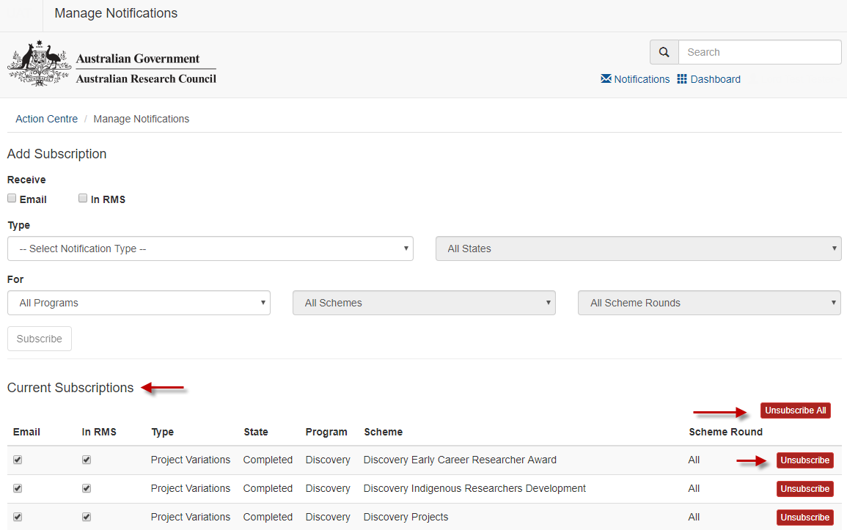

# **Additional information/FAQ's**

**If I move to another Administering Organisation, will I lose all my customised dashboards and notifications?**

Yes, moving to another Administering Organisation, will wipe all customised dashboards and notifications.

**Can I set up my notifications to go to another email address?**

No, email notifications are only sent to the email address attached to your RMS account.

**Why can I see scheme rounds that have no Post-award data?**

This functionality has been built to provide RMS data both now and in the future. This may result in RMS displaying rounds currently under assessment.