NATIONAL INTELLIGENCE AND SECURITY DISCOVERY RESEARCH GRANTS (NISDRG)

End of Year Reporting in RMS

(User Guide)

Updated September 2022

# Contents

Contents 2

Introduction 3

Key Points 4

Summary of Workflow 4

Quick Reference 5

PART 1 - Locate the EoYR within RMS 6

PART 2 - Complete the EoYR 8

Amending the End Date 8

Grant Expenditure 8

Amount Spent 9

Unspent Reason 9

Research Office Comments 11

Justification 12

Progress Report 12

PART 3 – Submitting the EoYR to the RO EoYR Delegate 14

PART 4 – RO EoYR Delegate Certification and Submission 14

Edits required – De-submit 15

Certify and Submit EoYR to the Funding Entity for assessment 15

Definitions and Glossary 17

Definitions 17

Glossary 18

# Introduction

The Australian Research Council (ARC), on behalf of the Office of National Intelligence (ONI) and   
the Defence National Security Science and Technology Centre (Defence-NSSTC), is conducting   
grant management for the National Intelligence and Security Discovery Research Grants (NISDRG) program.

The NISDRG program supports excellent research that deepens understanding of emerging science and technology and addresses intelligence and national security interests. The grant program will facilitate innovation and develop national security and intelligence capacity. It will also enable Australia’s National Intelligence and Security Communities to systematically engage with Australia’s research and technology community.

The NISDRG program requires that an End-of-Year Report (EoYR) be submitted for all active grants.

The purpose of the EoYR is to: collect information regarding the financial activity relating to NISDRG funding received during the previous financial year and reconcile it against the Funding Entity’s records.

EoYRs are completed and submitted to the Funding Entity by the Administering Organisation (AO), via the ‘Grant Management >> Grant Reports’ module in the Research Management System (RMS). The EoYR must be certified by the Research Office (RO) EoYR Delegate before it can be submitted to the Funding Entity.

All EoYRs must be submitted in RMS by 30 September each year. Extensions will not be allowed unless approved by the RGS team prior to this date.

It is the responsibility of each AO to ensure that all the information contained in the Reports is accurate and that all required fields are completed as comprehensively as possible.

Report forms, relevant to their organisation, can be accessed in RMS by RO staff and Funding Entity approved EoYR Delegates.

For any RMS access issues, please contact the ARC RMS Helpdesk at [ARC-Systems@arc.gov.au](mailto:ARC-Systems@arc.gov.au).

All requests for RO EoYR Delegate access must be requested through the ‘Manage Users’ module in the relevant RMS portal.

* Intelligence Challenges – ONI RMS Portal: [https://rmsoni.researchgrants.gov.au](https://rmsoni.researchgrants.gov.au/)
* National Security Challenges – Defence RMS Portal: [https://defence.researchgrants.gov.au](https://defence.researchgrants.gov.au/)

The following instructions provide information for the entry and submission of End-of-Year Reports. All screenshots provided within this document have been sourced from the Defence RMS portal and images may differ slightly dependent on the portal you are using.

# Key Points

* The target audience for this user guide is AO RO Delegates for NISDRG awarded grants.
* The purpose of the EoYR is to: collect information regarding the financial activity relating to NISDRG funding received during the financial year, and reconcile it against the Funding Entity’s records.
* EoYRs will be opened at the beginning of September for the AO to complete.
* EoYRs must be submitted in RMS by 30 September each year.
* The reporting period is for the full previous financial year, July to June.
* An RO EoYR Delegate is required to certify and submit the EoYR by the due date.   
  Extensions will not be allowed unless approved by the RGS team prior to the due date.
* The RGS team will review the submitted report.
* EoYRs will also be made available to ONI and Defence-NSSTC staff.

## Summary of Workflow

## Quick Reference

**PART 1 – Locate the EoYR within RMS**

* EoYRs are available within the RMS portal of the funded grant:
  + Intelligence Challenges – ONI RMS Portal: <https://rmsoni.researchgrants.gov.au>
  + National Security Challenges – Defence RMS Portal: <https://defence.researchgrants.gov.au>

**PART 2 – Complete the EoYR**The EoYR must be completed by the RO.

* **Amending the End Date**  
  An ‘*End Date’* change can only be requested in the final year of the Grant.
* **Project Expenditure**   
  Information will auto-populate when opened by the RO.
* **Amount Spent**   
  Enter the total actual funds spent in the last financial year.
* **Unspent Reason**

If there is a carryover requested, select the Unspent Reason from the drop-down list.

* **Research Office Comments**  
  This field should be used when the unspent reason *‘Other’* is selected.
* **Justification**

If the *‘Total Amount Unspent’* (carryover request) is more than 75% of the previous financial year’s allocation, a comment must be entered advising the reason.

* **Progress Report**

Reports on Project issues related to any research issues that affected the progress of the Project during the financial year. If the answer to this question is ‘Yes’, at least one ‘Project Issue’ must be selected from the dropdown menu provided.

**PART 3 – Submit to the RO EoYR Delegate**Once all mandatory fields have been completed and the RO is satisfied that all details have been accurately entered, the report must be submitted to the RO EoYR Delegate for review and final submission.

**PART 4 – RO EoYR Delegate Certification and Submission**The EoYR must be certified and submitted by the RO EoYR Delegate to the Funding Entity.

Once submitted to the Funding Entity, if edits are required, a request to de-submit the EoYR must be made to the RGS team by email: [arc-nisdrg@arc.gov.au](mailto:arc-nisdrg@arc.gov.au).

**Note:** Within RMS report forms, hover over this icon information icon for further information and guidance.

# PART 1 - Locate the EoYR within RMS

The NISDRG EoYR is available within the RMS portal of the funded grant. The EoYR is intended to capture the yearly expenditure of the grant. The AO must complete, certify and submit the EoYR to the Funding Entity for grants administered by their organisation during the financial year that have a net value greater than $0 by 30 June.

**To locate the NISDRG End of Year Report:**

1. Navigate to the RMS portal for the funded grant

ONI RMS Portal: [https://rmsoni.researchgrants.gov.au](https://rmsoni.researchgrants.gov.au/)

Defence RMS Portal: [https://defence.researchgrants.gov.au](https://defence.researchgrants.gov.au/)

1. Select the ‘*Research Office* *Grant Reports’* link from the RMS action centre.

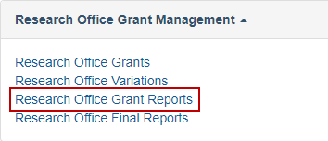

Figure 1 - Research Office Grant Reports’ link from the RMS Action Centre

1. Select the ‘*NISDRG End of Year Report YYYY/YYYY’* with the relevant year from the dropdown menu.

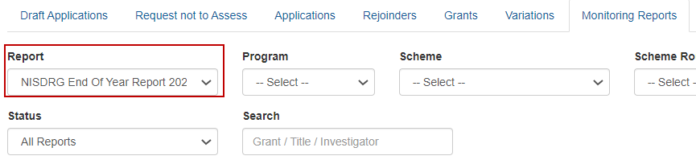

Figure 2 - Dropdown menu to select report

1. Reports can then be searched by:

* the relevant information under the ‘Program, Scheme and/or Scheme Round’ dropdown lists
* searching for a specific Grant ID, Title or Investigator under the ‘Search’ bar
* searching on the status of the Report/s under the ‘Status’ dropdown list.

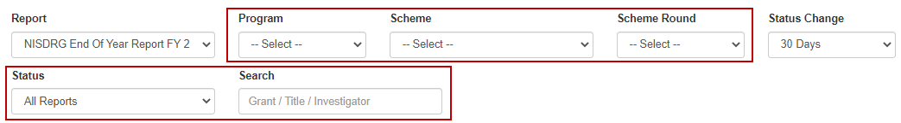

Figure 3 - Monitoring Reports filter selections

1. Select ‘Save’ at the top of the page regularly during the completion of the report.



Figure 4 - ‘Save’ button

1. Once you have located the required End of Year report select the ‘*Form*’ button to view the report.



Figure 5 - 'Form' button to open report

1. A reporting form will display with questions to be responded to.

**Please note**: The Grant expenditure details will not populate into the report until the report is open in RMS by the RO. If you want to view the details in excel, all reports will need to be opened in RMS prior to executing the spreadsheet download.

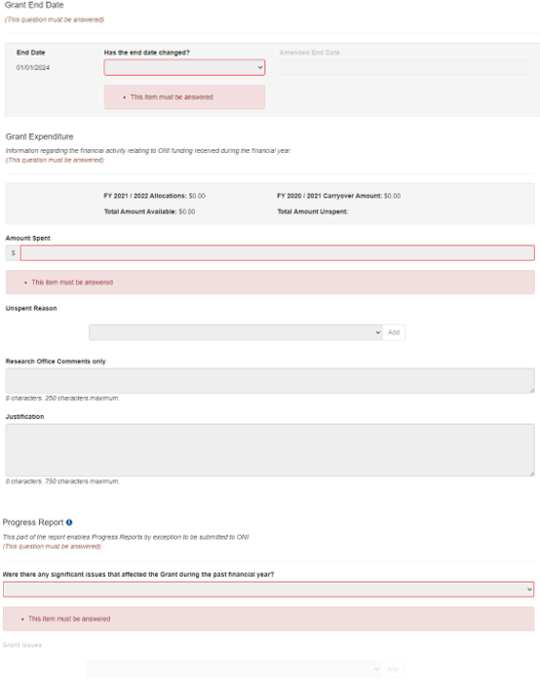

Figure 6 - End-of-Year Report Sections

# PART 2 - Complete the EoYR

The End-of-Year Report is made up of three sections:

* End Date
* Grant Expenditure
* Progress Report.

## Amending the End Date

An End Date change can only be requested in the final year of the Grant, where there are funds carried over to the following year, or the Grant is deemed to have concluded once the Grant funds have been expended or relinquished.

Where an end date is required to be amended:

1. From the drop-down list select ‘Yes’ or ‘No’

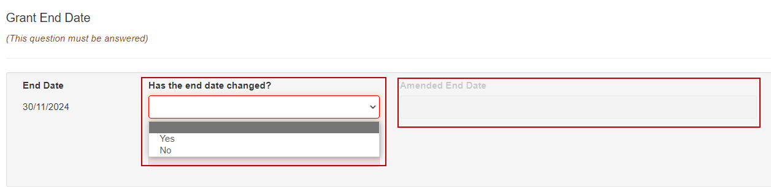

Figure 7 - End date change question

When ‘*Yes’* has been selected the Amended End Date field will become visible.

1. Enter the appropriate end date required.

## Grant Expenditure

The following fields are auto-populated into the EoYR once the report is opened by the RO.

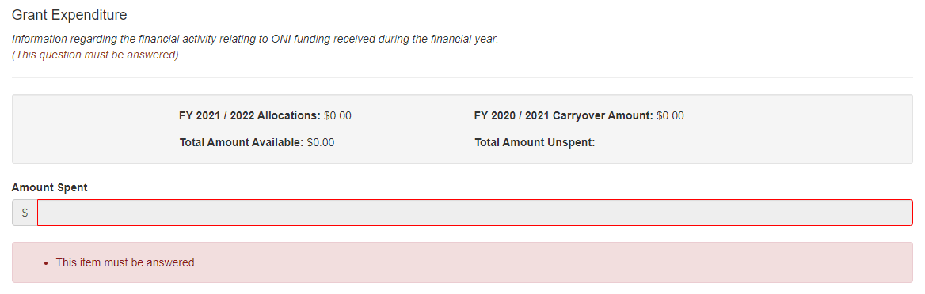

Figure 8 - Grant Expenditure financial information

**Please note:** If you are downloading the report to excel to be sent to the CI for input, all reports will need to be opened first to populate this section.

Table 1 – List of Grant Expenditure Field Explanations

| **Field** | **Explanation** |
| --- | --- |
| Allocations | The net income received by the Administering Organisation for payments made in the financial year |
| Carryover Amount | The approved EoYR carryover amount from the previous financial year/s to the current financial year. Note – For the first EoYR the figure will be $0.00 |
| Total Amount Available | This is the sum of the Allocations' plus the previous financial year/s ‘Carryover Amount' |
| Total Amount Unspent | This will show the requested carryover amount once the amount spent is entered and saved |

## Amount Spent

The AO is responsible for reporting all expenditure for a grant, regardless of the location of funds. Funding is only to be recorded in the *‘Amount Spent’* field (Figure 9) if the funds were actually used. This includes the funds located at other Organisations. Funds are not to be 'written off' because they are located outside the Administering Organisation. If this occurs, it may be seen as committing a fraudulent act and may result in serious action.

Only numbers may be entered into this field and a full stop to show the cents. An amount that is less than $0 or greater than the *‘Total Allocations’* displayed for the Grant cannot be entered into this field. The use of symbols such as $, or commas must not be entered into this field.

1. Enter the total amount of grant funds spent in the last financial year (including funds spent at collaborating organisations).



Figure 9 - Amount spent field

## Unspent Reason

Where funds are unspent and a carryover is requested an *‘Unspent Reason’* must be selected from the drop-down list. Reason Codes let the Funding Entity know why funding is being requested to carryover into the next financial year. Reason Codes are described in Table 2 below.

Entering a Reason Code does not replace the need for the submission of a Variation.

If *‘Other’* is selected, the *‘Research Office Comments’* field will become mandatory, and a reason must be entered.

1. From the drop-down selection (Figure 10) choose the appropriate Unspent Reason(s). More than one *‘Unspent Reason’* may be selected from the list provided.

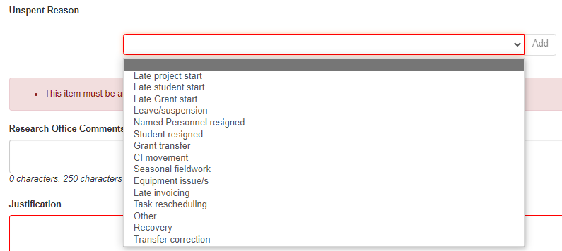

Figure 10 - Unspent reason drop-down list

1. To add the Unspent Reason click ‘*Add’*.

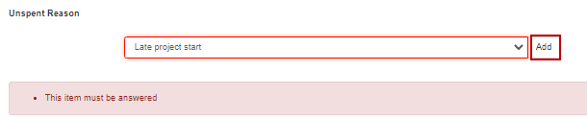

Figure 11 - Button to add the unspent reason

1. If the reason has been selected in error select the ‘*x’* button to the right of the reason.



Figure 12 - Select the cross to remove an unspent reason

Table 2 – List of Unspent Reason codes

| Reason code | Explanation |
| --- | --- |
| Late project start | Project started late (e.g. due to late signing of agreement/s, Funding Entity approved deferment) |
| Late student start | Late commencement of HDR/PGR student funded directly from the grant |
| Late staff start | Late commencement of staff funded directly from the grant  (that are not named participants or students) |
| Leave/suspension | Named Participant/s on the grant took a period of leave or suspension during the reporting period |
| Named Personnel Resigned | Withdrawal of named participants (CIs and PIs only) |
| Student resigned | Resignation of student funded by the grant |
| Grant Transfer | Grant transferred during the reporting period |
| CI Movement | Delays due to movement of named investigators (CIs and PIs only) |
| Seasonal Fieldwork | Seasonal nature of fieldwork (e.g. wet season, migratory practices, remote community access, natural disaster etc.) |
| Equipment Issue/s | Equipment Issues (e.g. breakdown of Project equipment, unavailability of new equipment causing delays, delay in new equipment being available from supplier, delay in construction of equipment) |
| Late Invoicing | Late invoicing for services or equipment that were not paid in the reporting period |
| Task Rescheduling | Rescheduling of tasks, resulting in expenditure being moved into the following year |
| Other  (must specify reason) | If Other is chosen a reason must be entered in the Research Office Comment field |
| Recovery | A recovery occurs when unspent funding is repaid to the Funding Entity. When funds have not been spent and there is no approved carryover, funding will be recovered. Only include this reason if there are funds to be recovered by the Funding Entity. Please make a reference to the variation number if a recovery has already been entered into RMS. |
| Transfer Correction | Use this category if there is a need to correct the figures provided at the time of the Transfer of the grant. If this is selected, additional information must be entered into the justification stating what occurred and the amount that needs to be transferred and/or corrected. |

## Research Office Comments

This field should be used when the unspent reason *‘Other’* is selected to communicate any   
additional administrative issues with the Funding Entity. For example, if the reason for a delay   
in the research progress is not listed in the drop-down selection the reason should be noted in   
the *‘Research Office Comments’* field.



Figure 13 - Research Office Comment box

## Justification

If the *‘Total Amount Unspent’* (carryover request) is more than 75% of the previous financial year’s allocation, a comment must be entered advising the reason. Where the unspent amount is less than 75%, the justification comment box becomes optional.



Figure 14 - Justification comment box

1. Once the report is complete select ‘*Save’*



Figure 15 - 'Save' button

1. Once the report is complete select ‘*Close’*.

The image shows the save and close buttons.

Figure 16 - 'Close' button

## Progress Report

This part of the report enables Progress Reports by exception to be submitted to Funding Entity.

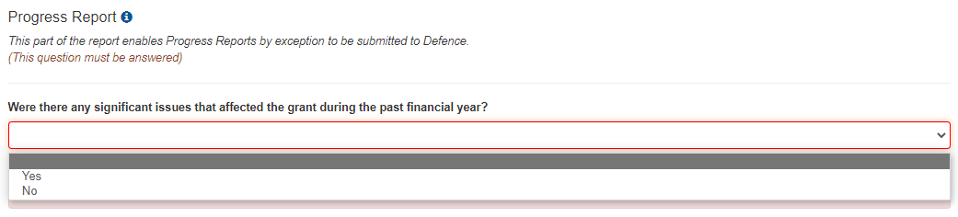

Figure 17 - Significant Issues drop-down selection

If the answer is ‘*No’* (i.e. no additional changes or issues have affected the Grant than those already reported and approved by Funding Entity):

1. Select ‘*No’*

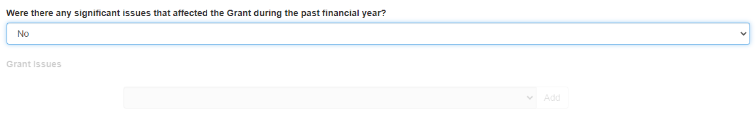

Figure 18 - 'No' Significant Issues

1. Select ‘*Save’*



Figure 19 - 'Save' button

If the answer to this question is ‘*Yes’*, at least one ‘*Grant Issue’* must be selected from the drop-down menu provided.

**Please note: If ‘yes’ is selected this does not replace the need for a submission of a Variation, as set out in the Grant Agreement**.

1. Select ‘*Yes’* if the Grant’s progress was affected during the financial year and this was not already reported in a previous financial year.

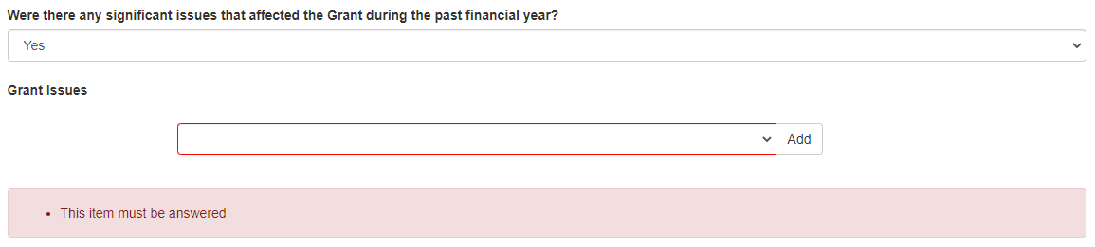

Figure 20 - Reporting a significant issue(s)

1. To add a Grant issue reason code, select the most appropriate code from the list provided

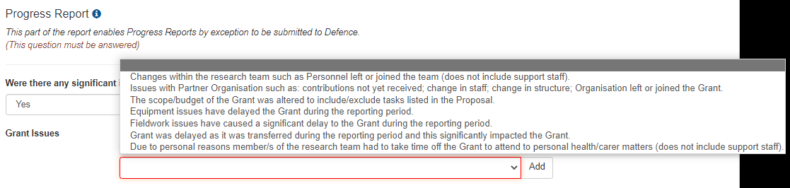

Figure 21 - Grant issues drop-down selection

1. Click ‘*Add’*. (Note - to remove a Grant issue reason code, select the ‘x’ button associated with the appropriate code.)
2. Select ‘*Save’*



Figure 22 - 'Save' button

*Table 3 – List of Grant Issues*

| Grant Issues |
| --- |
| Changes within the research team such as Personnel left or joined the team (does not include support staff). |
| Issues with Partner Organisation such as contributions not yet received, change in structure; Organisation left or joined the Grant. |
| The scope/budget of the Grant was altered to include/exclude tasks listed in the Proposal. |
| Equipment issues have delayed the Grant during the reporting period. |
| Fieldwork issues have caused a significant delay to the Grant during the reporting period. |
| Grant was delayed as it was transferred during the reporting period and this significantly impacted the Grant. |
| Due to personal reasons member/s of the research team had to take time off the Grant to attend to personal health/carer matters (does not include support staff). |

# PART 3 – Submitting the EoYR to the RO EoYR Delegate

Once all required information has been entered, RO staff must submit reports to the   
RO EoYR Delegate for assessment and certification.

Where there are multiple reports to be submitted you can select all from bulk submission.

1. The *‘Ready to Submit’* status will appear against each Report which is ready to be submitted to the RO EoYR Delegate.
2. Select ‘*Submit to RO Delegate’.*

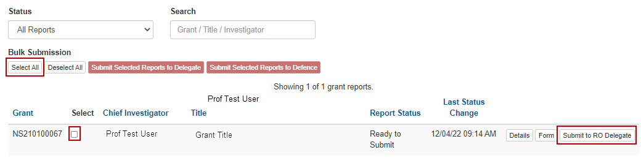

Figure 23 - Submit to RO Delegate button (RO EoYR Delegate)

# PART 4 – RO EoYR Delegate Certification and Submission

EoYRs must be checked and certified by the RO EoYR Delegate prior to submitting the reports to the Funding Entity. RO EoYR Delegates are required to certify that the Grant has complied with the relevant schemes Grant Guidelines and Grant Agreement and that all information provided within the report is accurate and up to date.

Submission of this report must only be done by a person who has the financial delegation to do so on behalf of the AO, as this is a legal document that is being supplied to the Funding Entity.

RO EoYR Delegates are required to certify that the Grant has complied with the relevant schemes Grant Guidelines and Grant Agreement and that all information provided within the report is accurate and up to date.

All EoYRs must be submitted in RMS by 30 September for the previous financial year. Extensions will not be allowed unless approved by the RGS team prior to this date.

## Edits required – De-submit

If information needs editing or is incorrect, RO EoYR can return the report back to RO staff

1. Select *‘Return to Research Office’*.



Figure 24 - Return to Research Office button

## Certify and Submit EoYR to the Funding Entity for assessment

1. The ‘*Certify’* button will appear against each Report which is ready to be certified and submitted to the Funding Entity for assessment. Select Certify.



Figure 25 - 'Certify' button

1. A pop-up box will appear, select ‘*Agree to Certification’*.

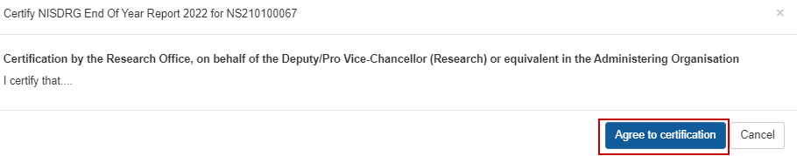

Figure 26 - ‘Agree to certification’ pop-up confirmation

1. Once certified, the status of the report will appear as ‘*Certified’* and may then be submitted to the Funding Entity. In the example, Figure 20, select ‘*Submit to Defence’*.

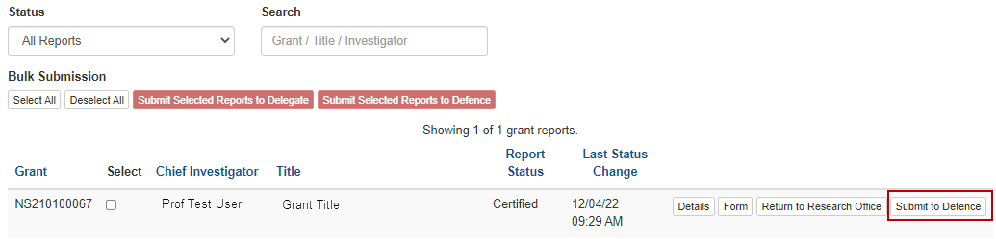

Figure 27 - 'Submit to Defence' Button

1. Once EoYRs are submitted to the Funding Entity, the progress of the report can then be tracked using its status in RMS. If further information is required, RGS will return the report to the AO and send an email advising the details required or queried. 

Figure 28 - Report status view 'Submitted to Funding Entity'

1. Once approved, the Report Status will show ‘Accepted’.



Figure 29- Report status 'Approved'

If you have any questions regarding the completion of the NISDRG End-of-Year Report, please contact Research Grants Services [arc-nisdrg@arc.gov.au](mailto:arc-nisdrg@arc.gov.au).

# Definitions and Glossary

## Definitions

| **Term** | **Definition** |
| --- | --- |
| Administering Organisation (AO) | An Eligible Organisation responsible for the administration of the grant. |
| [Australian National Intelligence Community](https://www.oni.gov.au/national-intelligence-community) | Comprises the six agencies that formerly made up the Australian Intelligence Community (AIC):   * ONA * the Australian Signals Directorate (ASD) * the Australian Geospatial-Intelligence Organisation (AGO) * the Australian Secret Intelligence Service (ASIS) * the Australian Security Intelligence Organisation (ASIO) * the Defence Intelligence Organisation (DIO)   as well as the Australian Criminal Intelligence Commission (ACIC) and the intelligence functions of the Australian Federal Police (AFP), Australian Transaction Reports and Analysis Centre (AUSTRAC) and The Department of Home Affairs. |
| Australian National Security Community | Comprises the:   * Department of Defence * Department of Home Affairs * Office of National Intelligence * Department of Home Affairs * Department of Foreign Affairs and Trade * Prime Minister and Cabinet * Department of Industry, Science, Energy and Resources. |
| Funding Entity | Either the Department of Defence-NSSTC, or Office of National Intelligence |
| Intelligence Challenges | Those challenge areas aligned with the National Security Science and Technology Priorities identified by the Australian Government to be funded by the ONI, and available on the [RGS website](https://www.researchgrants.gov.au/). |
| Lead Chief Investigator (CI) | The first named investigator of a Project |
| National Security Science and Technology Centre (Defence – NSSTC) | The Department of Defence National Security Science and Technology Centre within the Defence Science and Technology (DST) Group that coordinates whole of government national security science and technology. |
| National Security Challenges | Those challenge areas aligned with the National Security Science and Technology Priorities identified by the Australian Government to be funded by the Defence – NSSTC, and available on the [RGS website](https://www.researchgrants.gov.au/). |
| Progress Report | Progress Reports by exception to be submitted to Funding Entity. |
| Project | An application approved by the ONI Delegate or the Department of Defence Delegate to receive funding, may also be referred to as a Grant. |
| Reporting Period | The period of the report, July to June. A full financial year. |
| Research Office | A business unit within an Eligible Organisation that is responsible for contact with Us regarding applications and projects. |
| Us/We | The Australian Research Council |

## Glossary

| **Acronym** | **Elaboration** |
| --- | --- |
| AO | Administering Organisation |
| ARC | Australian Research Council |
| CI | Chief Investigator |
| EoYR | End-of-Year Report |
| Defence - NSSTC | Department of Defence, National Security Science and Technology Centre |
| ONI | Office of National Intelligence |
| NISDRG | National Intelligence and Security Discovery Research Grants |
| RGS | Research Grants Services team |
| RMS | Research Management System |
| RO | Research Office |