National Intelligence and Security Discovery Research Grants Round 3

Key Performance Indicator Reporting   
in RMS User Guide

Updated June 2023

Contents

National Intelligence and Security Discovery Research Grants Round 3 1

Introduction 3

Key Points 4

Summary of Workflow 4

Quick Reference 5

PART 1 – Locate the KPI Report within RMS 6

PART 2 – Complete the KPI Report 7

2.1 Research Output Targets 7

2.1.1 High-level Research Output Targets 7

2.1.2 Additional Research Output Categories 9

2.1.3 Quality of Research Outputs 10

2.2 Grant Personnel Targets 12

2.3 Grant Outreach Targets 13

2.4 Project Specific Performance Measures (KPIs) 14

PART 3 – Submit to the RO 17

PART 4 – RO Certification and Submission 18

4.1 To review the details entered in a KPI Report 18

4.2 To return a KPI Report to a Lead CI for updates 19

4.3 To certify and submit a KPI report to ARC 19

Glossary and Definitions 21

Definitions 21

Glossary 22

# Introduction

The Australian Research Council (ARC), on behalf of the Office of National Intelligence (ONI), is conducting grant management for the National Intelligence and Security Discovery Research Grants (NISDRG) program.

The NISDRG program supports excellent research that deepens our understanding of emerging science and technology and addresses intelligence and national security interests. The grant program will facilitate innovation and develop national security and intelligence capacity. It will also enable Australia’s National Intelligence and Security Communities to systematically engage with Australia’s research and technology community.

In addition, the NISDRG program provides support to research that aligns with the priority research areas identified by the Australian Government. These research areas are outlined in the Intelligence Challenges developed under the broad National Security Science and Technology Priorities. More information on the Intelligence Challenges is available on the [Research Grants Services website.](https://www.researchgrants.gov.au/)

In order to ensure that the NISDRG program achieves the objectives and intended outcomes, all awarded grants are required to provide periodic progress updates against set Program focused Key Performance Indicators (KPIs) as well as performance measures that help demonstrate how the project is progressing. KPIs must be set for each grant against the standard Program KPIs, and performance measures when the grant commences using a KPI Report in RMS.

Following the acceptance of the KPI Report by RGS, Progress Reports will be submitted twice yearly to advise the progress of the grant against the aspirational performance goals set in the KPI Report to reflect the highest possible level of achievement for a grant. It is important to note that KPIs and progress reporting are one measure of progress and will be reviewed in context with other reports, outreach, and engagement activities.

All grant management activities, including the submission of variations and grant reporting, must be completed within the ONI Research Management System (RMS) portal, unless otherwise advised by the ARC’s Research Grants Services (RGS) team.

* Intelligence Challenges – ONI RMS Portal: [https://rmsoni.researchgrants.gov.au](https://rmsoni.researchgrants.gov.au/)

Upon submission of a KPI report by an Administering Organisation (AO), the RGS team will review the submitted KPIs and ensure that the targets reflect the aims, activities and anticipated outcomes as outlined in the original application and are acceptable to ONI. KPI Reports will also be made available to ONI staff.

The following instruction provides information for the entry and submission of KPIs into the available RMS report. All screenshots provided within this document have been sourced from the ONI RMS portal.

**Note:** The KPIs submitted in the original KPI report will not continue past the original grant period. If your grant is extended, or there is a gap in project activity, please respond to the relevant questions in the Progress Report to note significant variances to the original targets.

# Key Points

* The KPI report must be submitted within 60 days of this report being available in RMS.
* The target audience for this user guide is Lead Chief Investigators (CI) and Research Office (RO) staff for NISDRG awarded grants.
* All NISDRG grants are required to provide a KPI Report at the commencement of the grant.
* KPIs are entered for all years of funding, if carry over funding is requested additional KPIs will not be required.
* The KPIs entered will help measure the progress of the grant in the Progress Report.
* KPI Reports are one measure of grant progress along with other reports, engagement, and outreach activities.
* KPIs must be completed by the first named CI, then certified and submitted by the AO RO Delegate.
* KPI targets will not be editable after KPI Report acceptance.

## Summary of Workflow

*\*The RGS team may request amendments to targets prior to acceptance on behalf of the ONI.*

# Quick Reference

**PART 1 –** **Locate the KPI report within RMS**

KPI Reports are available in the ONI RMS portal: [https://rmsoni.researchgrants.gov.au](https://rmsoni.researchgrants.gov.au/)

**PART 2 –** **Complete the KPI Report**The KPI Report must be completed by the Lead CI. All KPI Report details for the project should reflect the aims, activities and anticipated outcomes as outlined in the original application.

* **Part A –** Research Outputs Research Outputs  
  This section is designed to capture outputs the project has produced that are peer and industry reviewed.
* **Part B –** Grant Personnel   
  This section is intended to show the project’s ability to build capacity and capability by supporting researchers, fostering research trainees and engaging non-academic participants.
* **Part C** – Grant Outreach   
  This section is intended to demonstrate the project’s level of engagement between the research sector and the Australian Government, industry and business, and Australia’s National Intelligence Community.
* **Part D** – Project Specific Performance Measures  
  This section of the report is intended to allow each project to report on the qualitative and quantitative success measures.

**PART 3 –** **Submit to the RO**Once all mandatory fields have been completed, and the CI is satisfied that all details have been accurately entered, the report must be submitted to the RO Delegate for review and final submission.

**PART 4 –** **RO Certification and Submission** If edits are required, a request to de-submit the KPI Report must be made to the RGS team by email to [arc-nisdrg@arc.gov.au](mailto:arc-nisdrg@arc.gov.au).

**Note:** When you see the information icon (information icon), hover over for further information and guidance.

# PART 1 – Locate the KPI Report within RMS

The NISDRG KPI Report is available within the ONI RMS portal. The first named (Lead) CI listed on the grant will have the ability to view and enter details into the Report.

**To locate the NISDRG KPI Report:**

1. Navigate to the ONI RMS portal: [https://rmsoni.researchgrants.gov.au](https://rmsoni.researchgrants.gov.au/)
2. Select the ‘**Grant Reports’** link from the RMS Action Centre

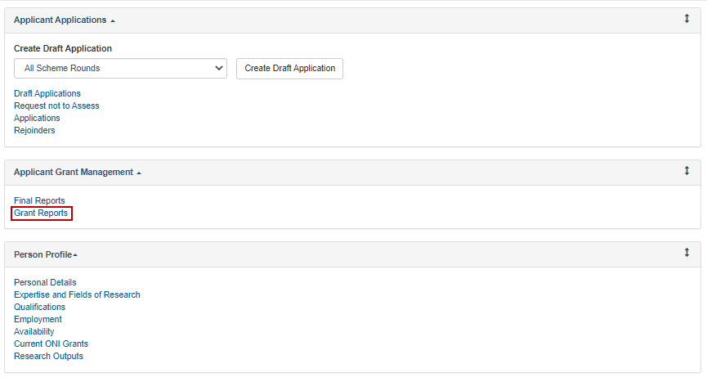

Figure 1 - Grant Reports link from the RMS Action Centre

1. Select ‘**NISDRG KPI Report’** from the dropdown menu

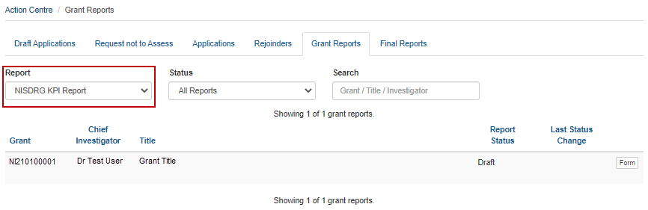

Figure 2 - Dropdown menu to select report

1. Select the ‘**Form’** button to open the KPI Report

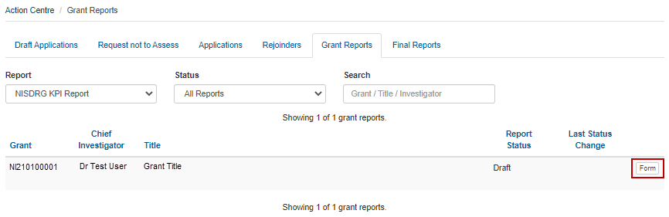

Figure 3 - 'Form' button to open report

1. The KPI Report will display with form parts and questions to be responded to.

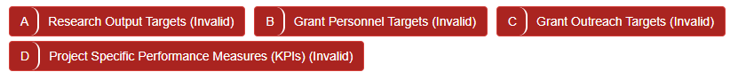  
Figure 4 - NISDRG KPI Report form parts

# PART 2 – Complete the KPI Report

Once located within RMS, the KPI Report must be completed by the Lead CI prior to submission to the AO for certification, and submission to the Funding Entity. The KPI Report is intended to capture aspirational targets against 4 specified categories, to which progress throughout the grant lifecycle will be reported against. Target details must be entered for anticipated research outputs, grant personnel engagement, grant outreach activities and project specific targets. All KPI target details for the grant should reflect the aims, activities and anticipated outcomes as outlined in the original application.

Mandatory fields within the Report will be flagged with a red outline. A target is required in each mandatory field, noting that a ‘**0**’ must be entered if an output is not expected within the reporting year.

## 2.1 Research Output Targets

The targets in this category are intended to demonstrate the grant’s ability to enhance the capacity of Australia’s National Intelligence Community, the wider research sector, and the general public to access relevant knowledge and research.

It is expected that the number of research outputs produced by a grant will increase throughout the life of the grant.

For the purposes of the KPI Report a research output is defined as “*all products of a research project*”. All research output targets entered in Part A of the Report should be research discipline and industry relevant.

### 2.1.1 High-level Research Output Targets

The High-level Research Output Targets question (A1) is intended to capture the highest aspirational targets for all research outputs expected to be produced by the grant.

Target details must be entered as a numeral against each research output category and the year of expected distribution. Research outputs have been categorised into peer reviewed outputs, non-peer reviewed outputs and data sets.

To complete the question, enter the aspirational target as a numeral in each mandatory field.

Please note that a research output target should be entered in *one category only* for this question (i.e. a non-peer reviewed data set should only be entered in the Data Set category).

#### Peer Reviewed Outputs

The details in this category are intended to capture the target for outputs of the grant that will undergo peer review by qualified members of a profession within the field of research prior to distribution, by year of funding.

Consider who the end users are. Would they be interested or involved in the research from the beginning or in the final year once the product is ready for launch?

It is expected that the number of research outputs produced by a project will increase throughout the life of the grant.

#### Non-Peer Reviewed Outputs

The details in this category are intended to capture the target for outputs of the grant that will be distributed without peer-review, by year of funding.

This category is intended to capture the grant’s ability to enhance the access the general public has to relevant knowledge and research.

Once again, consider who the end users are. Would they be interested in the research from the beginning or only in the final year once it is ready to be made public?

#### Data Sets

The details in this category are intended to capture the target for data set outputs of the grant, by year.

A data set is a collection of related information, like conclusions or numerical analysis that is composed of separate elements but can be used as a unit.

*All outputs should include a data set therefore this section should not be zero.*

**To enter details into the High-level Research Output Targets question:**

1. Open the KPI Report by selecting the ‘Form’ button (Figure 3)
2. Enter the aspirational target detail for each research output category as a numerical value against the anticipated year of distribution

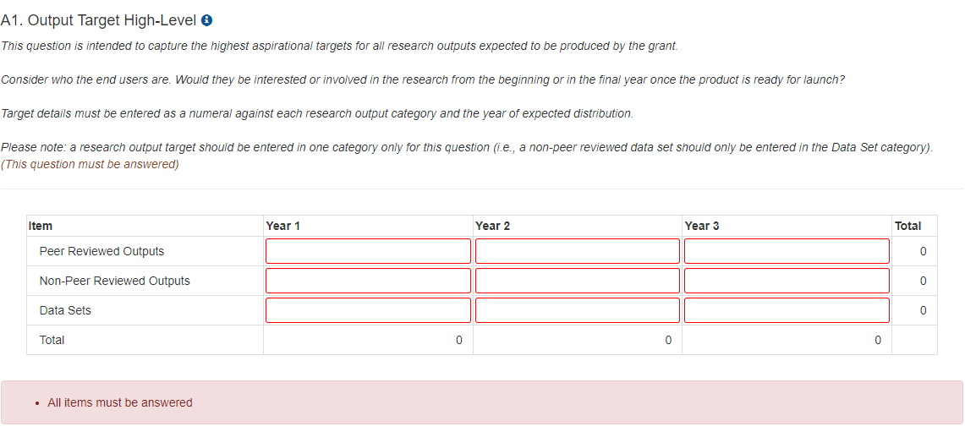

Figure 5 - A.1 High-Level Research Output Targets question

**Note:** Total research outputs for each year, and each category, will automatically calculate upon data entry.

1. Upon completion of the data entry ensure that the ‘Save’ button in the top right of the screen is selected to ensure no data is lost.

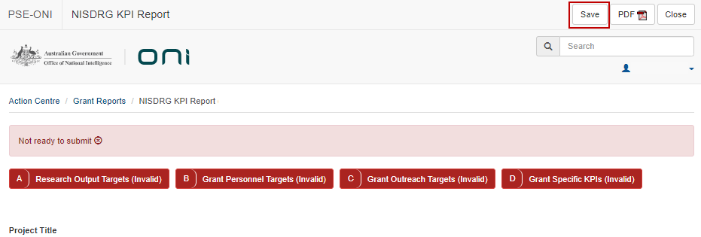

Figure 6 - 'Save' button

### 2.1.2 Additional Research Output Categories

The Additional Research Output Categories question (A2) is intended to provide additional information regarding the aspirational targets for specific output categories. Target details for collaborative (co-authored) outputs, outputs targeted at the Intelligence community, and outputs that are made openly available, should be entered as a numeral against each research output category and the year of expected distribution. Each expected output should also be represented in a category in question A1.

Please note that a research output target may be entered in *multiple categories* for this question (i.e. a co-authored research output which is openly available may be entered in both categories).

#### Collaborative (Co-authored) outputs

The details in this category are intended to capture the target for outputs of the grant that are authored in conjunction with someone outside the research team.

#### Outputs directed at the Intelligence community

The targets in this category are intended to demonstrate the grant’s delivery of research outputs to the Funding Entity and/or Intelligence community, including their ability to communicate complex scientific information effectively.

Outputs in this category could include papers specifically aimed at the National Intelligence Community.

#### Outputs made openly available

The targets in this category will demonstrate the Project’s level of engagement with the public and their ability to communicate complex scientific information effectively.

The outputs in this category could include an article in the Conversation, relevant publications (such as magazines), websites, and other media articles (including social media).

**To enter details into the Additional Research Output Categories question:**

1. Scroll to question A2 within Part A of the KPI Report
2. Enter the aspirational target detail for each research output category as a numerical value against the anticipated year of distribution

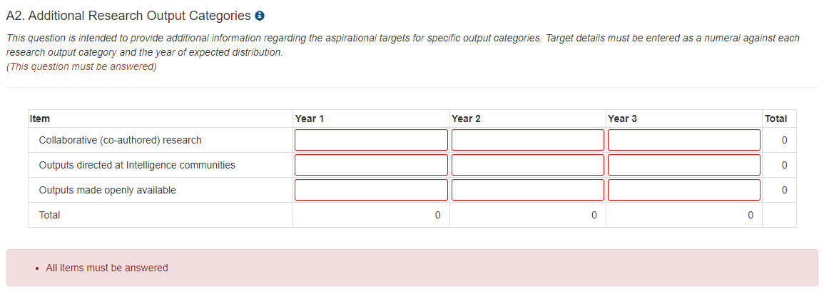

Figure 7 - Additional Research Output Categories Question

1. Save the form to ensure no data is lost (Figure 6).

### 2.1.3 Quality of Research Outputs

The Quality of Research Outputs question (A3) is intended to provide information regarding the measures that will be used to determine output quality. Quality measures entered in question A3 should be appropriate to the output types expected from the grant, and the research being conducted. A target for each quality measure is expected to be entered and the number of outputs that meet the quality measure will be reported through periodic progress reporting.

Look for interdisciplinary peer reviewed journals that may provide feedback or reviews to measure the quality of the output.

Examples of output types could include:

* Journal articles
* Conference publications
  + published to inform industry
  + published to inform the public
* Patents
* Book Chapters
* Awards.

The below identifies some examples of how a quality measure could be entered.

|  |  |  |
| --- | --- | --- |
| Quality Measure | Target for Quality Measure | Quality Measure applicable to output type |
| Impact factor > 2.5 | 50% | Refereed papers in journals |
| Citation Count | >5 | Book Chapter |
| H index | 5% | All peer reviewed publications |
| Award | 1 | All Outputs |

Table 1 - Quality Measure examples

A citation count is an example of measuring the quality of outputs, however these can take longer than the Project’s active period to be realised especially when published in the final year of the grant. Consider a target that you would use to measure the quality of your research.

**To enter details into the Quality of Research Outputs question:**

1. Scroll to question A3 within Part A of the KPI Report
2. Select the ‘**Add answer**’ button

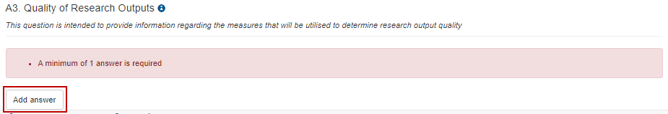

Figure 8 - 'Add answer' button

1. Complete the quality measure details

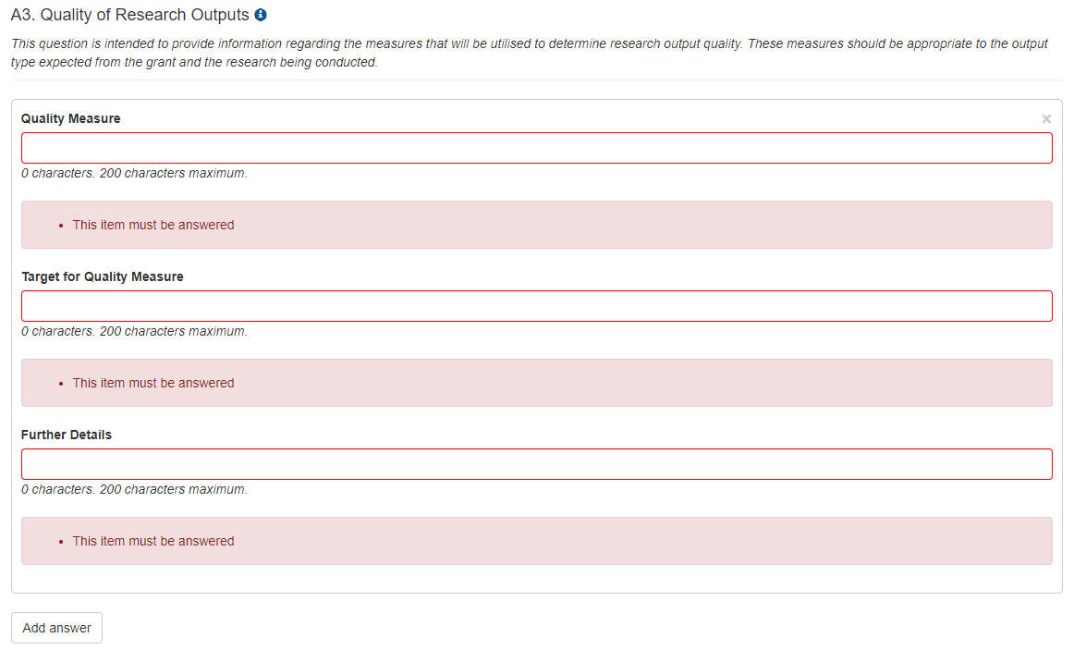

Figure 9 - Quality Measure details entry

1. Additional quality measures can be added by selecting the ‘**Add answer’** button
2. Save the form to ensure no data is lost (Figure 6).

**Note**: if the ‘**Add answer’** button is selected incorrectly, the ‘**x**’ at the top right of the answer box can be selected to clear the answer.

## 2.2 Grant Personnel Targets

The targets in this category are intended to demonstrate the grant’s ability to build capacity and capability by supporting researchers, fostering research trainees and engaging non-academic participants. Targets should be entered as a numeral and reflect the expected number of new personnel engagements by year (i.e. if an individual is to be engaged in year one and continue through to grant completion a ‘1’ should be entered in year 1 only).

When setting targets consider supervision requirements within the research team. For example, for new students will there be a post-doctorate currently employed who will provide supervision?

**To enter details into the Grant Personnel question:**

1. Navigate to Part B of the KPI Report
2. Enter the aspirational target detail for each new personnel to be employed by the grant as a numerical value against the anticipated year of engagement

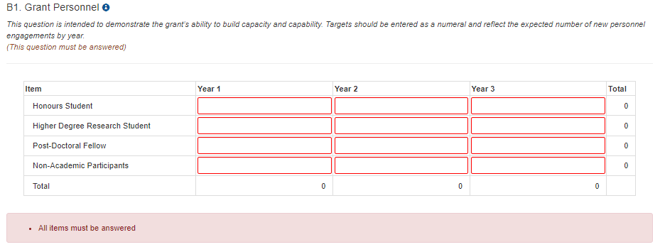

Figure 10 – B1 Grant Personnel question

1. Save the form to ensure no data is lost (Figure 6).

**To upload your Recruitment Plan:**

Since the inception of the program, various unanticipated pressures have impacted funded projects, including COVID-19 and its impacts on workforce availability and inflation. In addition, the restricted eligibility criteria for students including PhD students and Post-Doctoral candidates has frustrated the recruitment efforts of a number of funded projects.

To mitigate the challenges of recruiting project personnel, specifically Higher Degree Researchers (ie. PhD, Masters, Post Doc) students to undertake project activities, ONI requires a recruitment plan to be developed and uploaded.

To answer the recruitment plan question:

1. Scroll to question B2
2. Upload your recruitment plan
3. Save the form to ensure no data is lost (Figure 6).

A screenshot of Question B2 stating Please upload your recruitment plan. Another line showing two buttons: one to select to choose a file  and a second one to upload the file.


Figure 11 - Question B2 requesting upload of a recruitment plan

## 2.3 Grant Outreach Targets

The targets in this category are intended to demonstrate the grant’s level of engagement between the research sector and the Australian Government, industry and business, and Australia’s National Intelligence and Security Communities. Target details for keynote presentations and briefings should be entered as a numeral against each outreach category and the year of expected completion. It is expected that all participants involved with an NISDRG funded grant will have the opportunity to provide input to briefings and present to external stakeholders.

Please note that keynote presentations and briefing targets can include both invitations from external stakeholders, as well as events hosted by grant personnel.

In considering outreach targets note that it is expected that the number of engagements will increase throughout the life of the grant.

**To enter details into the Grant Outreach question:**

1. Navigate to Part C of the KPI Report
2. Enter the aspirational target detail for each outreach category as a numerical value against the anticipated year of engagement.

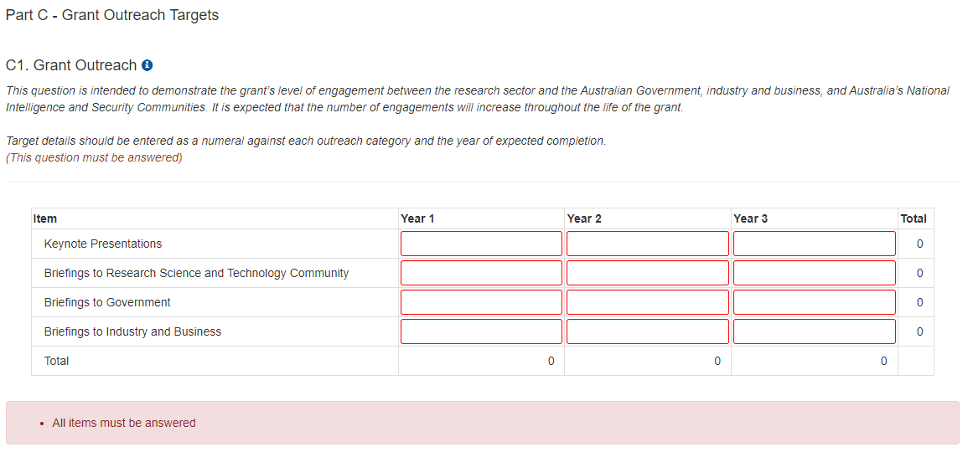

Figure 12 - Grant Outreach question

1. Save the form to ensure no data is lost (Figure 6).

## 2.4 Project Specific Performance Measures (KPIs)

This section of the Report is intended to allow each grant to set research specific performance measures. The question has been designed to allow for the entry of your performance measures, a description of the measure and classification as either a qualitative or quantitative success measure. Project Specific Performance Measures should align closely with the key benefits identified in the Project Plan, and the aims, activities and anticipated outcomes as outlined in the original application.

**Meaningful performance measures** track research results whilst achievement of research results is what defines performance. Completing a task or activity, such as reaching a milestone, does not define performance.

For qualitative measures particularly: consider if the proposed measure is a milestone, activity or performance measure. The measures that are proposed in this section should measure the research performance, and what the activity will hope to have achieved, rather than noting that an activity will have been completed.

Milestones are about **action**, measures are about **results**.

What does success look like as your project progresses? For instance:

#### Example 1

**X** Providing a briefing to a stakeholder is an activity that is completed and is therefore a milestone.

 Receiving feedback from stakeholders about how useful that briefing was provides a measure of performance and is a useful KPI.

#### Example 2

**X** Finishing a set of research activities shows that they have been completed and is a good milestone However it doesn’t help measure whether those activities were useful and contributed to the progress of research or the growth of understanding about the research topic.

 Having a complete and consistent data set or better understanding of a subject, that enables better planning or the ability to create an output or disseminate results, is a measure of performance.

#### Example 3

**X** Completing the creation of a piece of equipment, a tool or a system is a milestone.

 Measuring whether that equipment, tool or system was operational as anticipated (i.e., gives the expected results) is a performance measure. A non-performing item can still be good progress and help future research.

**To enter details into the Project Specific Performance Measure question:**

1. Navigate to Part D of the KPI Report
2. Select ‘**Add answer’**

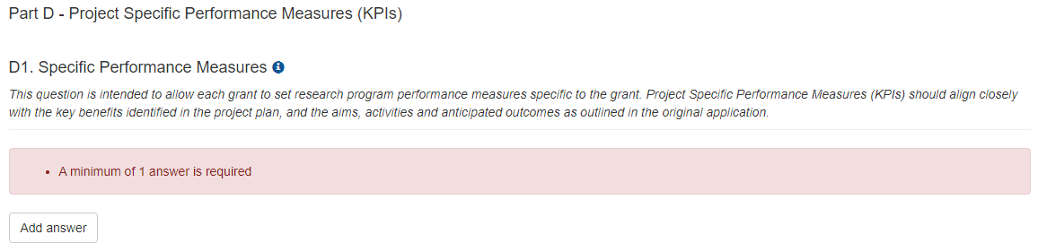

Figure 13 - 'Add answer' button

1. Complete the Performance Measure title and description detail

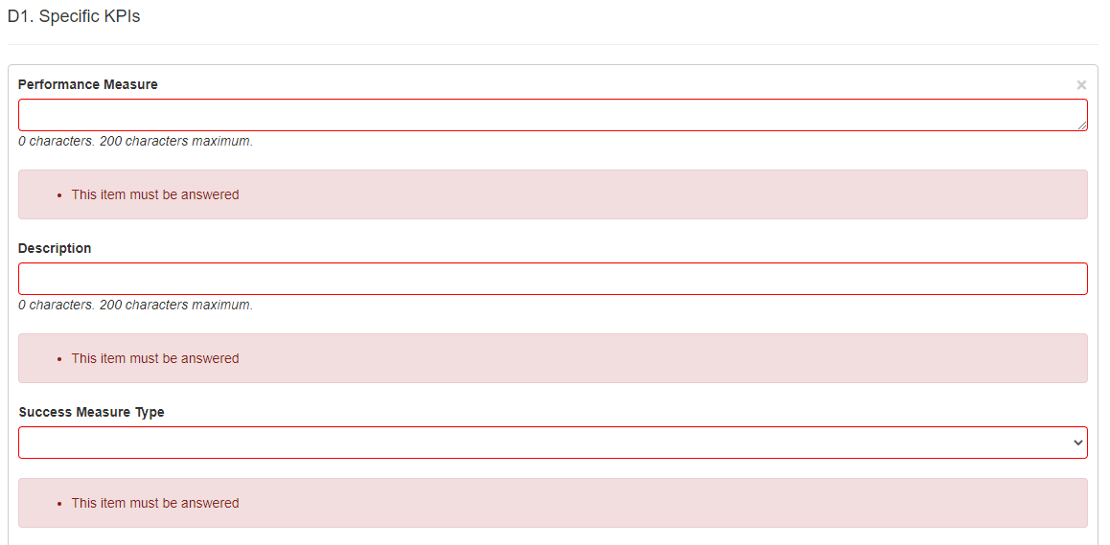

Figure 14 – Performance Measure title and description fields

1. Select the success measure type from the dropdown menu



Figure 15 - Success Measure Type

**Note**: If a quantitative measure is selected a table will display to provide numerical target details for each year of funding. If a qualitative measure is selected, 3 text fields will display to provide target details for each year of funding.

#### For Quantitative Performance Measures:

1. Enter the units of measure e.g. kg, km, km/s etc.
2. Enter a numerical aspirational target for each year of funding

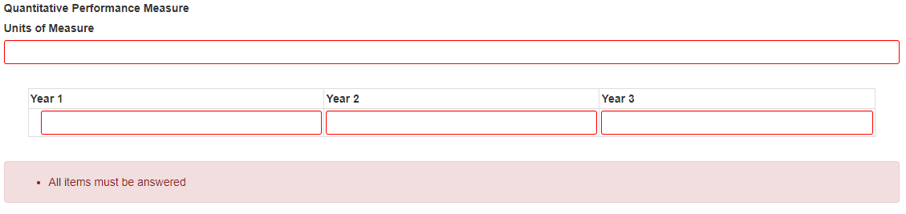

Figure 16 - Quantitative Performance Measure

#### For Qualitative Performance Measures:

Consider if the proposed measure is a milestone, activity or performance measure. The performance measures that are proposed in this section should measure the research performance, and the expected **results** of the activity.

##### Example 1

*Receiving feedback from stakeholders about how useful a briefing was, provides a measure of performance and is a useful KPI.*

##### Example 2

*Having a complete and consistent data set or better understanding of a subject, that enables better planning or the ability to create an output or disseminate results, is a measure of performance.*

##### Example 3

*Measuring whether a piece of equipment, tool or system was operating as anticipated (i.e. gives the expected results) is a performance measure. A non-performing item can still be good progress and help future research.*

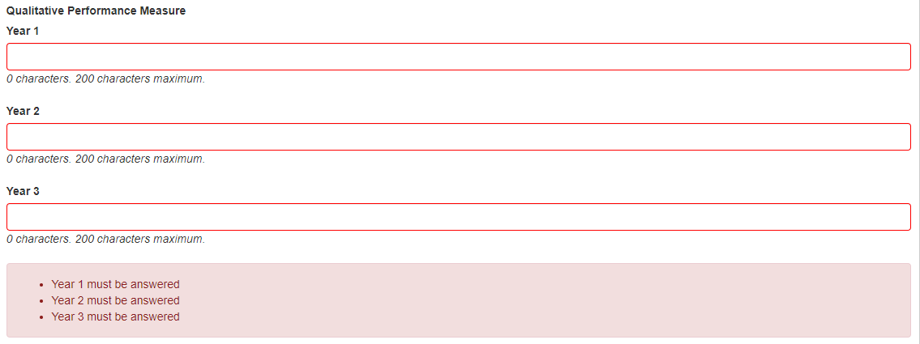

Figure 17 - Quantitative KPI detail entry

1. Enter the qualitative performance measures for each year of funding, see examples above
2. Save the form to ensure no data is lost



Figure 18 - 'Save' button

1. Additional KPIs can be added by selecting the ‘**Add answer’** button



Figure 19 - 'Add Answer' button

**Note**: if the ‘**Add answer**’ button is selected in error the ‘**x**’ at the top right of the answer box can be selected to clear the answer.

# PART 3 – Submit to the RO

Once all mandatory fields have been completed, and the Lead CI of the grant is satisfied that all aspirational KPI target details have been accurately entered, the report must be submitted to the   
AO RO for review and final submission.

To submit a completed report to the RO:

1. Ensure that all mandatory fields within the Report have been completed and that the ‘**Ready to submit’** message appears at the top of the Report



Figure 20 - Ready to submit message

1. Return to the Grant Reports menu by selecting the ‘**Grant Reports’** link at the top of the page

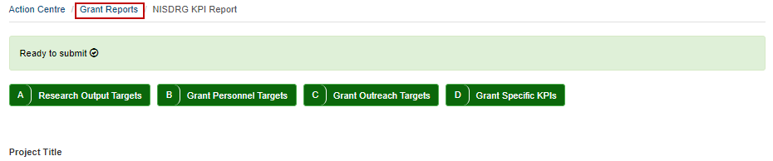

Figure 21 - 'Grant Reports' link

1. Locate the relevant report and select the ‘**Submit to RO’** button

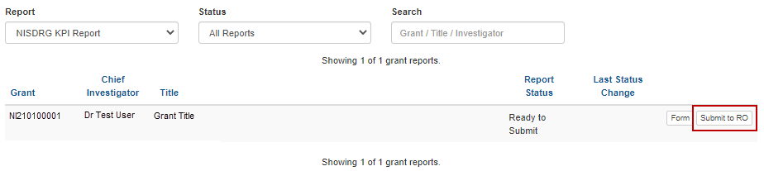

Figure 22 - 'Submit to RO' button

1. Confirm submission of the KPI Report by selecting ‘**Submit to RO’** in the pop-up message

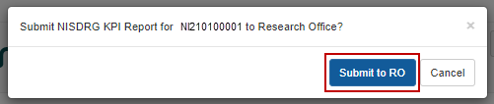

Figure 23 - Confirm Submission to RO

# PART 4 – RO Certification and Submission

The targets submitted within the KPI Report form part of the Grant Agreement between the AO and ONI due to the requirement to provide periodic progress updates against set KPIs. Therefore, each target should be reviewed to ensure that the entered KPI closely aligns with the key benefits identified in the Project Plan, and the aims, activities and anticipated outcomes as outlined in the original application.

Upon confirmation that the entered KPI target details are agreeable to the AO, the KPI report must be certified by a RO Delegate and submitted to ONI for review by the RGS team.

## 4.1 To review the details entered in a KPI Report

1. Navigate to the ONI RMS portal: [https://rmsoni.researchgrants.gov.au](https://defence.researchgrants.gov.au)
2. Select the ‘**Research Office Grant Reports**’ link within the ‘Research Office Grant Management’ module of the RMS action centre.

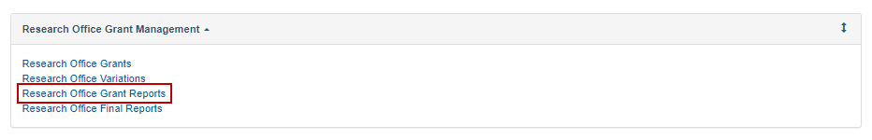

Figure 24 - 'Research Office Grant Reports' link from the RMS Action Centre

1. Locate the KPI Report to be reviewed and select ‘**Form’**

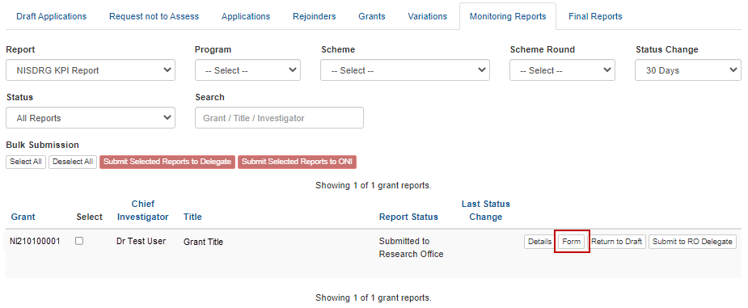

Figure 25 - 'Form' button to open a KPI report for review

1. Review the details entered in the Report.

## 4.2 To return a KPI Report to a Lead CI for updates

If the KPIs are not acceptable and require editing, the RO may return the KPI Report to the Lead CI.

1. Return to the list of available RO grant reports by selecting the ‘**Research Office Grant Reports’** link



Figure 26 - Research Office Grant Reports

1. Locate the report to be returned and select ‘**Return to Draft’**

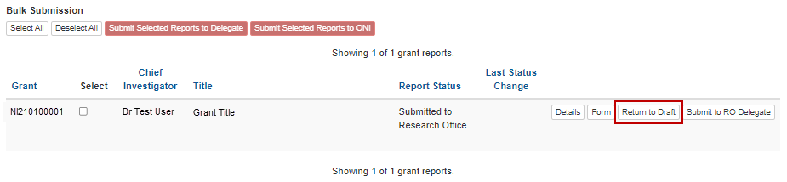

Figure 27 - 'Return to Draft' button

## 4.3 To certify and submit a KPI report to ARC

If the KPIs are acceptable, the RO must submit the report to the RO Delegate.

1. Return to the list of available RO grant reports by selecting the **‘Research Office Grant Reports**’ link (Figure 21)
2. Locate the report to be submitted and select **‘Submit to RO Delegate’**

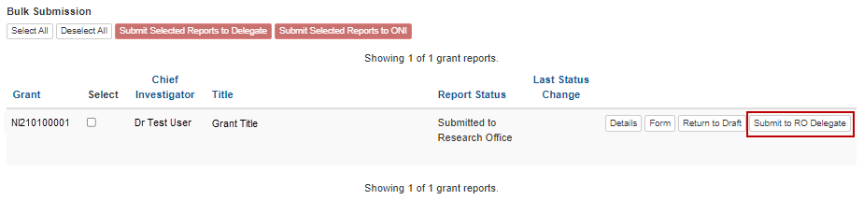

Figure 28 - 'Submit to RO Delegate' button

1. Confirm submission to the RO Delegate by selecting the ‘**Submit to RO Delegate’** button

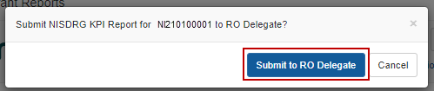

Figure 29 - Confirm Submission to RO Delegate

1. The report must be then certified by the RO Delegate by selecting the ‘**Certify’** button

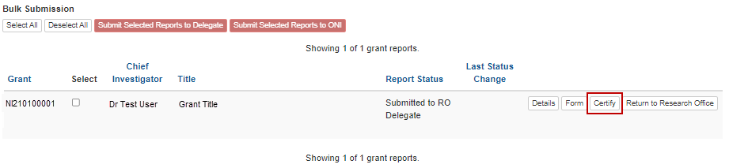

Figure 30 - 'Certify' button

1. Confirm RO Delegate certification by selecting ‘**Agree to certification’**

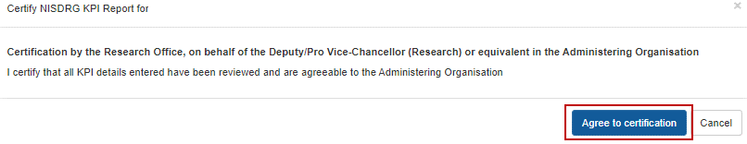

Figure 31 - Certification message

1. Finalise submission by selecting the ‘**Submit to ONI’** button.

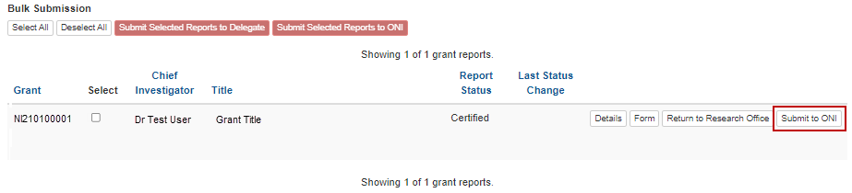

Figure 32 - Submit to Funding Entity button

# Glossary and Definitions

## Definitions

| **Term** | **Definition** |
| --- | --- |
| Administering Organisation (AO) | An Eligible Organisation responsible for the administration of the grant. |
| [Australian National Intelligence Community](https://www.oni.gov.au/) | The National Intelligence Community comprises of 10 agencies brought together to protect and enhance Australia’s security, prosperity and sovereignty:   * Australian Criminal Intelligence Commission (ACIS) * Australian Federal Police (AFP) * Australian Geospatial-Intelligence Organisation (AGO) * Australian Security Intelligence Organisation (ASIO) * Australian Secret Intelligence Service (ASIS) * Australian Signals Directorate (ASD) * Australian Transaction Reports and Analysis Centre (AUSTRAC) * Defence Intelligence Organisation * Department of Home Affairs (DHA) * Office of National Intelligence (ONI). |
| Funding Entity | The Office of National Intelligence |
| Intelligence Challenges | Those challenge areas aligned with the National Security Science and Technology Priorities identified by the Australian Government to be funded by the ONI, and available on the [RGS website](https://www.researchgrants.gov.au/). |
| Key Performance Indicators (KPIs) and/or Performance Measures | A set of quantitative and/or qualitative measures that We use to monitor and report on progress of research outcomes. |
| Lead Chief Investigator (CI) / Project Lead | The first named investigator of a Project. |
| Progress Report | A report submitted in RMS advising the progress of the grant against Key Performance Indicators (KPIs). |
| Project | An application approved by the ONI Delegate to receive funding, may also be referred to as a Grant. |
| Reporting Period | The period of the report, January to June or July to December. |
| Research Office (RO) | A business unit within an Eligible Organisation that is responsible for contact with Us regarding applications and projects. |
| Research output | All products of a research project. |
| Us/We | The Australian Research Council |

## Glossary

| **Acronym** | **Elaboration** |
| --- | --- |
| AO | Administering Organisation |
| ARC | Australian Research Council |
| CI | Chief Investigator |
| KPI | Key Performance Indicator |
| ONI | Office of National Intelligence |
| NISDRG | National Intelligence and Security Discovery Research Grants |
| RGS | Research Grants Services team |
| RMS | Research Management System |
| RO | Research Office |