# National Intelligence and Security Discovery Research Grants

Progress Reporting in RMS

(User Guide)

Updated July 2025

# Contents

National Intelligence and Security Discovery Research Grants 1

Contents 2

Introduction 3

Key Points 4

Summary of Workflow 4

Quick Reference 5

PART 1 – Locate the Progress Report within RMS 6

PART 2 – Complete the Progress Report 7

2.1 Research Outputs 8

A1. Output Target High-Level 8

A2. Output Target Detailed 9

A3. Quality of Research Outputs 10

A4. Output Issues 11

A5. Publications During the Reporting Period 11

A6. Upcoming Publications 13

2.2 Grant Personnel 15

B1. Grant Personnel 15

B2. Grant Personnel Departures 16

B4. Engaged Personnel details 18

B4/5. Recruitment 17

B5. Personnel Issues 17

2.3 Grant Outreach 18

C1. Grant Outreach 19

C2. Outreach Issues 19

C3. Additional Funding 20

C4. Future Additional Funding 20

2.4 Project Specific Performance Measures (formerly Grant Specific KPIs) 21

D1. Specific Performance Measures (KPIs) 23

D2. Provide a high-level update on the progress of the research Project 25

D3. Highlights 25

D4. Significant Issues 26

D5. Were there any security issues or incidents during the reporting period? 27

D6. Activity Budget 27

PART 3 – Submit to the Research Office 29

PART 4 – Research Office Certification and Submission 30

4.1 To review the details entered in a Progress Report 30

4.2 Returning a Progress Report to a Lead CI 31

4.3 To certify and submit a Progress Report to the Funding Entity 31

Glossary and Definitions 33

Definitions 33

Glossary 34

# Introduction

The Australian Research Council (ARC), on behalf of the Office of National Intelligence (ONI) and the Defence National Security Science and Technology Centre (Defence-NSSTC), is conducting grant management for the National Intelligence and Security Discovery Research Grants (NISDRG) Program.

The NISDRG program supports excellent research that deepens understanding of emerging science and technology and addresses intelligence and national security interests. The grant program will facilitate innovation and develop national security and intelligence capacity. It will also enable Australia’s National Intelligence and Security Communities to systematically engage with Australia’s research and technology community.

In addition, the NISDRG program provides support to research that aligns with the priority research areas identified by the Australian Government. These research areas are outlined in the Intelligence Challenges, and the National Security Challenges developed under the broader National Security Science and Technology Priorities. More information on the Intelligence Challenges and National Security Challenges are available on the [Research Grants website](https://www.researchgrants.gov.au/).

To ensure that the NISDRG program achieves the objectives and intended outcomes, all awarded grants are required to provide periodic progress updates against set Program focused Key Performance Indicators (KPIs) as well as performance measures that help demonstrate how a Project is progressing. KPIs must be set for each Project against the standard Program KPIs, and performance measures when the grant commences using a KPI form (KPI Report) in RMS.

Following the acceptance of the KPI Report by RGS, Progress Reports will be submitted twice yearly to advise the progress of the Project against the performance goals set in the KPI Report to reflect the grants achievements. It is important to note that KPIs and progress reporting are only one measure of progress and will be reviewed in context with other reports, outreach, and engagement activities.

All grant management activities, including the submission of variations and grant reporting, must be completed within the Research Management System (RMS) portal associated with the challenges under which the grant was awarded, unless otherwise advised by RGS.

* Intelligence Challenges – ONI RMS Portal - [https://rmsoni.researchgrants.gov.au](https://rmsoni.researchgrants.gov.au/)
* National Security Challenges – Defence RMS Portal - [https://defence.researchgrants.gov.au](https://defence.researchgrants.gov.au/)

Upon submission of a Progress Report by an Administering Organisation (AO), the Research Grants Services (RGS) team will review the submitted report against the targets in the KPI Report. The progress of the Project should reflect the aims, activities and anticipated outcomes as outlined in the original application. Progress Reports will also be made available to ONI and Defence-NSSTC staff.

**Note:** The KPIs submitted in the original KPI report will not continue past the original grant period. If your grant is extended, or there is a gap in project activity, please respond to the relevant questions in the Progress Report to note significant variances to the original targets.

The following instructions provide information for the entry and submission of Progress Reports into the available RMS report. Screenshots provided within this document have been sourced from the Defence and ONI RMS portals and images may differ slightly dependent on the portal being used.

# Key Points

* The target audience for this user guide is Lead Chief Investigators (CI) and Research Office (RO) staff for NISDRG awarded grants
* KPI’s are established by Project teams at the beginning of the Project
* Progress Reports are only one measure used to monitor project progress
* Progress reports will be opened each year for the Lead CI to complete in:
  + February (reporting period for previous July – December)
  + August (reporting period for previous January – June)
* An AO RO Delegate is required to certify and submit the Progress Report by the due date. Extensions will not be allowed unless approved by the RGS team prior to the due date.
* The RGS team will review the submitted report against the targets in the KPI Report. Progress Reports will also be made available to ONI and Defence-NSSTC staff.

## Summary of Workflow

Figure 1: Summary of Workflow

*\*The RGS team may request amendments prior to acceptance on behalf of the ONI or NSSTC.*

## Quick Reference

**PART 1 –** **Locate the Progress Report within RMS**

* Progress Reports are available within the RMS portal of the funded grant:
  + Intelligence Challenges - ONI RMS Portal - <https://rmsoni.researchgrants.gov.au>
  + National Security Challenges - Defence RMS Portal - <https://defence.researchgrants.gov.au>

**PART 2 –** **Complete the Progress Report**The Progress Report must be completed by the Lead CI. All Progress Report details for the Project should reflect the aims, activities and anticipated outcomes as outlined in the original application.

* **Part A –** Research Outputs Research Outputs  
  This section is designed to capture outputs the Project has produced that are peer and industry reviewed.
* **Part B –** Grant Personnel   
  This section is intended to show the Project’s ability to build capacity and capability by supporting researchers, fostering research trainees and engaging non-academic participants.
* **Part C** – Grant Outreach   
  This category is intended to demonstrate the Project’s level of engagement between the research sector and the Australian Government, industry and business, and Australia’s National Intelligence and Security Communities.
* **Part D** – Project Specific Performance Measures  
  This section of the report is intended to allow each Project to report on the qualitative and quantitative success measures as detailed in the KPI Report.

**PART 3 –** **Submit to the RO**Once all mandatory fields have been completed, and the CI is satisfied that all details have been accurately entered, the report must be submitted to the RO Delegate for review and final submission.

**PART 4 –** **RO Certification and Submission** If edits are required after submission to the Funding Entity, a request to de-submit the Progress Report must be made to the RGS team by emailing [arc-nisdrg@arc.gov.au](mailto:arc-nisdrg@arc.gov.au)

**Note:** Hover over this icon in the Progress Report form for further information and guidance.

# PART 1 – Locate the Progress Report within RMS

The NISDRG Progress Report is available within the RMS portal of the funded grant. The Lead Chief Investigator (CI) listed on the grant will have the ability to view and enter details into the report.

**To locate the NISDRG Progress Report:**

1. Navigate to the RMS portal for the funded grant

* ONI RMS Portal - [https://rmsoni.researchgrants.gov.au](https://rmsoni.researchgrants.gov.au/)
* Defence RMS Portal - [https://defence.researchgrants.gov.au](https://defence.researchgrants.gov.au/)

1. Select the ‘*Grant Reports’* link from the RMS action centre.

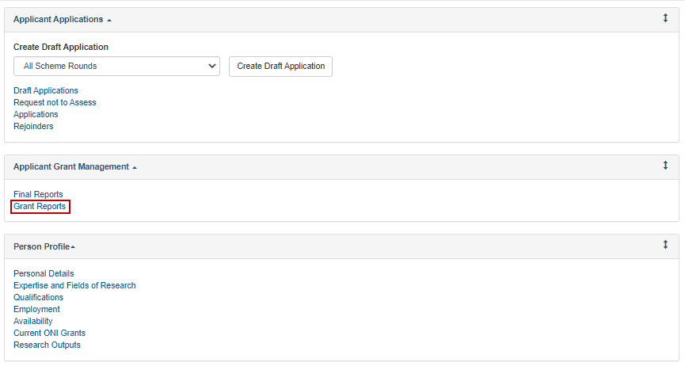

Figure 2: ‘Grant Reports’ link from the RMS Action Centre

1. Select the ‘*NISDRG Progress Report’* for the applicable period from the dropdown menu.

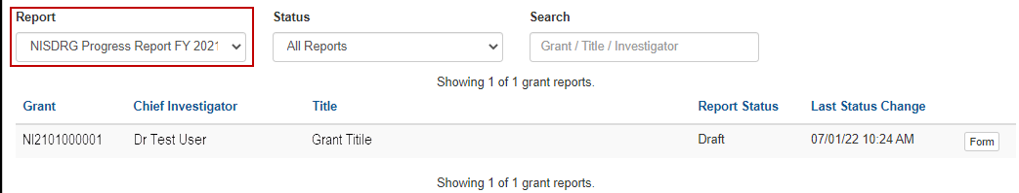

Figure 3: Dropdown menu to select report

1. Select the ‘*Form*’ button to begin completing the report.

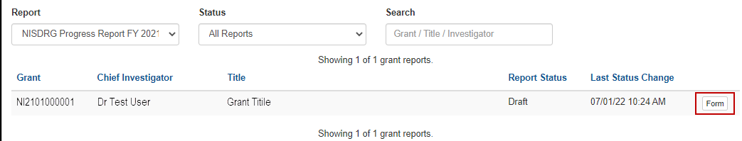

Figure 4: 'Form' button to open report

1. A reporting form will display with form parts and questions to be responded to.

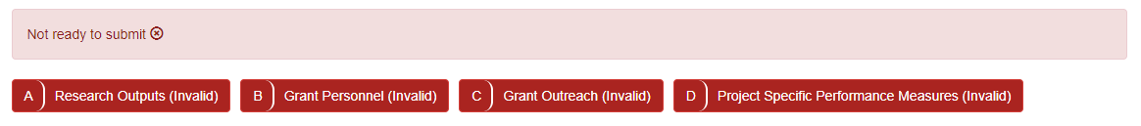

Figure 5: NISDRG Progress Report form parts

# PART 2 – Complete the Progress Report

The Progress Report must be completed by the Lead CI prior to submission to the Administering Organisation (AO) for certification. The Progress Report is intended to capture the **current** progress against four specified categories. Actual details must be entered for research outputs, grant personnel engagement, grant outreach activities and project specific performance targets. All Progress Report details for the grant should reflect the aims, activities and anticipated outcomes   
as outlined in the original application.

Sections of the Progress Report will populate with the targets previously submitted   
in the KPI Report. The current Progress Report will demonstrate the progress of the Project against those KPI targets. There should not be any double up of activity from one Progress Report to the next.

***Each Progress Report should only capture activity during the specified 6 month reporting period.***

Mandatory fields within the report will be flagged with a red outline. A response is required in each mandatory field, noting that a zero (‘0’) must be entered if, for example, an output was not published, or personnel not engaged during the reporting period.

Select ‘*Save*’ at the top of the page regularly during the completion of the report.



Figure 6: ‘Save’ button

## 2.1 Research Outputs

This section is designed to capture outputs the grant has produced that are peer and industry reviewed. The targets advised in the KPI Report will be imported into this section to assist the CI in recording the progress of the Project against the advised targets.

### A1. Output Target High-Level

The high-level research output question is intended to capture the targets for all research outputs produced by the Project during the reporting period.

The targets from the ***NISDRG KPI Report*** are not editable. Once all fields in the *Current Report* section are entered, the red outlined fields of the *NISDRG KPI Report* section will clear.

1. Under ‘**Current Report’***,* the CI will report the number of Peer Reviewed Outputs, Non-Peer Reviewed Outputs and Data Sets produced by the grant during the reporting period.
2. A zero should be entered if a research output was not produced.

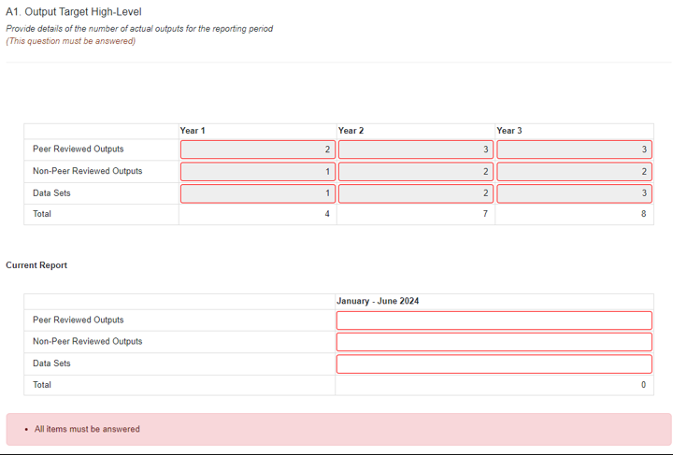

Figure 7: Question A1 Output Target High-Level

### A2. Output Target Detailed

This question is intended to provide information regarding the targets for specific output categories.

Once again, the targets from the ***NISDRG KPI Report*** are not editable. Once all fields in the *Current Report* section are entered, the red outlined fields of the *NISDRG KPI Report* section will clear.

1. Under ‘**Current Report’** the CI will report the number of Collaborative (co-authored) research, Outputs directed at the Intelligence or Security community and Outputs made openly available (including resource downloads) produced during the reporting period.
2. A zero should be entered if an output was not produced.

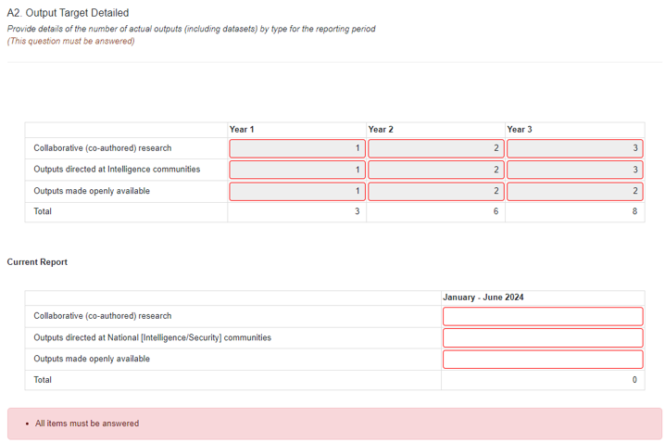

Figure 8: Question A2 Output Target Detailed

### A3. Quality of Research Outputs

The Quality of Research Outputs question is intended to report on the Project’s research output quality as determined in the KPI Report. The CI will report on how many outputs met the quality measure within the reporting period.

A minimum of one answer is required.

1. To import the targets from the KPI Report select ‘*Populate from Previous Report’.*

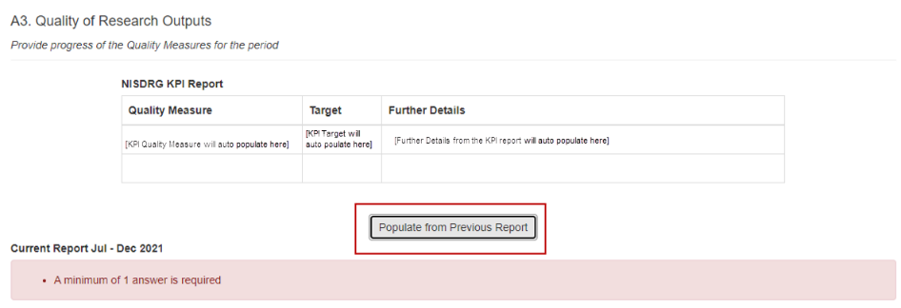

Figure 9: Question A3 ‘Populate from Previous Report’ button

1. A pop-up confirmation will appear. Select ‘*OK*’. All Quality Measure targets noted in the KPI Report will be imported into the Progress Report.

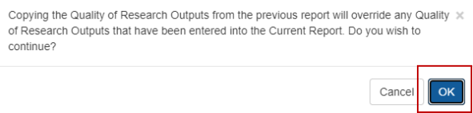

Figure 10: Pop-up confirmation to continue

1. Complete the question ‘*How many outputs met the quality measure within the reporting period?’* for each measure.

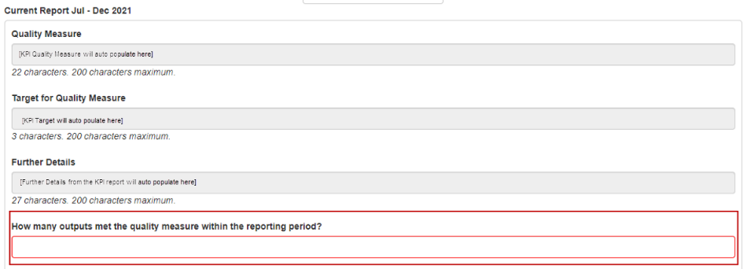

Figure 11: Quality Measure Answer box

### A4. Output Issues

This question is designed to inform the Funding Entity of any issues encountered with publications or the production of outputs of the research findings.

1. Select the drop-down box.
2. Select either ‘*Yes*’ or ‘*No*’.   
   If ‘*No*’ is selected, please provide details of the issues encountered.

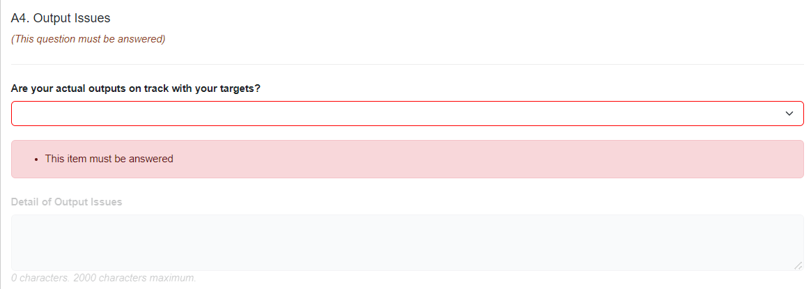

Figure 12: Question A4 Output Issues Question

### A5. Publications During the Reporting Period

The CI is asked to provide advice of any peer reviewed outputs that have been published *within the reporting period*, including the Title, Type of Publication, Intended place of Publication and a link to the publication. Only brief details of the publication should be entered in this section.

A full list of publications will also be required in the Project’s Final report.

This is a Yes/No question. When Yes is selected additional fields will become visible.

1. Select the drop-down box. Select either ‘*Yes*’ or ‘*No*’.

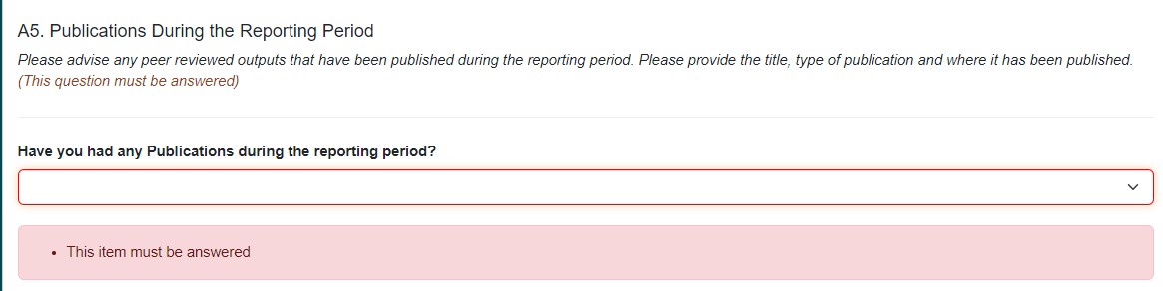

Figure 13: Question A5 drop-down selection

1. If ‘*Yes*’ is selected at least one publication will be required. Select ‘*Add answer’.*

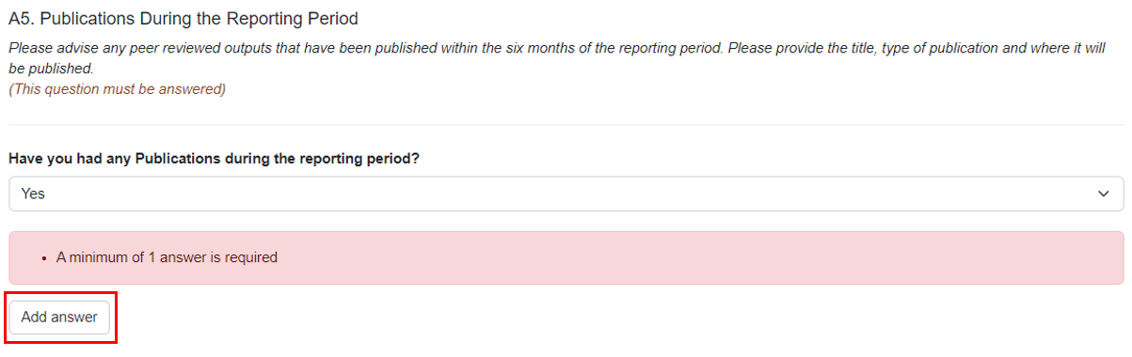

Figure 14: Select ‘Add answer’ to add more publications

1. Publication detail questions will appear. Provide details of the publication and upload a PDF copy of, or link to the publication.

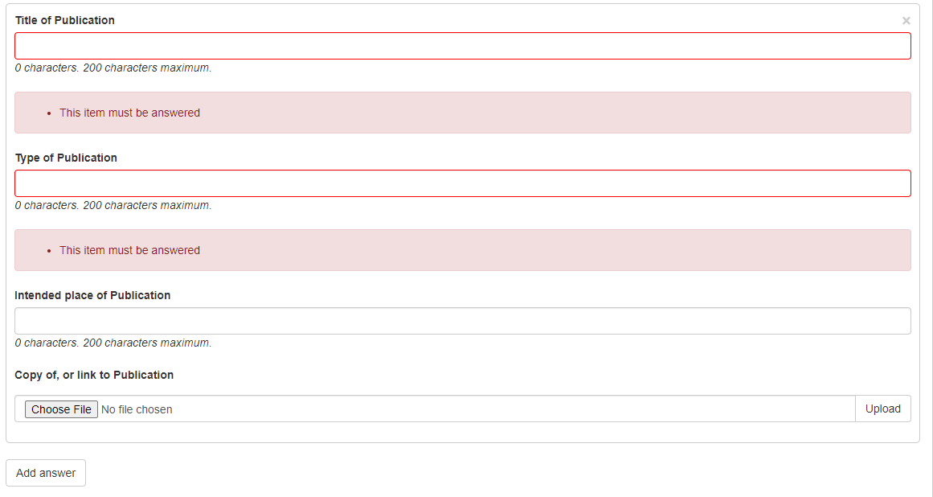

Figure 15: Details of the publication

1. If more than one publication has been published, select ‘*Add answer’* again and provide additional publications.

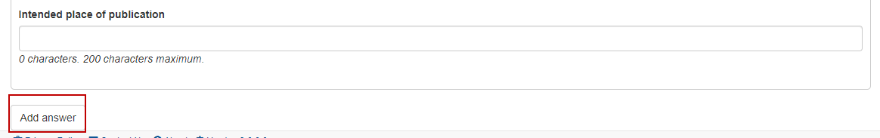

Figure 16: Select’ Add answer’ to add more publications

1. If ‘*Add answer’* has been selected in error, select the cross to the right of *Title of Publication* and the specific questions will disappear.

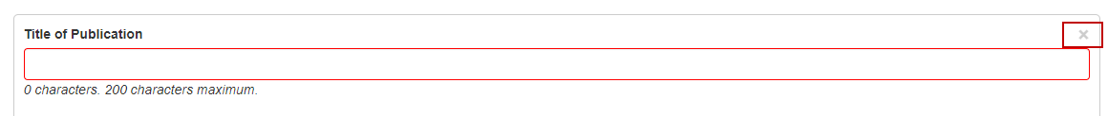

Figure 17: Select the cross to remove an answer

### A6. Upcoming Publications

The CI is asked to provide advice of any outputs that will be published within the *next six months* of the reporting period, including the Title, Type of Publication and Intended place of Publication. This section is to alert the Funding Entity that an output is due to be published. Only brief details of the publication should be entered in this section. A full list of publications will be required in the Project’s Final report. This is a Yes/No question. When Yes is selected additional fields will become visible.

1. Select the drop-down box. Select either ‘*Yes*’ or ‘*No*’.

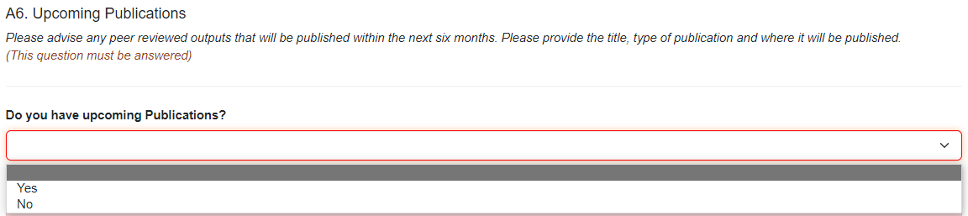

Figure 18: Question A6 drop-down selection

1. If ‘*Yes*’ is selected at least one publication will be required. Select ‘*Add answer’.*

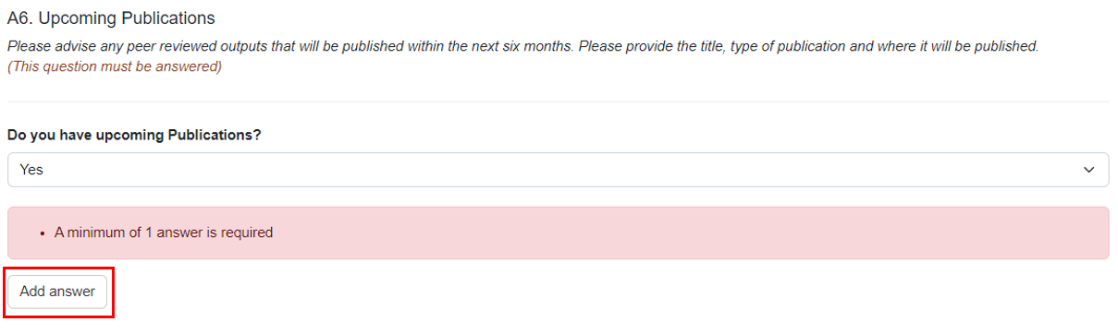

Figure 199: Select ‘Add answer’ to add more upcoming publications

1. Publication detail questions will appear. Provide details of the upcoming publication.



Figure 20: Details of an upcoming publication

1. If more than one publication will be published, select ‘*Add answer’* again and provide additional details.



Figure 21: Select’ Add answer’ to add more upcoming publications

1. If ‘*Add answer’* has been selected in error, select the cross to the right of *Title of Publication* and the specific questions will disappear.



Figure 22: Select the cross to remove an answer

1. Select ‘*Save*’. It is a good idea to save regularly throughout the completion of the report.



Figure 23: Select ‘Save’ at the end of each part

1. Part A will display in green once all questions are completed.



Figure 24: Part A completed

## 2.2 Grant Personnel

This section is intended to show the Project’s ability to build capacity and capability by supporting researchers, fostering research trainees and engaging non-academic participants.

### B1. Grant Personnel

This section will import the targets from the KPI Report. The CI will report the number of **new** personnel the grant has supported during the reporting period (i.e. if an individual is engaged in year 1 and continues through to grant completion, a ‘1’ should be entered in the first Progress Report only).

A zero should be entered if a there are no **new** personnel.

The targets from the ***NISDRG KPI Report*** are not editable. Once all fields in the *Current Report* section are entered, the red outlined fields of the *NISDRG KPI Report* section will clear.

1. Under ***Current Report*** the CI will report the number of **new** personnel employed during the reporting period.
2. A zero should be entered if there are no new personnel.

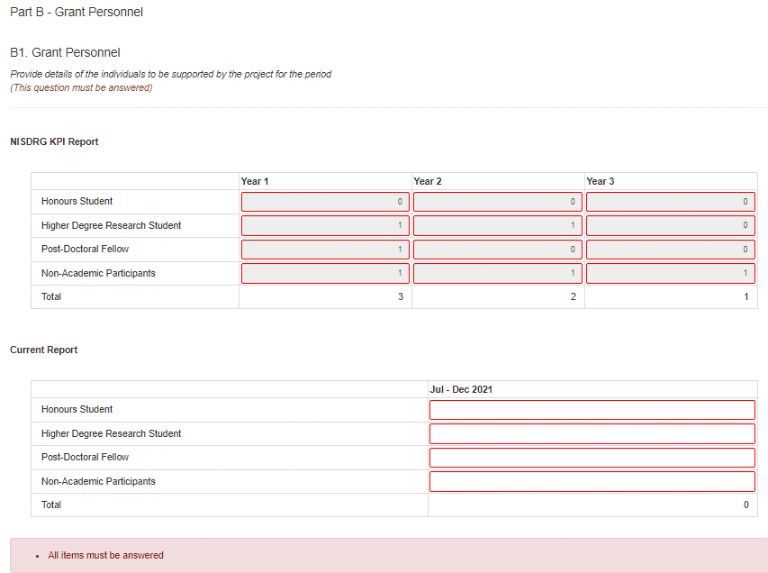

Figure 25: Question B1 Grant Personnel

### B2. Grant Personnel Departures

This section is used to inform the number of personnel who have left the Project during the reporting period.

1. All fields should be completed as a numeral and reflect the number of personnel who have left the grant during the reporting period.
2. A zero should be entered if no personnel left the grant.

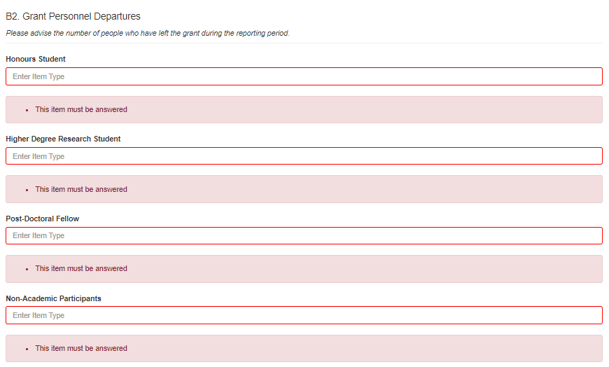

Figure 26: Question B2 Grant Personnel Departures

**B3. Total personnel engaged on the project**

This question will report the total number of personnel that are engaged on the project at the end of the reporting period.

This is a new question in the progress report. Due to inconsistencies in reporting against Questions B1 and B2 the ARC is seeking to re-baseline the number of personnel currently engaged against each project.

Please complete this question with the total number of personnel that were working on the project at the end of the reporting period.

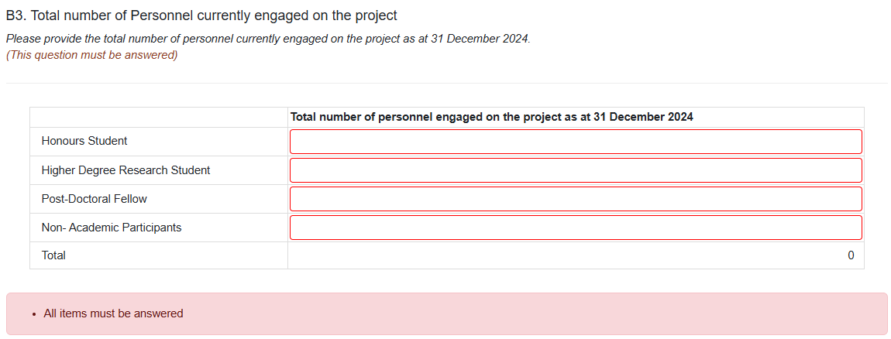

Figure 27: Question B3 Total number of Personnel currently engaged on the project

### B4. Recruitment

This question is designed to inform the Funding Entity the current state of the projects recruitment activities.

1. Please describe the projects current state of recruitment of funded personnel as detailed in your budget and/or recruitment plan.

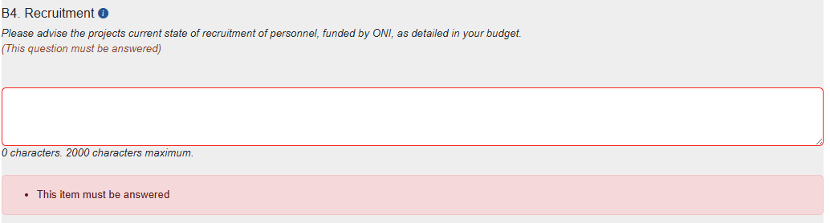

*Figure 28: Question B3 Recruitment*

### B5. Personnel Issues

This question is designed to inform the Funding Entity any issues encountered with recruitment and/or retaining personnel.

1. Select the drop-down box. Select either ‘Yes’ or ‘No’.   
   If ‘Yes‘ is selected, please provide details of the issues encountered.

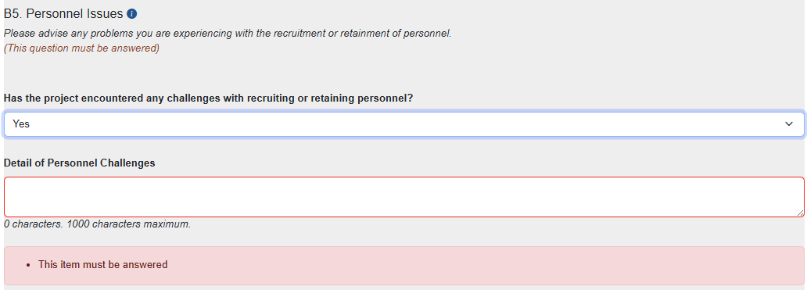

Figure 29: Question B3 Personnel Issues

### B6. Engaged Personnel details

***This question applies to ONI Grants only***. ONI grant recipients are required to confirm the eligibility of all un-named personnel working on the project.

The Grant Guidelines stipulate *all individuals who would be named in publications or would otherwise link their association with the Government funded project must comply with the eligibility criteria (Australian citizens, Australian permanent residents or New Zealand Special Category Visa).*

1. To advise each person’s eligibility to work on the grant whether they are paid from ONI Grant funding or other sources, upload a copy of the eligibility documentation by selecting *Add answer.*

*Figure 30: Question B4 Engaged Personnel Details*

1. Select ‘*Save*’. It is a good idea to save regularly throughout the completion of the report.



Figure 31: Select ‘Save’ at the end of each part

1. Part B will display in green once all questions have been completed.

This image captures with Part B is complete and changes to the colour green.

Figure 32: Part B completed

## 2.3 Grant Outreach

This category is intended to demonstrate the grant’s level of engagement between the research sector and the Australian Government, industry and business, and Australia’s National Intelligence and Security Communities.

In this section the CI is asked to provide information on any additional funding that has been applied for or has been received for this Project, or a closely related project, to assist in reaching the projects research goals.

### C1. Grant Outreach

This section will import against the Grant Outreach targets from the KPI Report.

The targets from the ***NISDRG KPI Report*** are not editable. Once all fields in the *Current Report* section are entered, the red outlined fields of the *NISDRG KPI Report* section will clear.

1. Under ***Current Report***, the CI will report the number of outreach activities achieved during the reporting period in the following categories: Keynote Presentations, Briefings to Research Science and Technology Community, Briefings to Government*, and Briefings to Industry and Business.
2. A zero should be entered if a grant outreach KPI was not achieved in the reporting period.

***\*Note:*** *Briefings to Government includes updates provided during site visits by, or meetings (including phone conversations and video conferences) regarding research progress, with the Funding Entity as well as any other correspondence where you provide an update to the Funding Entity.  If you have a significant breakthrough or output, the Funding Entity will be keen to hear about it outside of the normal reporting periods.*

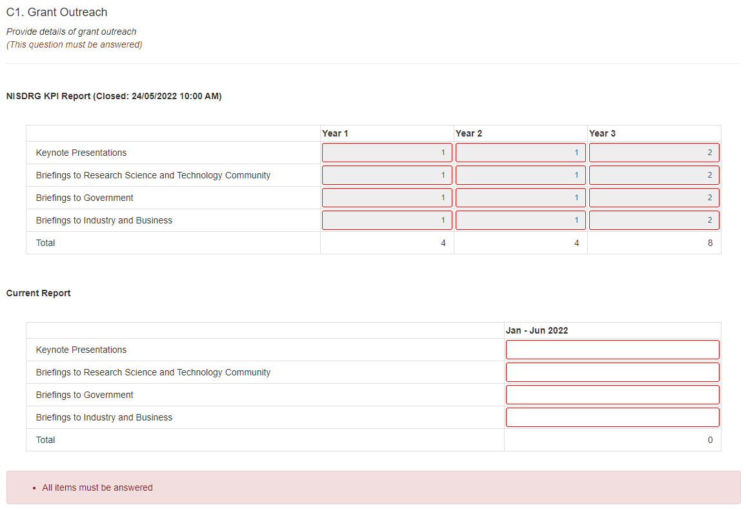

Figure 33: Question C1 Grant Outreach

### C2. Outreach Issues

This question is designed to inform the Funding Entity of any issues encountered with Outreach activities.

1. Select the drop-down box.
2. Select either ‘*Yes*’ or ‘*No*’.   
   If ‘*No’* is selected, please provide details of the issues encountered.

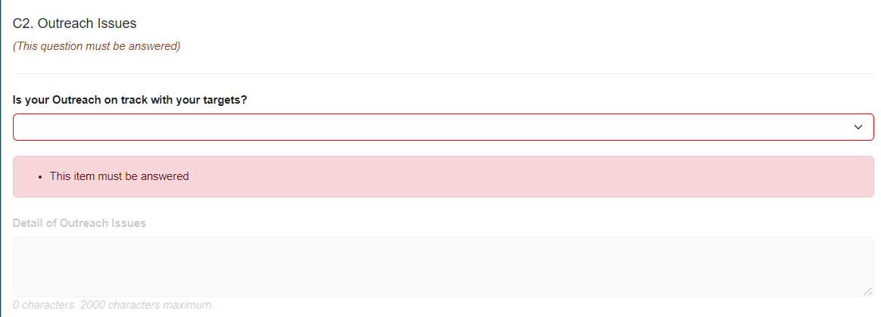

Figure 34: Question C2 Outreach Issues

### C3. Additional Funding

This question is designed to inform the Funding Entity of any additional funding that has been received during the reporting period. Additional funding is funding that was not listed in the application. This could be from a new organisation or additional funding from a current organisation involved in the Project.

1. Select the drop-down box.
2. Select either ‘*Yes*’ or ‘*No*’.
3. If ‘*Yes*’ is selected, please provide details of the:

* funding source
* funding amount
* what the funds will be used for.

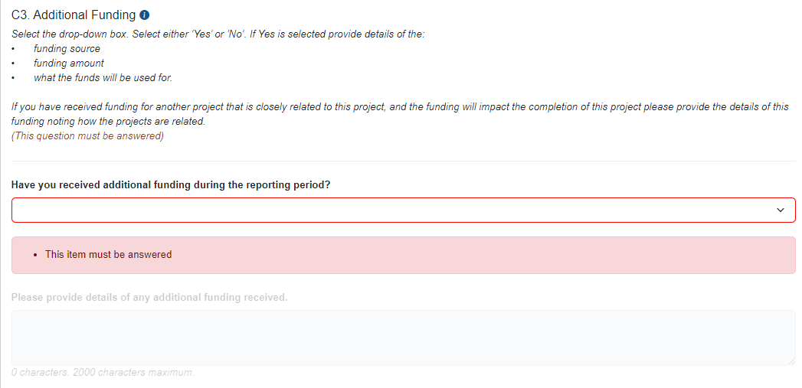

Figure 35: Question C3 Additional Funding

**Note:** If additional funding is received from a current organisation a POACR should be submitted. If additional funding is from a new partner organisation a variation should also be submitted.

If the funding is for a closely related project describe how the projects are related and how the funding will impact on the outcomes of this funded project.

### C4. Future Additional Funding

This question is designed to inform the Funding Entity of any additional funding that has been applied for and/or has been successfully secured, that will be paid in a future year and that will be used to achieve the projects research goals. Additional funding is funding that was not listed in the application. This could be from a new partner organisation or additional funding from a current partner organisation.

1. Select the drop-down box.
2. Select either ‘*Yes*’ or ‘*No*’.
3. If ‘*Yes*’ is selected, please provide details of the:

* funding source
* funding amount
* what the funds will be used for.

**Note:** If additional funding is received from a current organisation a POACR should be submitted

If the funding is for a closely related project describe how the projects are related and any impact on the outcomes of this funded project.

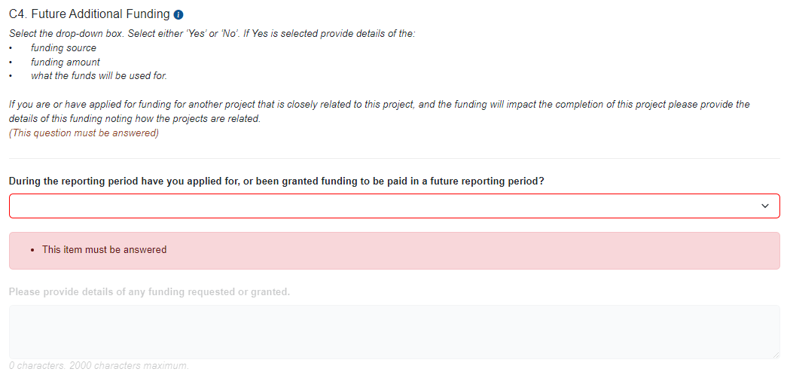

Figure 36: Question C4. Future Additional Funding

1. Select ‘*Save*’. It is a good idea to save regularly throughout the completion of the report.



Figure 37: Select ‘Save’ at the end of each part

1. Part C will display in green once all mandatory fields have been completed.

This image captures with Part C is complete and changes to colour green.

Figure 38: Part C completed

## 2.4 Project Specific Performance Measures (formerly Grant Specific KPIs)

This section of the report is intended to allow each Project to report on the qualitative and quantitative success measures as outlined in the KPI Report. It is also intended to report on the progress against the Challenges selected in the application and report any issues encountered during the reporting period.

**Please note:** within Part D the following terminology will be used interchangeably

- KPI with Performance Measure

- Grant with Project.

### D1. Specific Performance Measures (KPIs)

Project Specific Performance Measures allow the CI to report on the specific qualitative and/or quantitative measures advised in the KPI Report. This section will import the targets from the KPI Report.

1. To import the measure types advised in the KPI Report select ‘*Populate from Previous Report’.*

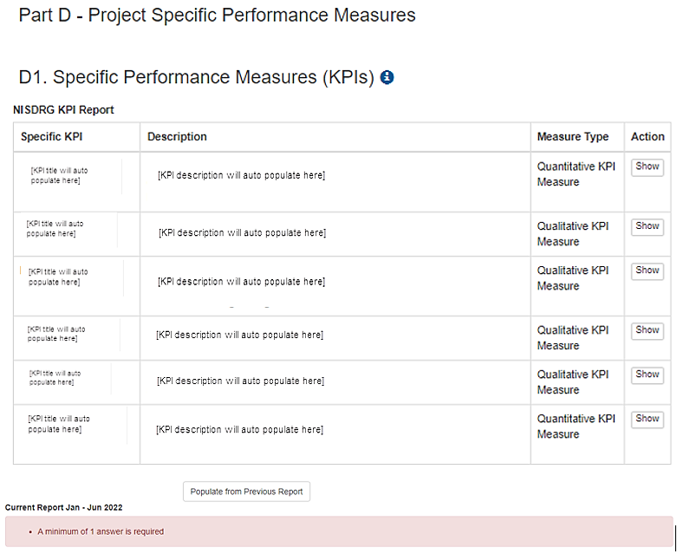

Figure 39: Select ‘Populate from Previous Report’ button

1. A pop-up confirmation will appear. Select ‘*OK*’.



Figure 40: Pop-up confirmation to continue

1. Each measure type selected in the KPI Report will create a question to be answered for either a Qualitative or Quantitative measure.
2. For a Quantitative performance measure enter a Value to report for the period.

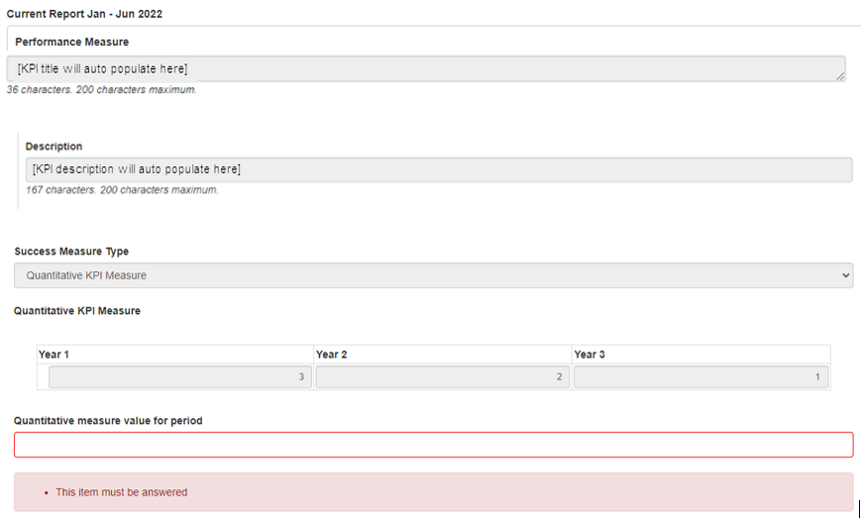

Figure 41: Quantitative Measure

1. For a Qualitative measure enter a comment to report progress for the period.

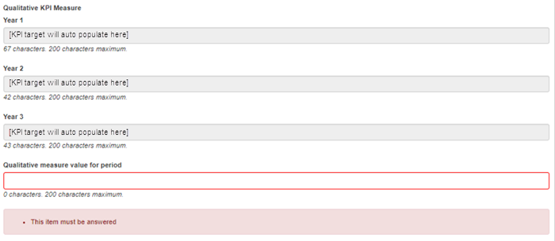

Figure 42: Qualitative Measure

1. Select the drop-down box to advise if the measure has or has not been met, in progress or not commenced.
2. If further information would be useful in interpreting the Performance Measures, a PDF of up to **one** **page** can be attached. Please select ‘Choose file’ and then ‘Upload’.

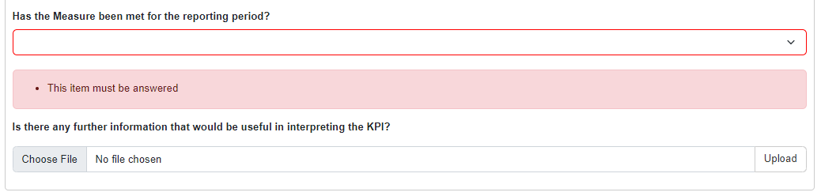

Figure 43: Upload a PDF

### D2. Provide a high-level update on the progress of the research Project

This question asks for a high-level update on the progress of the research. You can also include information about achievements against any relevant challenges here.

Please upload a maximum **two** **page** pdf.

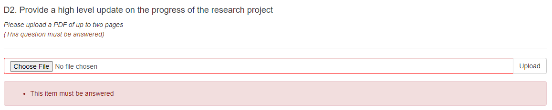

Figure 44: Question D2 Project update

### D3. Highlights

This question asks for up to three highlights or milestones the Project has experienced during the reporting period.

An example of a highlight of the Project could be the successful engagement of personnel or an outcome of the research has been achieved. At least one highlight should be provided for the Project. Select ‘*Add answer’* to provide details of these highlights.

Note: Add Answer should be selected for each Highlight.

1. Select ‘Add answer’

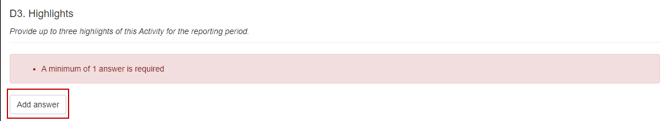

Figure 45: Select ‘Add answer’ to report a Project highlight

1. Each highlight should be detailed in separate answer boxes.
2. Select ‘*Add answer’* for each additional highlight.

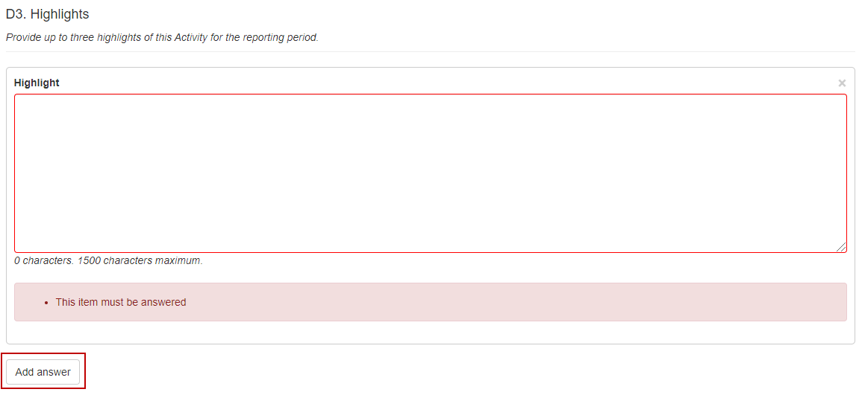

Figure 46: Report Project highlights

### D4. Significant Issues

This question asks for information on any issues the Project has experienced during the reporting period.

This is a Yes/No question. When ‘*Yes*’ is selected, a comment box will become visible to provide details of the issues.

1. Select ‘*Yes’* or ‘*No*’ from the drop-down selection.

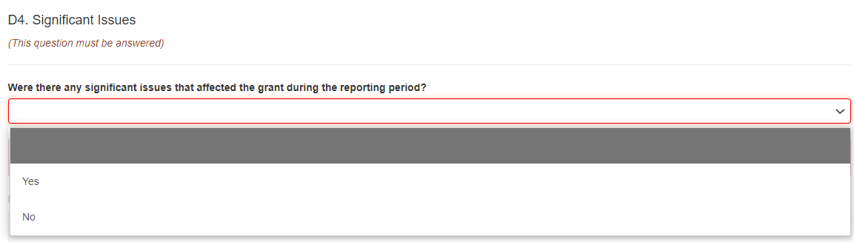

Figure 47: Question D4 drop-down selection

1. When ‘*Yes*’ is selected a *Details of Significant Issues* description box will appear. Please provide details of the issues encountered during the reporting period.

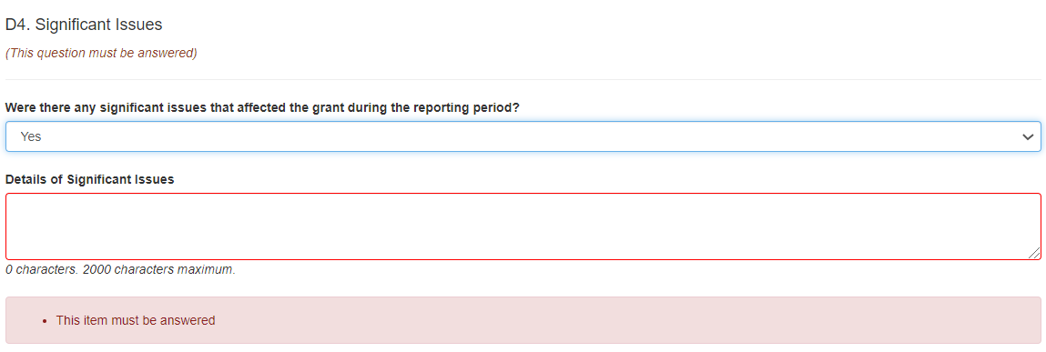

Figure 48: Question D4 Report Significant Project issues

1. Select ‘*Save*’. It is a good idea to save regularly throughout the completion of the report.



Figure 49: Select ‘Save’ at the end of each part

### D5. Were there any security issues or incidents during the reporting period?

Enter the details of any security or foreign interference incidents.

1. From the drop down list select ‘Yes’ or ‘No’
2. When ‘Yes’ is selected the Details of the security issue or incident field will become visible.

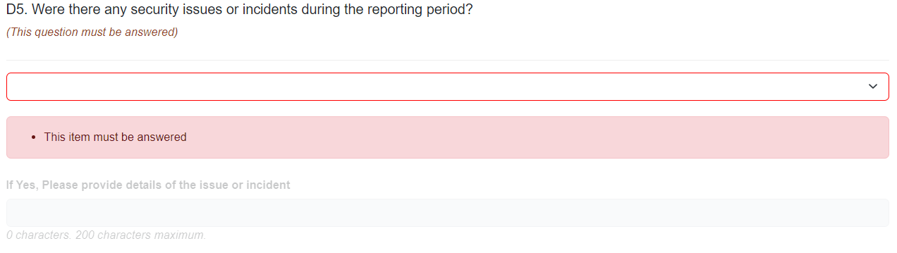

*Figure 50: Security Issues or incidents*

### D6. Activity Budget

An Activity Budget template located in the Research Grants [Resource Hub](https://view.officeapps.live.com/op/view.aspx?src=https%3A%2F%2Fwww.researchgrants.gov.au%2Fsites%2Fdefault%2Ffiles%2F2024-09%2FActivity%2520Budget%2520%2528Progress%2520Report%2529.xlsx&wdOrigin=BROWSELINK) must be uploaded to advise the funding entity any changes to the activity plan and budget since the proposal was submitted.

Notes for completing the Activity Budget:

1. The Activity Budget for each category should be the same as the proposal submission
2. Where a Budget Variation request has been approved for a category, the category budget should be updated with the variation details in the comments field.
3. Year one of the budget starts on the Project commencement date and ends 12 months after.
4. Years two and three of the budget starts on the anniversary of the project commencement date and ends 12 months after.

**Note:** You may report a full years budget across multiple project years. For example if your project commenced in October Year 1 you will report expenditure in the Year 1 Budget/Actual until October the following year.

1. All positions budgeted or held by Personnel paid by project funding should be listed individually under the Personnel Category (Names are not required).
2. A comment should be entered for all budget categories where the budget has significantly deviated from the budget, including planned action (e.g. how funding will be spent by the budget by the project end date).

Upload the completed Activity Budget noting the changes from the Budget to Actual.

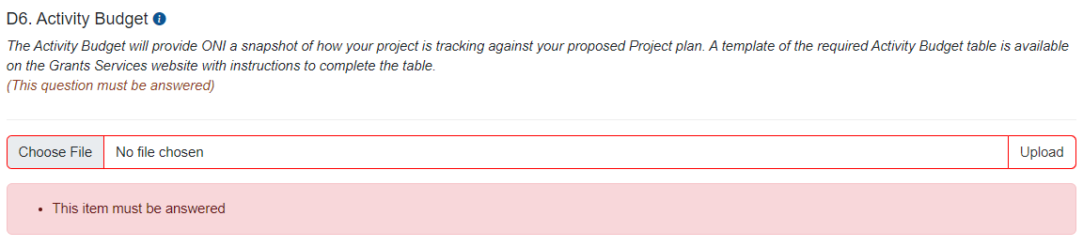

Figure 51: Question D6 Activity Budget



Figure 52: Select ‘Save’ at the end of each part

1. Part D will display in green once all questions have been completed.

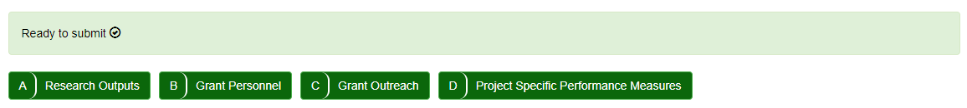

Figure 53: All NISDRG Progress Report form parts completed and valid

# PART 3 – Submit to the Research Office

Once all mandatory fields have been completed, and the first named CI of the grant is satisfied   
that all details have been entered, the report must be submitted to the grant AO Research Office (RO) for review and final submission.

To submit a completed report to the RO:

1. Ensure that all mandatory fields within the report have been completed and that the   
   ‘*Ready to Submit*’ message appears at the top of the report.



Figure 54: ‘Ready to Submit’ message

1. Return to the Grant Reports menu by selecting the ‘*Grant Reports’* link at the top of the page.

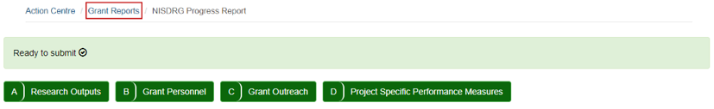

Figure 55: 'Grant Reports' link

1. Locate the relevant report and select the ‘*Submit to RO’* button.

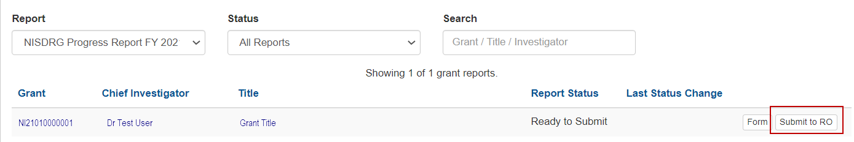

Figure 56: 'Submit to RO' button

1. Confirm submission of the Progress Report by selecting ‘*Submit to RO’* in the pop-up message.

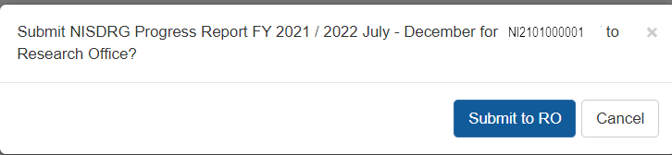

Figure 57: Confirm Submission to RO

# PART 4 – Research Office Certification and Submission

The submission of the Progress Report forms part of the Agreement between the AO and Funding Entity to provide periodic progress updates against set KPIs and Performance Measures. Therefore, each answer should be reviewed to ensure that the reported progress closely aligns with the key benefits identified in the Project Plan, and the aims, activities and anticipated outcomes as outlined in the original application. Upon confirmation that the entered details are agreeable to the AO, the Progress Report must be certified by an RO Delegate and submitted to the Funding Entity for review.

## 4.1 To review the details entered in a Progress Report

1. Navigate to the appropriate RMS portal for the funded grant.

ONI RMS Portal - [https://rmsoni.researchgrants.gov.au](https://defence.researchgrants.gov.au)

Defence RMS Portal - [https://defence.researchgrants.gov.au](https://www.arc.gov.au/research-grants-services)

1. Select the ‘*Research Office Grant Reports*’ link within the ‘*Research Office Grant Management*’ section of the RMS action centre.

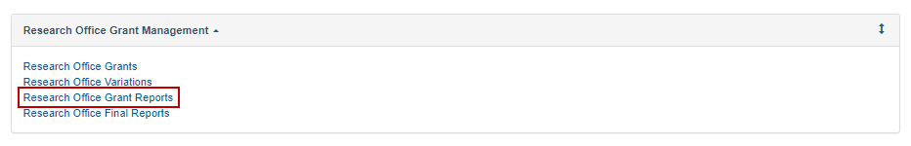

Figure 58: 'Research Office Grant Reports' link from the RMS Action Centre

1. Locate the report to be reviewed using the filters provided and select ‘*Form*’.

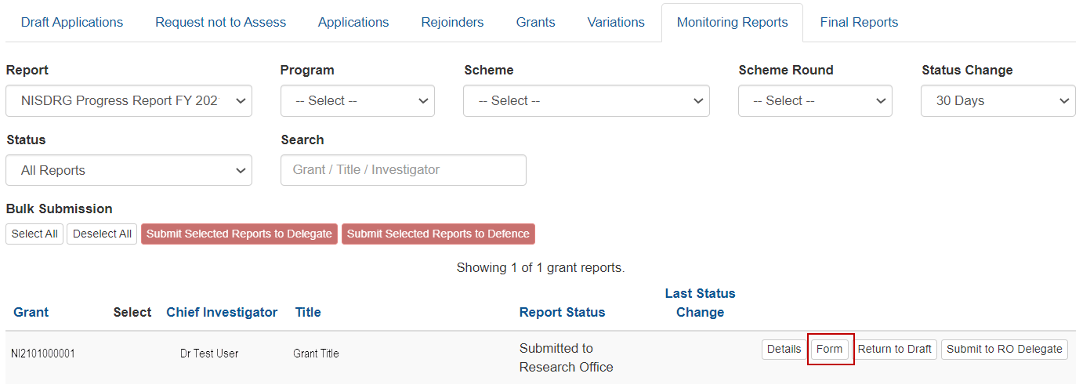

Figure 59: 'Form' button to open a report for review

1. Review the details entered in the Progress Report.
2. If edits are required, return the Progress Report to the lead CI – see Section 4.2.
3. If the Progress Report is acceptable to the RO, submit the Report to the RO Delegate – see Section 4.3.

## 4.2 Returning a Progress Report to a Lead CI

1. Return to the list of available RO grant reports by selecting the ‘*Research Office Grant Reports’* link.

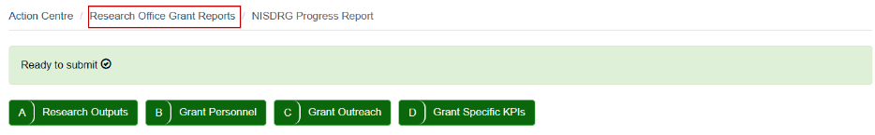

Figure 60: 'Research Office Grant Reports' link

1. Locate the report to be returned and select ‘*Return to Draft’.*

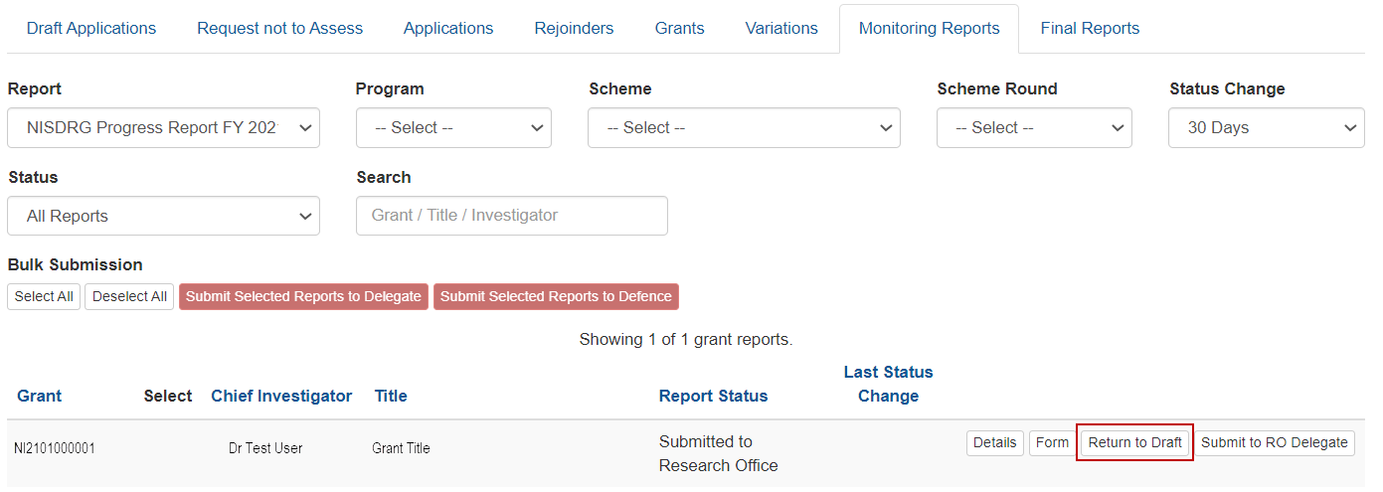

Figure 61: 'Return to Draft' button

## 4.3 To certify and submit a Progress Report to the Funding Entity

1. Return to the list of available RO grant reports by selecting the ‘Research Office Grant *Reports*’ link (Figure 54).
2. Locate the report to be submitted and select ‘*Submit to RO Delegate’.*

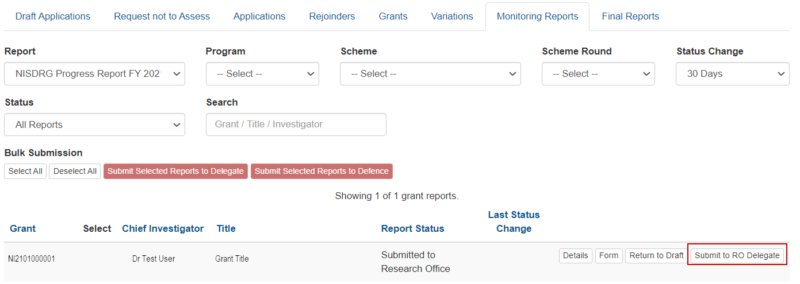

Figure 62: 'Submit to RO Delegate' button

1. Confirm submission to the RO Delegate by selecting the ‘*Submit to RO Delegate*’ button.

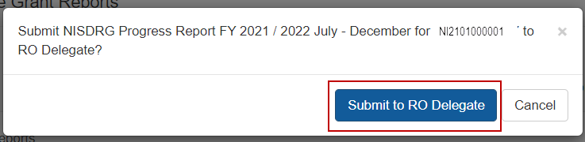

Figure 63: Confirm submission to RO Delegate

1. The report must be certified by the RO Delegate. The **RO Delegate** will do this by:
   1. Navigating to the ‘*Research Office Grant Reports*’ page
   2. Locating and reviewing the report
   3. Selecting the ‘*Certify*’ button.

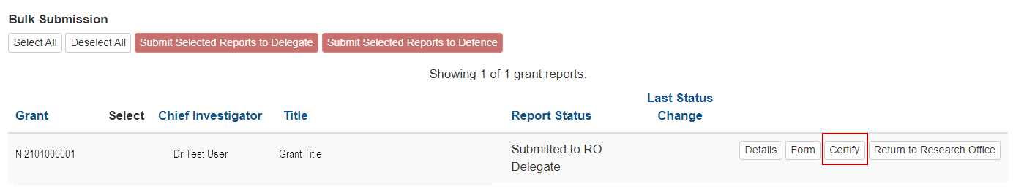

Figure 64: 'Certify' button

1. Confirm RO Delegate certification by selecting ‘*Agree to Certification’.*

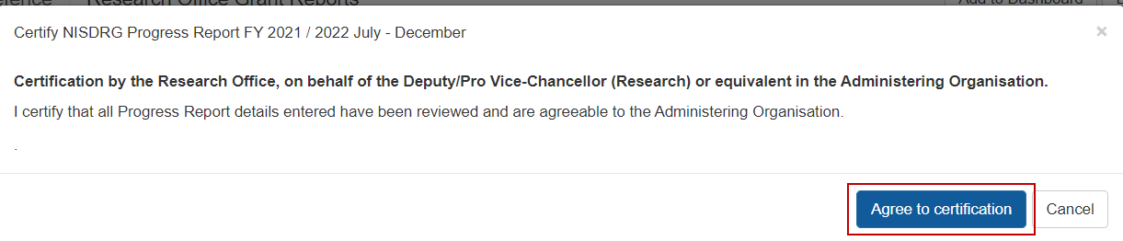

Figure 65: Certification message

1. Finalise submission by selecting the ‘*Submit to [Funding Entity]’* button.

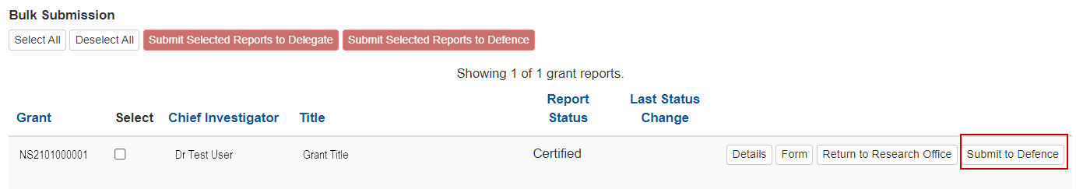

Figure 66: ‘Submit to [Funding Entity]’ button

If additional edits are required once the progress report has been submitted to the funding entity, the RO must contact the RGS team at arc-nisdrg.gov.au to request the return of the report.

Once the report has been reviewed and it is deemed acceptable by RGS and the funding entity it will be accepted in RMS. If additional information is required, the RGS team will contact the RO.

# Glossary and Definitions

## Definitions

| **Term** | **Definition** |
| --- | --- |
| Activity or budget Plan | A table advising the projects proposed budget to actual expenditure. |
| Administering Organisation (AO) | An Eligible Organisation responsible for the administration of the grant. |
| [Australian National Intelligence Community](https://www.oni.gov.au/national-intelligence-community) | Comprises the six agencies that formerly made up the Australian Intelligence Community (AIC):   * ONA * the Australian Signals Directorate (ASD) * the Australian Geospatial-Intelligence Organisation (AGO) * the Australian Secret Intelligence Service (ASIS) * the Australian Security Intelligence Organisation (ASIO) * the Defence Intelligence Organisation (DIO)   as well as the Australian Criminal Intelligence Commission (ACIC) and the intelligence functions of the Australian Federal Police (AFP), Australian Transaction Reports and Analysis Centre (AUSTRAC) and The Department  of Home Affairs. |
| Australian National Security Community | Comprises the:   * Department of Defence * Department of Home Affairs * Office of National Intelligence * Department of Home Affairs * Department of Foreign Affairs and Trade * Prime Minister and Cabinet * Department of Industry, Science, Energy and Resources. |
| Funding Entity | Either the Department of Defence-NSSTC, or Office of National Intelligence. |
| Intelligence Challenges | Those challenge areas aligned with the National Security Science and Technology Priorities identified by the Australian Government to be funded by the ONI, and available on the [RGS website](https://www.researchgrants.gov.au/). |
| Key Performance Indicators (KPIs) and/or Performance Measures | A set of quantitative and/or qualitative measures that We use to monitor and report on progress of research outcomes. |
| Lead Chief Investigator (CI) | The first named investigator of a Project. |
| National Security Science and Technology Centre (Defence – NSSTC) | The Department of Defence National Security Science and Technology Centre within the Defence Science and Technology (DST) Group that coordinates whole of government national security science and technology. |
| National Security Challenges | Those challenge areas aligned with the National Security Science and Technology Priorities identified by the Australian Government to be funded by the Defence – NSSTC, and available on the [RGS website](https://www.researchgrants.gov.au/). |
| Progress Report | A report submitted in RMS advising the progress of the grant against Key Performance Indicators (KPIs). |
| Project | An application approved by the ONI Delegate or the Department of Defence-NSSTC Delegate to receive funding, may also be referred to as a Grant. |
| POACR | Participating Organisation Agreed Contribution Report |
| Reporting Period | The period of the report, January to June or July to December. |
| Research Office (RO) | A business unit within an Eligible Organisation that is responsible for contact with Us regarding applications and projects. |
| Research output | All products of a research project. |
| Us/We | The Australian Research Council. |

## Glossary

| **Acronym** | **Elaboration** |
| --- | --- |
| AO | Administering Organisation |
| ARC | Australian Research Council |
| CI | Chief Investigator |
| KPI | Key Performance Indicator |
| Defence - NSSTC | Department of Defence, National Security Science and Technology Centre |
| ONI | Office of National Intelligence |
| NISDRG | National Intelligence and Security Discovery Research Grants |
| RGS | Research Grants Services team |
| RMS | Research Management System |
| RO | Research Office |