National Intelligence Discovery Grants

Key Performance Indicator Reporting   
in RMS User Guide

Updated September 2025

Contents

National Intelligence Discovery Grants 1

Introduction 3

Key Points 4

Summary of Workflow 4

Quick Reference 5

PART 1 – Locate the KPI Report within RMS 6

PART 2 – Complete the KPI Report 7

2.1 Research Output Targets 7

2.1.1 Research Output Targets 7

2.1.2 Research Output Attributes 9

2.1.3 Quality of Research Outputs 10

2.2 Grant Personnel Targets 12

2.2 Recruitment Plan 13

2.3 Grant Outreach Targets 14

2.4 Project Specific Performance Measures (KPIs) 15

2.5 Activity Budget and Ethics Plan 18

PART 3 – Submit to the RO 21

PART 4 – RO Certification and Submission 22

4.1 To review the details entered in a KPI Report 22

4.2 To return a KPI Report to a Lead CI for updates 23

4.3 To certify and submit a KPI report to ONI 23

Glossary and Definitions 25

Definitions 25

Glossary 26

# Introduction

The Australian Research Council (ARC), on behalf of the Office of National Intelligence (ONI), is conducting grant management for the National Intelligence Grants Program encompassing National Intelligence Discovery Grants (NIDG).

The NIDG supports excellent research that deepens our understanding of emerging science and technology and addresses intelligence and national security interests. The grant program will facilitate innovation and develop national security and intelligence capacity. It will also enable Australia’s National Intelligence Communities to systematically engage with Australia’s research and technology community.

In addition, the NIDG provides support to research that aligns with the priority research areas identified by the Australian Government. These research areas are outlined in the Intelligence Challenges developed under the broad National Security Science and Technology Priorities. Information regarding the Intelligence Challenges is available on the [Research Grants Services website.](https://www.researchgrants.gov.au/)

In order to ensure that the NIDG Program achieves the objectives and intended outcomes, all awarded grants are required to provide periodic progress updates against set Program focused Key Performance Indicators (KPIs) as well as performance measures that help demonstrate how the project is progressing against the aims and objectives contained in the Proposal. KPIs must be set for each grant against the standard Program KPIs, and performance measures when the grant commences using a KPI Report in Research Management System (RMS).

Following the acceptance of the KPI Report by the Research Grants Services (RGS) team on behalf of ONI, Progress Reports will be submitted twice yearly to enable Projects to advise the progress of the grant against the performance goals set in the KPI Report to reflect the level of achievement for a grant. It is important to note that KPI and progress reporting are one measure of progress and will be reviewed in context with other reports including publications, outreach, and engagement activities.

All grant management activities, including the submission of variations and grant reporting, must be completed within the ONI RMS portal [rmsoni.researchgrants.gov.au](https://rmsoni.researchgrants.gov.au/), unless otherwise advised by the ARC’s RGS team.

Upon submission of a KPI report by an Administering Organisation (AO), the RGS team will review the submitted KPIs and ensure that the targets reflect the aims, activities and anticipated outcomes as outlined in the original application and are acceptable to ONI. KPI Reports will also be made available to ONI staff.

The following instruction provides information for the entry and submission of targets into the KPI report in RMS.

# Key Points

* The KPI report must be submitted by 31 December.
* The target audience for this user guide is Lead Chief Investigators (CI) and Research Office (RO) staff for NIDG awarded grants.
* All NIDG grants are required to provide a KPI Report at the commencement of the grant.
* KPIs are entered for all years of funding, if carry over funding is requested additional KPIs will not be required however you will continue to report on the Projects progress against the set Project KPIs until the project is complete.
* The KPIs entered will help measure the progress of the grant against the proposals aims and objectives in the 6-monthly Progress Report.
* KPI Reports are one measure of grant progress along with other publications, engagement, and outreach activities.
* KPIs must be completed by the first named CI, then certified and submitted to ONI by the AO RO Delegate.
* KPI targets will not be editable after KPI Report acceptance.

## Summary of Workflow

*\*The RGS team may request amendments to targets prior to acceptance on behalf of the ONI.*

# Quick Reference

**PART 1 –** **Locate the KPI report within RMS**

KPI Reports are available in the ONI RMS portal: [rmsoni.researchgrants.gov.au](https://rmsoni.researchgrants.gov.au/)

**PART 2 –** **Complete the KPI Report**The KPI Report must be completed by the Lead CI. All KPI Report targets for the project should reflect the aims, activities and anticipated outcomes as outlined in the original application.

* **Part A –** Research Outputs Research Outputs  
  This section is designed to capture outputs the project expects to produce that are peer and industry reviewed.
* **Part B –** Grant Personnel   
  This section is intended to show the project’s ability to build capacity and capability by supporting researchers, fostering research trainees and engaging non-academic participants.
* **Part C** – Grant Outreach   
  This section is intended to demonstrate the project’s level of engagement between the research sector and the Australian Government, industry and business, and Australia’s National Intelligence Community.
* **Part D** – Project Specific Performance Measures  
  This section of the report is intended to allow each project to create their own qualitative and quantitative success measures aligned to the projects aims and objectives.
* **Part E** - Activity Budget & Ethics Plan

This section of the report requires the upload of a templated [Activity Budget](https://www.researchgrants.gov.au/resource-hub/activity-budget-kpi-report), located on the [Research Grants Resource Hub](https://www.researchgrants.gov.au/resource-hub), advising the expected Project expenditure for each budget category. This template should note any changes from the applications proposed budget.

The Projects agreed Ethics plan must also be uploaded.

**PART 3 –** **Submit to the RO**Once all mandatory fields have been completed, and the CI is satisfied that all details have been accurately entered, the report must be submitted to the RO Delegate for review.

**PART 4 –** **RO Certification and Submission** The RO Delegate will review then Certify and Submit the Report to ONI. If the CI or RO require changes to the targets after the report has been submitted to ONI, a request to de-submit the KPI Report must be made to the RGS team by email to [arc-nidg@arc.gov.au](mailto:arc-nidg@arc.gov.au).

**Note:** When you see the information icon (  ), hover over or click for further information and guidance.

# PART 1 – Locate the KPI Report within RMS

The ONI KPI Report is available within the ONI RMS portal. The first named (Lead) CI listed on the grant will have the ability to view and enter details into the Report.

**To locate the KPI Report:**

1. Navigate to the ONI RMS portal: [rmsoni.researchgrants.gov.au](https://rmsoni.researchgrants.gov.au/)
2. Select the ‘**Grant Reports’** link from the RMS Action Centre

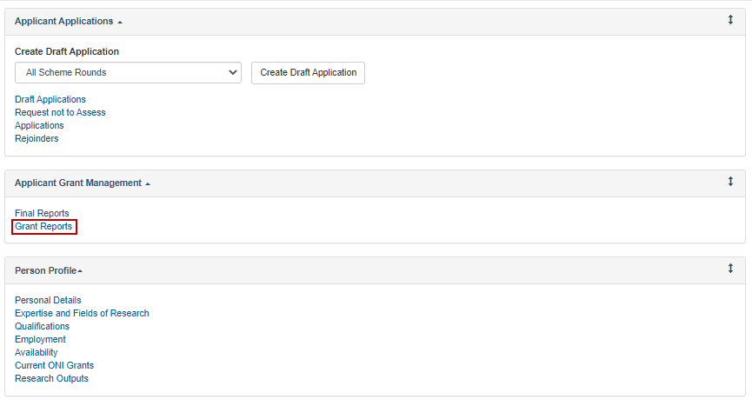

Figure 1 - Grant Reports link from the RMS Action Centre

1. Select ‘**ONI KPI Report’** from the dropdown menu

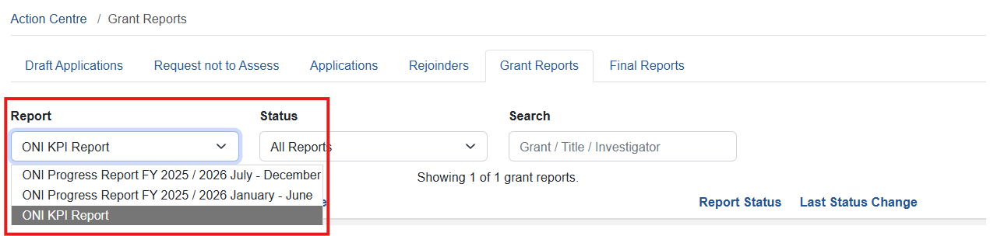

Figure 2 - Dropdown menu to select report

1. Select the ‘**Form’** button to open the KPI Report

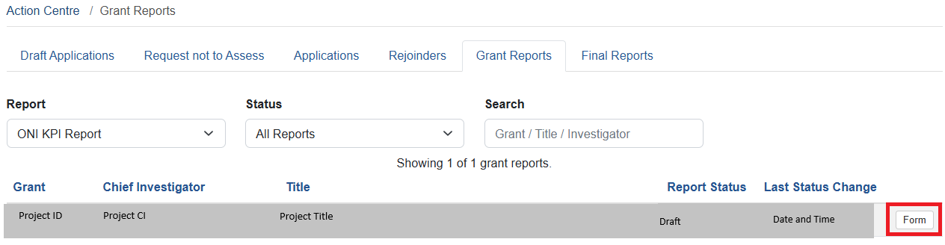

Figure 3 - 'Form' button to open report

1. The KPI Report will display form parts or chapters with questions to be responded to.

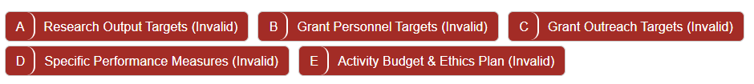  
Figure 4 - KPI Report form parts

# PART 2 – Complete the KPI Report

Once located within RMS, the KPI Report must be completed by the Lead CI prior to submission to the AO for review, certification, and submission to ONI. The KPI Report is intended to capture targets against 4 specified categories, to which progress throughout the grant lifecycle will be reported against. Target details must be entered for anticipated research outputs, grant personnel engagement, grant outreach activities and project specific targets. All KPI target details for the grant should reflect the aims, activities and anticipated outcomes as outlined in the original application.

Mandatory fields within the Report will be flagged with a red outline. A target is required in each mandatory field, noting that a ‘**0**’ must be entered if an output is not expected within the reporting year.

## 2.1 Research Output Targets

The targets in this category are intended to demonstrate the grant’s ability to enhance the capacity of Australia’s National Intelligence Community, the wider research sector, and the general public to access relevant knowledge and research.

It is expected that the number of research outputs produced by a grant will increase throughout the life of the grant.

For the purposes of the KPI Report a research output is defined as “*all products of a research project*”. All research output targets entered in Part A of the Report should be research discipline and industry relevant.

### 2.1.1 Research Output Targets

The Research Output Targets question (A1) is intended to capture the total number of publications, presentations and all research outputs the Project expects to produce each year of the Grant.

Target details must be entered as a numeral against each research output category and the year of expected distribution. Research outputs have been categorised into peer reviewed, non-peer reviewed and data sets. Consider when you will be able to divulge your research and findings to the sector and the public.

To complete the question, enter the target as a numeral in each mandatory field.

Please note that each research output should be entered into *one category only* for this question (i.e. a non-peer reviewed data set should only be entered in the Data Set category).

#### Peer Reviewed Outputs

The details in this category are intended to capture the target for outputs of the grant that will undergo peer review by qualified members of a profession within the field of research prior to distribution, by year of funding.

Consider who the end users are. Would they be interested or involved in the research from the beginning or in the final year once the product is ready for launch?

It is expected that the number of research outputs produced by a project will increase throughout the life of the grant.

#### Non-Peer Reviewed Outputs

The details in this category are intended to capture the target for outputs of the grant that will be distributed without peer-review, by year of funding.

This category is intended to capture the grant’s ability to enhance the access the general public has to relevant knowledge and research.

Once again, consider who the end users are. Would they be interested in the research from the early stages or only once it is ready to be made public?

#### Data Sets

The details in this category are intended to capture the target for data set outputs of the grant, by year.

A data set is a collection of related information, like conclusions or numerical analysis that is composed of separate elements but can be used as a unit. Generally used to test a hypothesis of experiments or form conclusions.

*All outputs should include a data set therefore this section should not be zero for the duration of the project.*

**To enter details into the Research Output Targets question:**

1. Open the KPI Report by selecting the ‘Form’ button (Figure 3)
2. Enter the target for each research output category as a numerical value against the anticipated year of distribution.
3. A number must be entered in each field to validate the question.

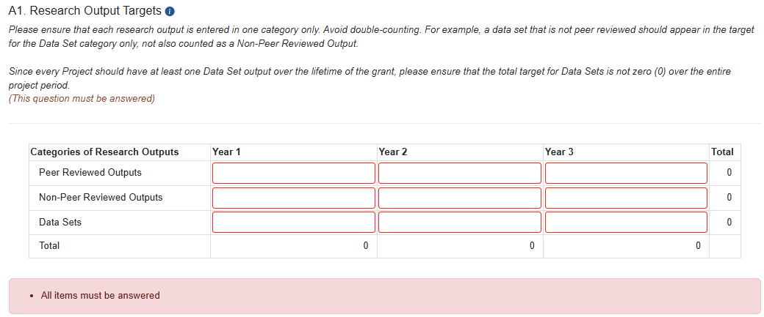

Figure 5 - A.1 High-Level Research Output Targets question

**Note:** Total research outputs for each year, and each category, will automatically calculate upon data entry.

1. Upon completion of the data entry ensure that the ‘Save’ button in the top right of the screen is selected to ensure no data is lost.



Figure 6 - 'Save' button

### 2.1.2 Research Output Attributes

The Research Output Attributes question (A2) provides information as to where the Research Outputs from Question A1 will be attributed to: were they co-authored, directed at the Intelligence community and/or made openly accessible?

Target details for collaborative (co-authored) outputs, outputs targeted at the Intelligence community, and outputs that are made openly available, should be entered as a numeral against each research output category and the year of expected distribution. Each expected output should also be represented in a category in question A1.

Please note that a research output target may be entered in *multiple categories* for this question (i.e. a co-authored research output which is openly available may be entered in both categories).

#### Collaborative (Co-authored) outputs

The details in this category are intended to capture the target for outputs of the grant that are authored in conjunction with someone outside the research team.

#### Outputs directed at the Intelligence community

The targets in this category are intended to demonstrate the grant’s delivery of research outputs to ONI and/or the Intelligence community, including the Projects ability to communicate complex scientific information effectively.

Outputs in this category could include papers specifically aimed at the National Intelligence Community.

#### Outputs made openly available

The targets in this category will demonstrate the Project’s level of engagement with the public and their ability to communicate complex scientific information effectively.

The outputs in this category could include an article in the Conversation, relevant publications (such as magazines), websites, and news articles (including social media).

**To enter details into the Research Output Attributes question:**

1. Scroll to question A2 within Part A of the KPI Report
2. Enter the target for each research output category as a numerical value against the anticipated year of distribution
3. A number must be entered in each field to validate the question

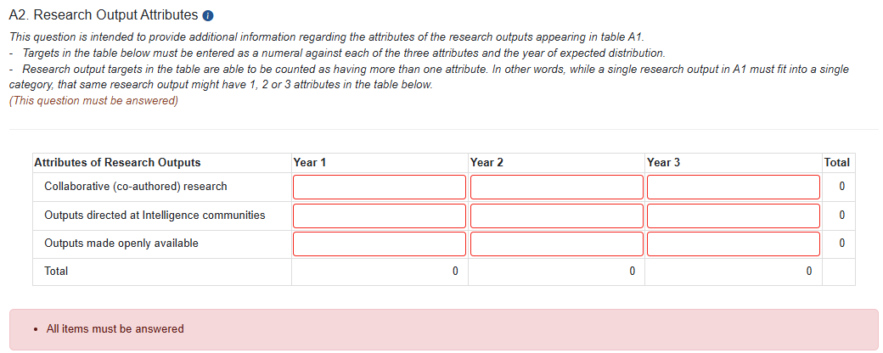

Figure 7 - Research Output Attributes Question

1. Save the form to ensure no data is lost (Figure 6).

### 2.1.3 Quality of Research Outputs

The Quality of Research Outputs question (A3) is intended to provide information regarding the measures that will be used to determine output quality. Quality measures entered in question A3 should be appropriate to the output types expected from the grant, and the research being conducted, we suggest using the categories in question A1. Peer Reviewed, Non-Peer reviewed and Data Sets, for each output type, look for evidence (something that can be reviewed or measured in some way) that helps demonstrate the output will be of high quality.

A target for each quality measure is expected to be entered and the number of outputs that meet the quality measure will be reported through the periodic progress reporting.

Look for interdisciplinary peer reviewed journals that may provide feedback or reviews to measure the quality of the output.

* A citation count – including Google scholar citation count, with greater than 10 citations, although a citation count can take longer than the Projects active period to be realised, so may not be able to be measured fully during the grant reporting period.
* Impact Factor with 80% papers Impact Factor greater than 3
* Scimago journal ranking with 80% papers in Q1 journals

Examples of output types could also include:

* Journal articles
* Conference publications
  + published to inform industry
  + published to inform the public
* Patents
* Book Chapters
* Awards.

The below table identifies some examples of how a quality measure could be entered.

|  |  |  |
| --- | --- | --- |
| Quality Measure | Target for Quality Measure | Quality Measure applicable to output type |
| Impact factor > 2.5 | 50% | Refereed papers in journals |
| Citation Count | >5 | Book Chapter |
| H index | 5% | All peer reviewed publications |
| Award | 1 | All Outputs |

Table 1 - Quality Measure examples

**To enter details into the Quality of Research Outputs question:**

1. Scroll to question A3 within Part A of the KPI Report
2. Select the ‘**Add answer**’ button

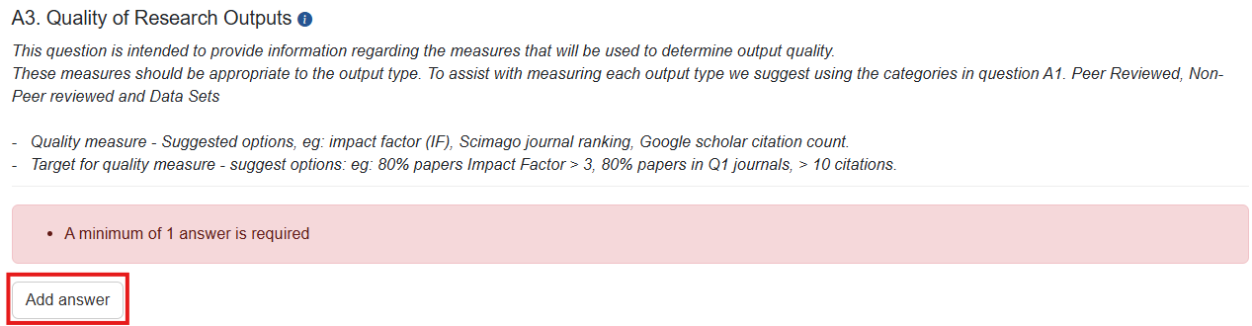

Figure 8 - 'Add answer' button

1. Complete the quality measure details

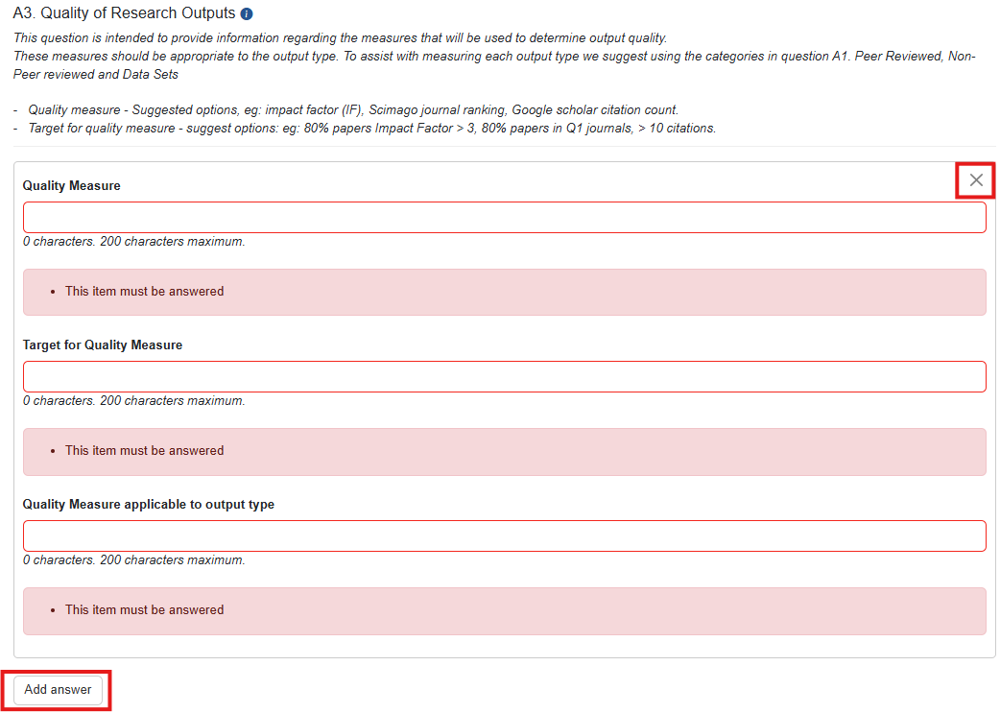

Figure 9 - Quality Measure details entry

1. Additional quality measures can be added by selecting the ‘**Add answer’** button
2. Save the form to ensure no data is lost (Figure 6).

**Note**: if the ‘**Add answer’** button is selected incorrectly, the ‘**x**’ at the top right of the answer box can be selected to clear the answer.

## 2.2 Grant Personnel Targets

The targets in this category are intended to demonstrate the grant’s ability to build capacity and capability by supporting researchers, fostering research trainees and engaging non-academic participants. Targets should be entered as a numeral and reflect the expected number of new personnel engagements by year (i.e. if an individual is to be engaged in year 1 and continue through to grant completion a ‘1’ should be entered in year 1 only).

When setting targets consider supervision requirements within the research team. For example, for new students will there be a post-doctorate currently employed who will provide supervision?

**To enter details into the Grant Personnel question:**

1. Navigate to Part B of the KPI Report
2. Enter the anticipated number of personnel to be employed by the grant as a numerical value against the anticipated year of engagement
3. A number must be entered in each field to validate the question

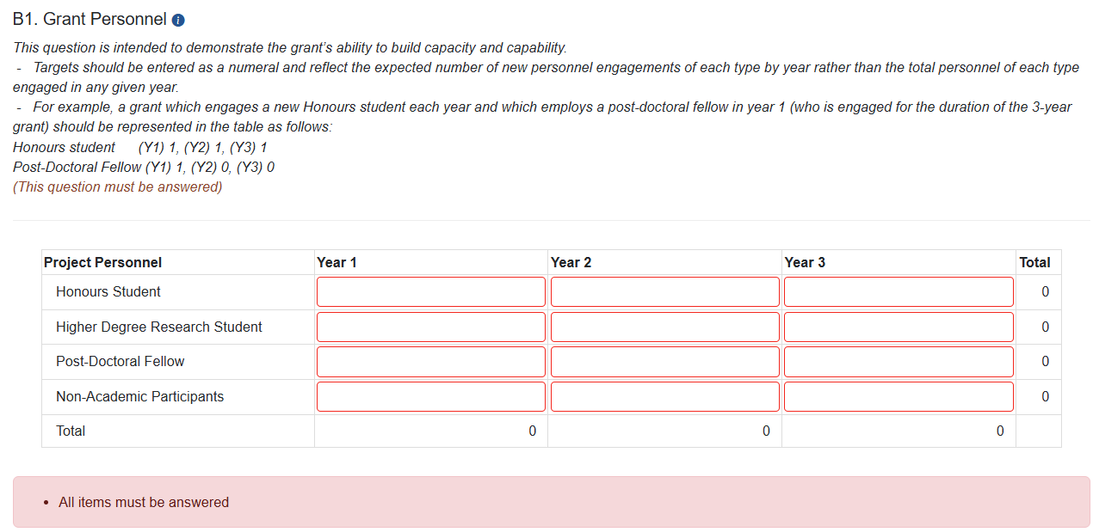

Figure 10 – B1 Grant Personnel question

1. Save the form to ensure no data is lost (Figure 6).

## 2.2 Recruitment Plan

Due to the personnel eligibility requirements for this Program and the difficulties existing projects have encountered in recruiting staff specifically Higher Degree Researchers (ie. PhD, Masters, Post Doc students) to undertake project activities, ONI require a recruitment plan to be provided.

When creating your recruitment plan consider:

* where you will be targeting your recruitment advertising
* what is the pool of eligible personnel available in your research area (taking into account how this may be impacted by the eligibility citizenship requirements)
* have you provided enough salary funding in the budget for the personnel required

A template of the Recruitment Plan required is located on the [Grants Services Resource Hub](https://www.researchgrants.gov.au/resource-hub/recruitment-plan-template)

To answer the recruitment plan question:

1. Scroll to question B2
2. Upload your recruitment plan
3. Ensure all columns fit to one page.
4. Save the form to ensure no data is lost (Figure 6)

This image is a screenshot of question B2 Recruitment plan. 
A recruitment plan should be completed for each position requested in the budget or identified in question B1 Grant Personnel. Please complete a new line for each position You are planning to recruit during the Project activity period.

Figure 11 - Question B2 requesting upload of a recruitment plan

## 2.3 Grant Outreach Targets

The targets in this category are intended to demonstrate the grant’s level of engagement between the research sector and the Australian Government, industry and business, and Australia’s National Intelligence Communities. Target details for keynote presentations and briefings should be entered as a numeral against each outreach category and the year of expected completion. It is expected that all participants involved with an NIDG funded grant will have the opportunity to provide input to briefings and present to external stakeholders.

Please note that keynote presentations and briefing targets can include both invitations from external stakeholders, as well as events hosted by grant personnel.

In considering outreach targets it is expected that the number of engagements will increase throughout the life of the grant.

**To enter details into the Grant Outreach question:**

1. Navigate to Part C of the KPI Report
2. Enter the target for each outreach category as a numerical value against the anticipated year of engagement.
3. A number must be entered in each field to validate the question

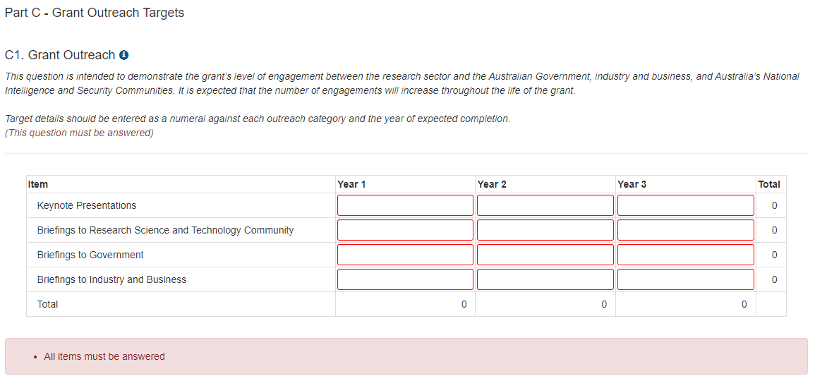

Figure 12 - Grant Outreach question

1. Save the form to ensure no data is lost (Figure 6).

## 2.4 Project Specific Performance Measures (KPIs)

This section of the Report is intended to allow each Project to set research specific performance measures. The question has been designed to allow for the entry of your performance measures, a description of the measure and classification as either a qualitative or quantitative success measure. Project Specific Performance Measures should align closely with the key benefits identified in the Project Plan, and the aims, activities and anticipated outcomes as outlined in the original application.

**Meaningful performance measures** track research results whilst achievement of research results is what defines performance. Completing a task or activity, such as reaching a milestone, does not define performance.

For qualitative measures particularly: consider if the proposed measure is a milestone, activity or performance measure. The measures that are proposed in this section should measure the research performance, and what the activity will hope to have achieved, rather than noting that an activity will have been completed.

Milestones are about **action**, measures are about **results**.

What does success look like as your project progresses? For instance:

#### Example 1

**X** Providing a briefing to a stakeholder is an activity that is completed and is therefore a milestone.

 Receiving feedback from stakeholders about how useful that briefing was provides a measure of performance and is a useful KPI.

#### Example 2

**X** Finishing a set of research activities shows that they have been completed and is a good milestone However it doesn’t help measure whether those activities were useful and contributed to the progress of research or the growth of understanding about the research topic.

 Having a complete and consistent data set or better understanding of a subject, that enables better planning or the ability to create an output or disseminate results, is a measure of performance.

#### Example 3

**X** Completing the creation of a piece of equipment, a tool or a system is a milestone.

 Measuring whether that equipment, tool or system was operational as anticipated (i.e., gives the expected results) is a performance measure. A non-performing item can still be good progress as it may show another way to achieve the result and help future research.

**To enter details into the Project Specific Performance Measure question:**

1. Navigate to Part D of the KPI Report
2. Select ‘**Add answer’**

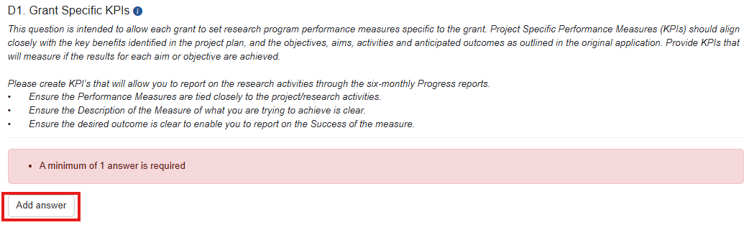

Figure 13 - 'Add answer' button

1. Complete the Performance Measure title and description detail

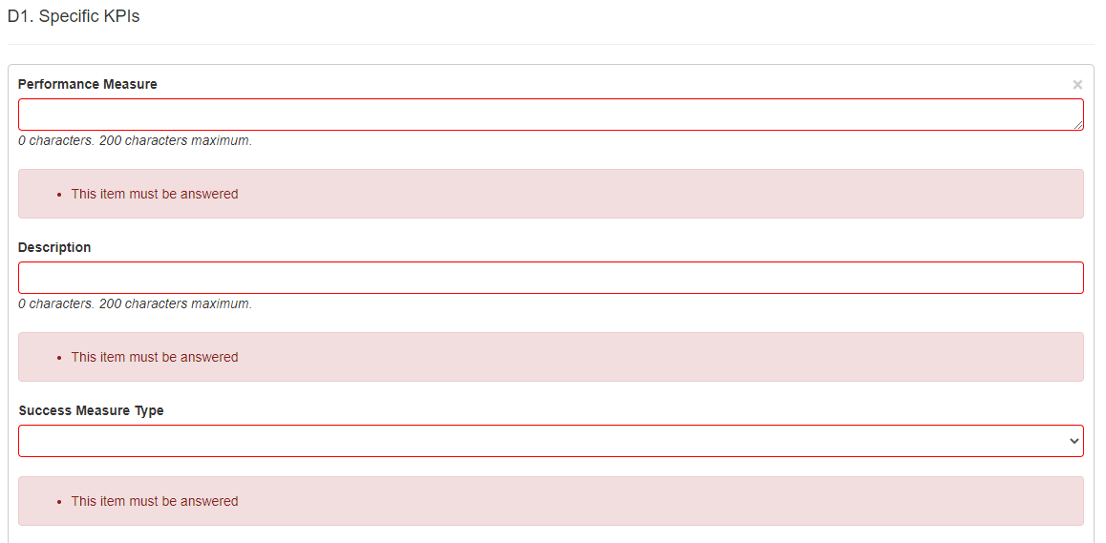

Figure 14 – Performance Measure title and description fields

1. Select the success measure type from the dropdown menu



Figure 15 - Success Measure Type

**Note**: If a quantitative measure is selected a table will display to provide numerical target details for each year of funding. If a qualitative measure is selected, 3 text fields will display to provide target details for each year of funding.

#### For Quantitative Performance Measures:

1. Enter the units of measure e.g. kg, km, km/s etc.
2. Enter a numerical target for each year of funding

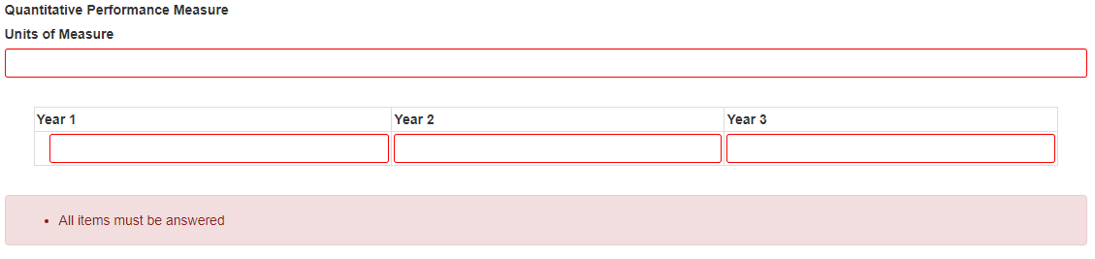

Figure 16 - Quantitative Performance Measure

#### For Qualitative Performance Measures:

Consider if the proposed measure is a milestone, activity or performance measure. The performance measures that are proposed in this section should measure the research performance, and the expected **results** of the activity.

##### Example 1

*Receiving feedback from stakeholders about how useful a briefing was, provides a measure of performance and is a useful KPI.*

##### Example 2

*Having a complete and consistent data set or better understanding of a subject, that enables better planning or the ability to create an output or disseminate results, is a measure of performance.*

##### Example 3

*Measuring whether a piece of equipment, tool or system was operating as anticipated (i.e. gives the expected results) is a performance measure. A non-performing item can still be good progress and help future research.*

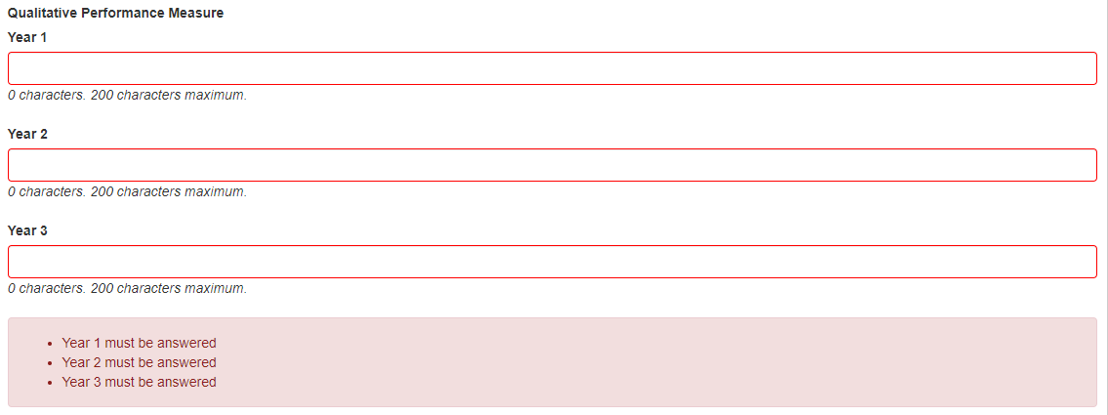

Figure 17 - Quantitative KPI detail entry

1. Enter the qualitative performance measures, appropriate for your project, for each year of funding
2. Save the form to ensure no data is lost



Figure 18 - 'Save' button

1. Additional KPIs can be added by selecting the ‘**Add answer’** button



Figure 19 - 'Add Answer' button

**Note**: if the ‘**Add answer**’ button is selected in error the ‘**x**’ at the top right of the answer box can be selected to clear the answer.

## 2.5 Activity Budget and Ethics Plan

The Activity budget requested to advise ONI of any changes to the budget since the application was submitted. When completing the Activity Budget use the same funding categories selected in the application. In each 6-monthly Progress Report ONI requires the Project to provide an indication of the current expenditure of the project, this will enable ONI to see the progress that has been made especially in the area of increasing capacity and capability with recruitment and retainment of personnel.

If the project budget has changed, for example where there may have been negotiation regarding your project scope, or you need to move funding between lines to cater for additional personnel expenses, an updated budget must be uploaded to the KPI report. Any movement of funding from/to budgeted lines will also require the submission of a Budget Change Variation in RMS to ONI by the Research Office for final approval.

When support personnel funded by ONI are identified, the Activity Budget should be uploaded naming these positions and the funding attributed to each position in the KPI report or subsequent Progress reports.

Please also note that **Un-named personnel** names and eligibility documentation must be forwarded to ONI [nidg@oni.gov.au](mailto:nidg@oni.gov.au) as they are recruited and in the following Progress Report.

The Activity Budget template is located on the [Grants Services Resource Hub](https://www.researchgrants.gov.au/resource-hub/activity-budget-kpi-report)

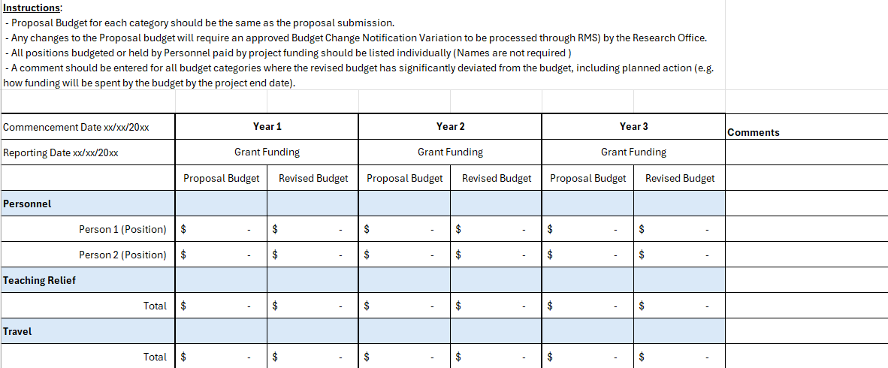

Figure 20 – Activity Budget

E1. Has your activity budget changed since your proposal was submitted?

1. This is a Yes/ No question. If **Yes** describe the changes from the proposal budget in the text box. If the budget has not changed since the project proposal, this can be advised by selecting **No**.
2. Complete and upload the Activity budget (if required).
3. Select Save.

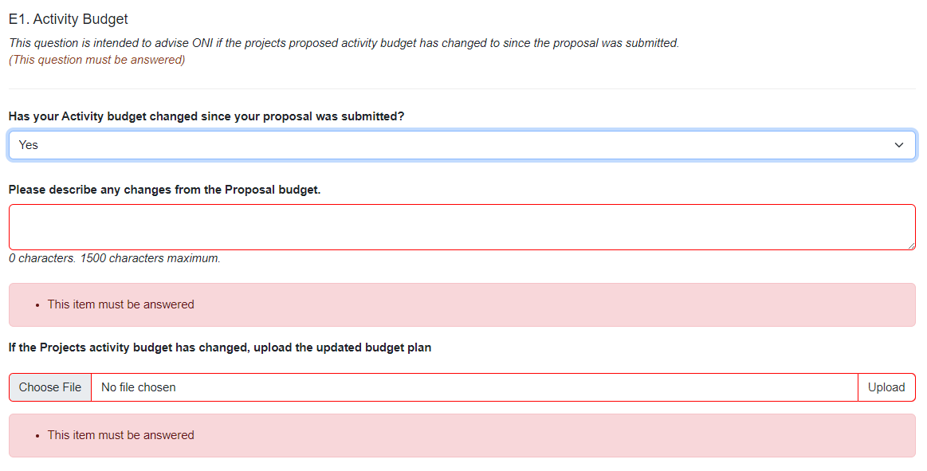

Figure 21 – Question E1 Activity Budget

E2. Ethics Plan

ONI requires an approved Ethics Plan for any project involving human participation and/or the use of animals. For such projects, an Ethics Plan must be in place prior to the commencement of the project and a copy of the approved Ethics Plan must be provided in the KPI report, if clearances are not available now, these can be notified in the Progress report.

For projects which involve neither human participation nor the use of animals, please upload a PDF confirming that no Ethics Plan is required.

Human participation in research is understood broadly, to include the involvement of human beings through:

* taking part in surveys, interviews or focus groups;
* undergoing psychological, physiological or medical testing or treatment;
* being observed by researchers;
* researchers having access to their personal documents or other materials;
* the collection and use of their body organs, tissues or fluids (eg skin, blood, urine, saliva, hair, bones, tumour and other biopsy specimens) or their exhaled breath;
* access to their information (in individually identifiable, re-identifiable or non-identifiable form) as part of an existing published or unpublished source or database;
* Research involving human embryos and gametes, including the creation of hybrid and chimeric embryos.

Australian code for the care and use of animals for scientific purposes is for the care and use of all live non-human vertebrates and cephalopods.

* the care and use of animals for scientific purposes;
* animal materials imported for use in xenotransplantation research.

To upload the Ethics Plan or confirmation that your project does not require an Ethics Plan:

1. Upload the PDF to the KPI report by selecting Choose file
2. Select Upload to attach the PDF to the report
3. Select Save.

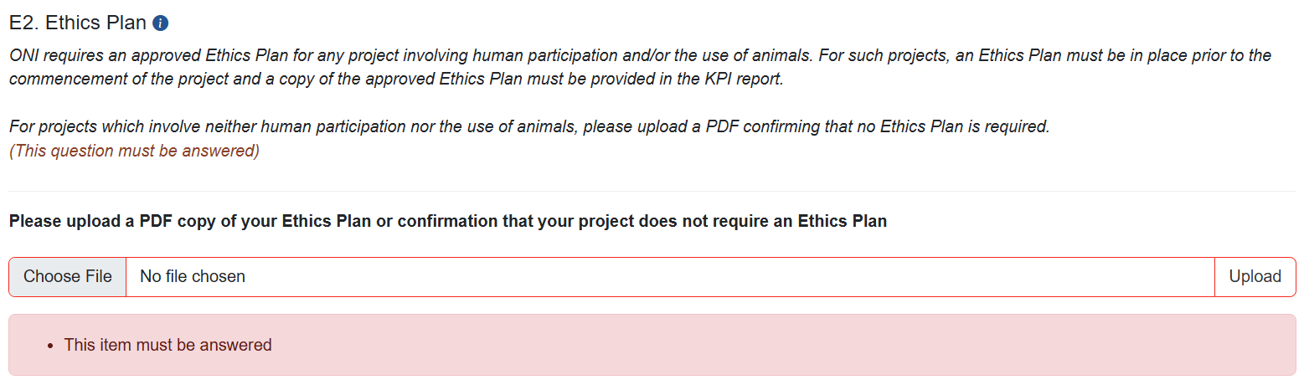

Figure 22 – Question E2 Ethics Plan

# PART 3 – Submit to the RO

Once all mandatory fields have been completed, and the Lead CI of the grant is satisfied that all KPI target details have been accurately entered, the report must be submitted to the   
AO RO for review and final submission.

To submit a completed report to the RO:

1. Ensure that all mandatory fields within the Report have been completed and that the ‘**Ready to submit’** message appears at the top of the Report

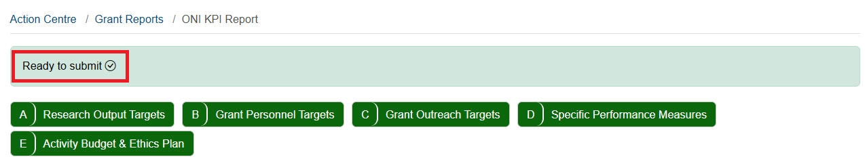

Figure 23 - Ready to submit message

1. Return to the Grant Reports menu by selecting the ‘**Grant Reports’** link or Close Button at the top of the page

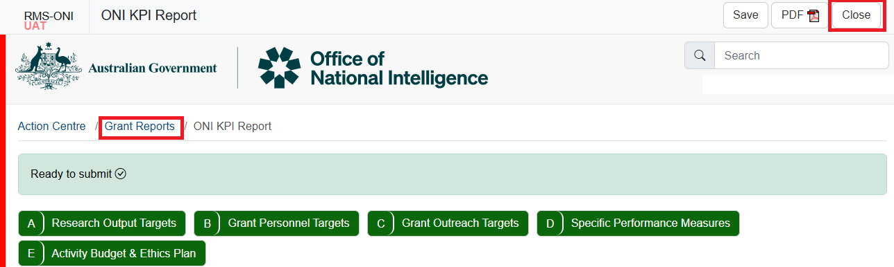

Figure 24 - 'Grant Reports' link and Close Button

1. Locate the relevant report and select the ‘**Submit to RO’** button

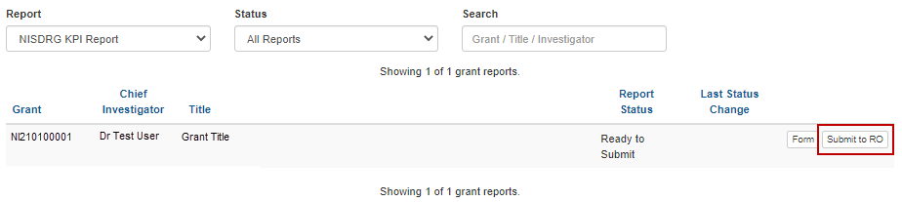

Figure 25 - 'Submit to RO' button

1. Confirm submission of the KPI Report by selecting ‘**Submit to RO’** in the pop-up message

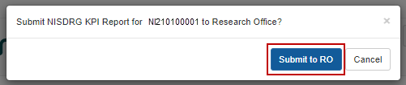

Figure 26 - Confirm Submission to RO

# PART 4 – RO Certification and Submission

The targets submitted within the KPI Report form part of the Grant Agreement between the AO and ONI due to the requirement to provide periodic progress updates against set KPIs. Therefore, each target should be reviewed to ensure that the entered KPIs closely aligns with the key benefits identified in the Project Plan, and the aims, activities and anticipated outcomes as outlined in the application.

Upon confirmation that the entered KPI target details are agreeable to the AO, the KPI report must be certified by a RO Delegate and submitted to ONI for review by the RGS team.

## 4.1 To review the details entered in a KPI Report

1. Navigate to the ONI RMS portal: [rmsoni.researchgrants.gov.au](https://defence.researchgrants.gov.au)
2. Select the ‘**Research Office Grant Reports**’ link within the ‘Research Office Grant Management’ module of the RMS action centre.

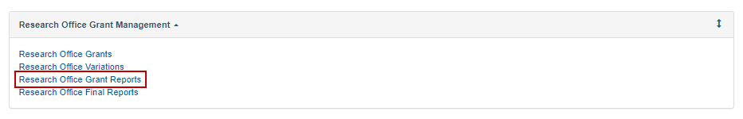

Figure 27 - 'Research Office Grant Reports' link from the RMS Action Centre

1. From the Report drop-down list locate the KPI Report to be reviewed and select ‘**Form’**

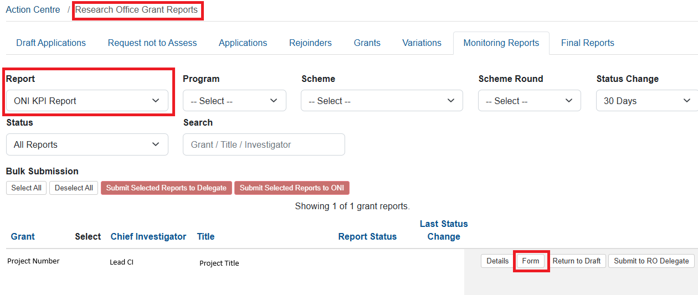

Figure 28 - 'Form' button to open a KPI report for review

1. Review the details entered in the Report.

## 4.2 To return a KPI Report to a Lead CI for updates

If the KPIs are not acceptable and require editing, the RO may return the KPI Report to the Lead CI.

1. Return to the list of available RO grant reports by selecting the ‘**Research Office Grant Reports’** link or Close button.

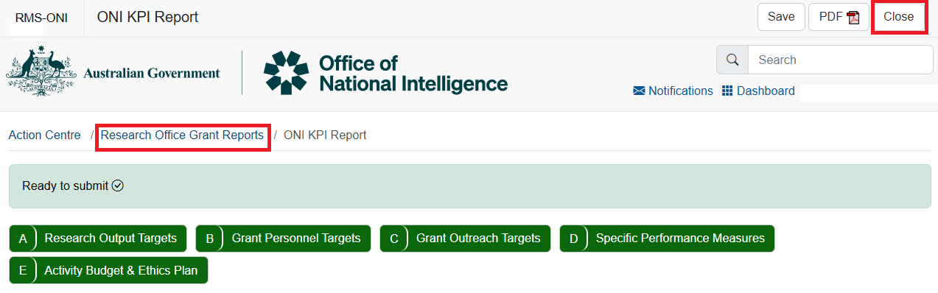

Figure 29 - Research Office Grant Reports

1. Locate the report to be returned and select ‘**Return to Draft’**

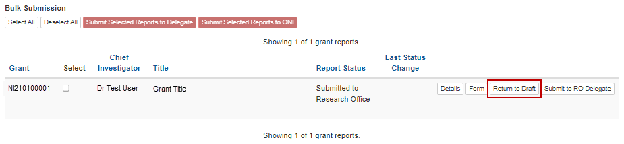

Figure 30 - 'Return to Draft' button

## 4.3 To certify and submit a KPI report to ONI

If the KPIs are acceptable, the RO must submit the report to the RO Delegate.

1. Return to the list of available RO grant reports by selecting the **‘Research Office Grant Reports**’ link (Figure 21)
2. Locate the report to be submitted and select **‘Submit to RO Delegate’**

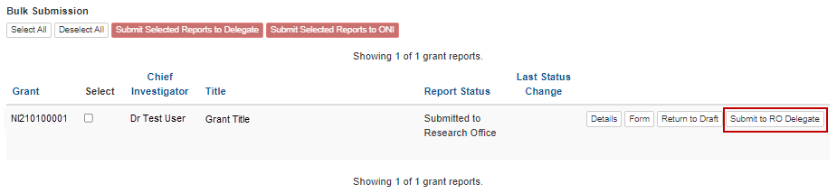

Figure 31 - 'Submit to RO Delegate' button

1. Confirm submission to the RO Delegate by selecting the ‘**Submit to RO Delegate’** button

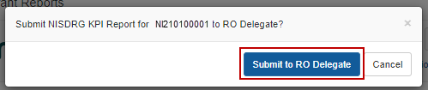

Figure 32 - Confirm Submission to RO Delegate

The report must be then certified by the RO Delegate by selecting the ‘**Certify’** button

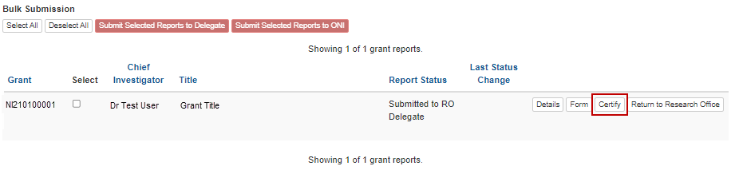

Figure 33 - 'Certify' button

1. Confirm RO Delegate certification by selecting ‘**Agree to certification’**

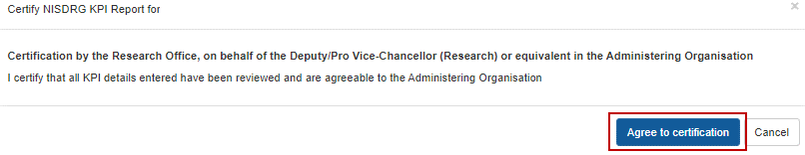

Figure 34 - Certification message

1. Finalise submission by selecting the ‘**Submit to ONI’** button.

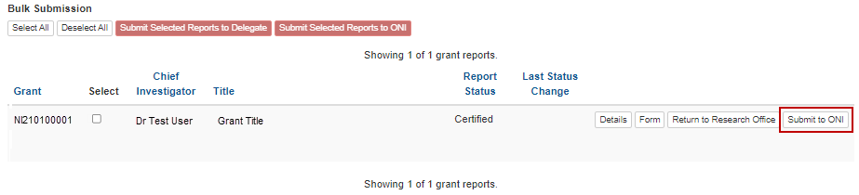

Figure 35 - Submit to Funding Entity button

# Glossary and Definitions

## Definitions

| **Term** | **Definition** |
| --- | --- |
| Administering Organisation (AO) | An Eligible Organisation responsible for the administration of the grant. |
| [Australian National Intelligence Community](https://www.oni.gov.au/) | The National Intelligence Community comprises of 10 agencies brought together to protect and enhance Australia’s security, prosperity and sovereignty:   * Australian Criminal Intelligence Commission (ACIS) * Australian Federal Police (AFP) * Australian Geospatial-Intelligence Organisation (AGO) * Australian Security Intelligence Organisation (ASIO) * Australian Secret Intelligence Service (ASIS) * Australian Signals Directorate (ASD) * Australian Transaction Reports and Analysis Centre (AUSTRAC) * Defence Intelligence Organisation * Department of Home Affairs (DHA) * Office of National Intelligence (ONI). |
| Funding Entity | The Office of National Intelligence |
| Intelligence Challenges | Those challenge areas aligned with the National Security Science and Technology Priorities identified by the Australian Government to be funded by the ONI, and available on the [RGS website](https://www.researchgrants.gov.au/). |
| Key Performance Indicators (KPIs) and/or Performance Measures | A set of quantitative and/or qualitative measures that We use to monitor and report on progress of research outcomes. |
| Lead Chief Investigator (CI) / Project Lead | The first named investigator of a Project. |
| Progress Report | A report submitted in RMS advising the progress of the grant against Key Performance Indicators (KPIs). |
| Project | An application approved by the ONI Delegate to receive funding, may also be referred to as a Grant. |
| Reporting Period | The period of the report, January to June or July to December. |
| Research Office (RO) | A business unit within an Eligible Organisation that is responsible for contact with Us regarding applications and projects. |
| Research output | All products of a research project. |
| Us/We | The Australian Research Council |

## Glossary

| **Acronym** | **Elaboration** |
| --- | --- |
| AO | Administering Organisation |
| ARC | Australian Research Council |
| CI | Chief Investigator |
| KPI | Key Performance Indicator |
| ONI | Office of National Intelligence |
| NIDG | National Intelligence Discovery Grants |
| RGS | Research Grants Services team |
| RMS | Research Management System |
| RO | Research Office |