NATIONAL INTELLIGENCE DISCOVERY GRANTS (NIDG)

End of Year Reporting in RMS
(User Guide)
Updated July 2026

Contents
Introduction 3
Key Points 4
Summary of Workflow 4
Quick Reference 5
PART 1 - Locate the EoYR within RMS 6
PART 2 - Complete the EoYR 8
Amending the Grant End Date 8
Grant Expenditure 8
Amount Spent 9
Unspent Reason 9
Research Office Comments Only 11
Justification 12
Project Income and expenditure statement 12
PART 3 – Submitting the EoYR to the RO EoYR Delegate 13
PART 4 – RO EoYR Delegate Certification and Submission 13
Edits required – De-submit 13
Certify and Submit EoYR to the Funding Entity for assessment 13
Definitions and Glossary 15
Definitions 15
Glossary 16

Introduction
The Australian Research Council (ARC), on behalf of the Office of National Intelligence (ONI) is conducting grant management for the National Intelligence and Security Discovery Research Grants (NISDRG) program. In 2025, the Office of National Intelligence (ONI) rebranded the NISDRG Program to National Intelligence Discovery Grants (NIDG) program to reflect a refined focus on the Intelligence Challenges. The NIDG program continues the aims of NISDRG to enhance systematic engagement between Australia’s National Intelligence Community and Australia’s research and technology community.
The NIDG program requires that an End of Year Report (EoYR) be submitted for all active grants.
The purpose of the EoYR is to collect information regarding the financial activity relating to funding received from ONI during the previous financial year/s.
EoYRs are completed and submitted to ONI by the Administering Organisation (AO), via the ‘Grant Management > Grant Reports’ module in the ONI Research Management System (RMS). The EoYR must be certified by the Research Office (RO) EoYR Delegate prior to submitting to ONI.
All EoYRs must be submitted to ONI in RMS by 30 September each year. Extensions will not be permitted unless approved by the RGS team prior to this date.
It is the responsibility of each AO to ensure that all the information contained in the report is accurate and that all required fields are completed as comprehensively as possible.
Report forms, relevant to their organisation, can be accessed in RMS by RO staff and approved EoYR Delegates.
For any RMS access issues, please contact the ARC RMS Helpdesk at ARC-Systems@arc.gov.au.
All requests for RO EoYR Delegate access must be requested through the ‘Manage Users’ module in the ONI RMS Portal: https://rmsoni.researchgrants.gov.au
The following instructions provide information for the entry and submission of End of Year Reports.

Key Points
- The target audience for this user guide is AO RO Delegates for NISDRG and NIDG awarded grants.
- The purpose of the EoYR is to collect information regarding the financial activity relating to NIDG funding received during the previous financial year/s.
- EoYRs will be opened after 30 June for the AO to complete.
- EoYRs must be submitted in RMS by 30 September each year.
- The reporting period is for the full previous financial year, July to June.
- An RO EoYR Delegate is required to certify and submit the EoYR by the due date.
Extensions will not be permitted unless approved by the RGS team prior to the due date.
- The RGS team will review the submitted report.
- EoYRs will also be made available to ONI staff.

Summary of Workflow

Quick Reference
PART 1 – Locate the EoYR within RMS
- EoYRs are available within the ONI RMS Portal: https://rmsoni.researchgrants.gov.au
- From the Action Centre locate the Research Office Grant Reports in the Research Office Grant Management module.
- From the Reports drop down locate the ONI End of Year Report for the relevant financial year.
PART 2 – Complete the EoYR
The EoYR must be completed by the finance area of the AO.
- Amending the Grant End Date
An End Date change is requested when the lead investigator advises a change to the current project end date is required. Justification for the change is required.
- Grant Expenditure
Information will auto-populate when opened by the AO.
- Amount Spent
Enter the total actual funds spent in the last financial year.
- Unspent Reason
If all funds available have not been spent and a carryover is requested, select the Unspent Reason from the drop-down list.
- Research Office Comments
This field should be used when the unspent reason ‘Other’ is selected.
- Justification
If the ‘Total Amount Unspent’ (carryover request) is more than 75% of the previous financial year’s allocation, or a change to the projects end date is requested, a comment must be entered advising the reason.
- Details of all Project Expenditure
Upload a PDF file with an Income Expenditure Statement for the reporting period. detailing the project expenditure for the financial year.
PART 3 – Submit to the RO EoYR Delegate
Once all mandatory fields have been completed and the AO is satisfied that all details have been accurately entered, the report must be submitted to the RO EoYR Delegate for review and final submission to ONI.
PART 4 – RO EoYR Delegate Certification and Submission
The EoYR must be certified and submitted to ONI by the RO EoYR Delegate.
Once submitted to ONI, if edits are required, a request to de-submit the EoYR must be made to the RGS team by email: arc-nidg@arc.gov.au.
Note: Within RMS report forms, hover over this icon for further information and guidance.

PART 1 - Locate the EoYR within RMS
The ONI EoYR is available within the ONI RMS Portal. The EoYR is intended to capture the yearly expenditure of the grant. The AO must complete, certify and submit the EoYR to ONI for grants administered by their organisation that have grant funds allocated during the financial year or carried over from a previous year, by 30 September.
To locate the ONI End of Year Report:
- Open the ONI RMS Portal: https://rmsoni.researchgrants.gov.au for the funded grant
- Select the ‘Research Office Grant Reports’ link from the RMS action centre.
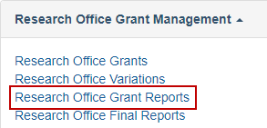
- Select the ‘ONI End of Year Report YYYY/YYYY’ with the relevant year from the dropdown menu.
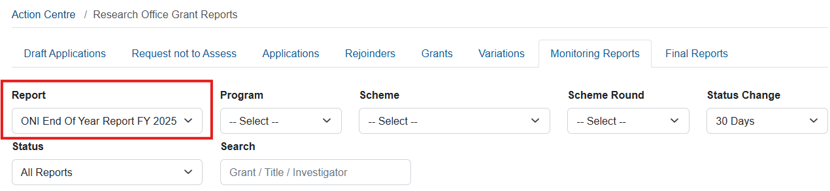
- Reports can then be searched by:
- the relevant information under the ‘Program, Scheme and/or Scheme Round’ dropdown lists
- searching for a specific Grant ID, Title or Investigator under the ‘Search’ bar
- searching on the status of the Report/s under the ‘Status’ dropdown list.
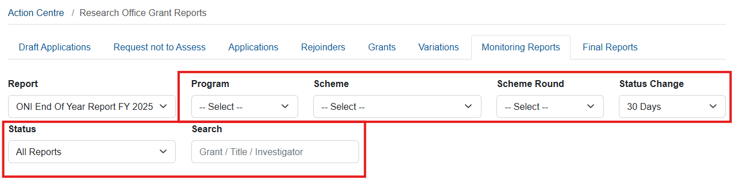
- Select ‘Save’ at the top of the page regularly during the completion of the report.

- Once you have located the required End of Year report select the ‘Form’ button to view the report.
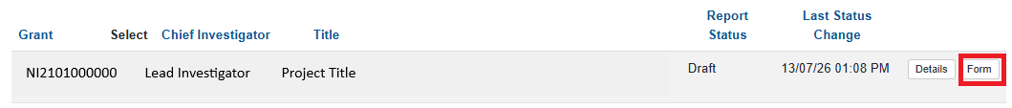
- A reporting form will display with questions to be responded to.
Please note: The Grant expenditure details will not populate into the report until the report is opened in RMS by the AO. If you want to view the details in excel, all reports will need to be opened in RMS prior to executing the spreadsheet download.
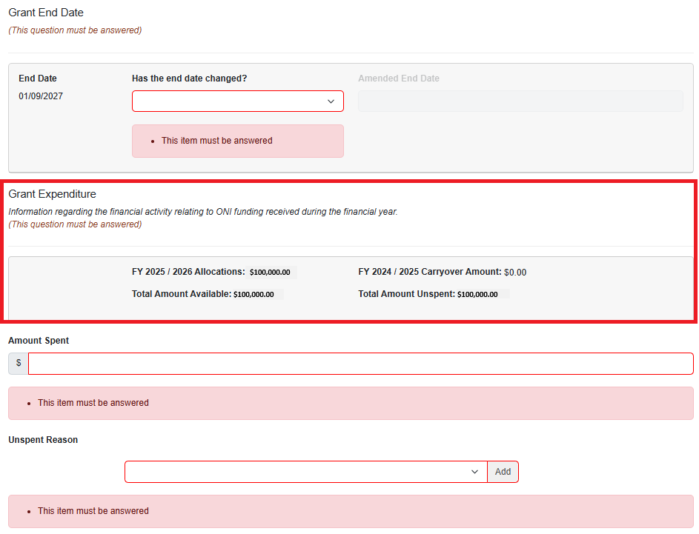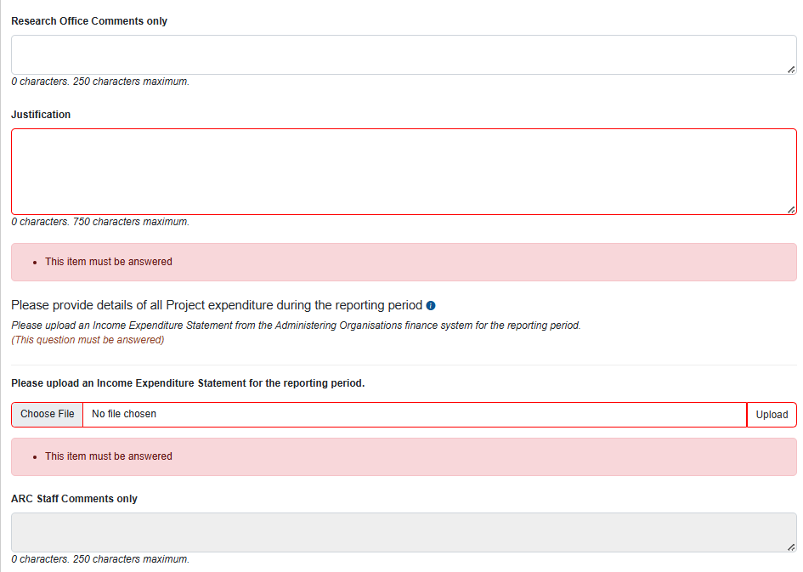

PART 2 - Complete the EoYR
The End of Year Report is made up of two sections:
- Grant End Date
- Grant Expenditure

Amending the Grant End Date
An End Date change can be requested when the lead investigator advises a change to the current project end date is required. This may occur where there are funds requested to carry over to the an additional year, or the Grant is deemed to have concluded once the Grant funds have been expended or relinquished.
Justification for the change is required.
- From the drop-down list select ‘Yes’ or ‘No’
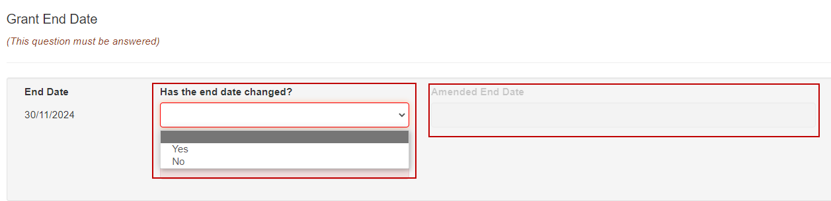
Where a new end date is to be requested select ‘Yes’, the Amended End Date field will activate.
- Enter the end date requested.
- Enter a comment in the Justification field.

Grant Expenditure
The following fields are auto populated into the EoYR once the report is opened by the AO.
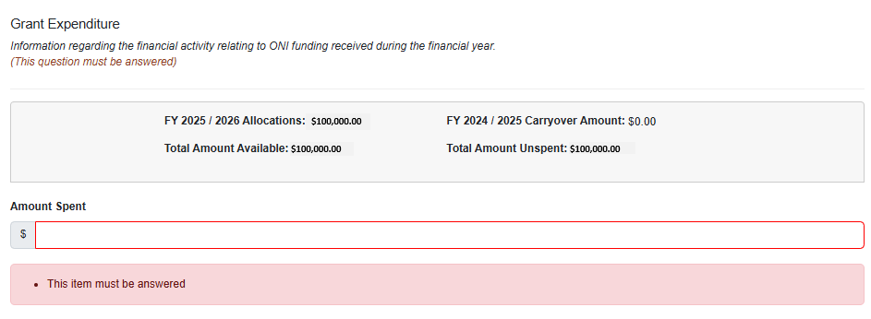
Please note: If you are downloading the report to excel to be sent to the CI for input, all reports will need to be opened first to populate this section.
Field | Explanation
Allocations | The amount paid to the Grant by ONI in the financial year
Carryover Amount | The Total Amount Unspent approved from the previous EOYR to the current EOYR.
Total Amount Available | The sum of the Allocations plus the Carryover Amount
Total Amount Unspent | The difference between the Total Amount Available and Amount Spent

Amount Spent
The AO is responsible for reporting all expenditure for a grant, regardless of the location of funds. Funding is only to be recorded in the ‘Amount Spent’ field if the funds were actually spent. This includes the funds located at other Organisations. Funds are not to be expended or written off because they are located outside the Administering Organisation. Funds transferred to a participating organisation must be reported as spent, as they are spent.
If funds are reported as spent when they are not, it may be seen as committing a fraudulent act and may result in serious action.
Only numbers may be entered into this field and a full stop to show the cents. An amount that is less than $0 or greater than the ‘Total Allocations’ displayed for the Grant, cannot be entered into this field. The use of symbols such as $, or commas must not be entered into this field.
- Enter the total amount of grant funds spent in the last financial year (including Grant funds spent at collaborating organisations).
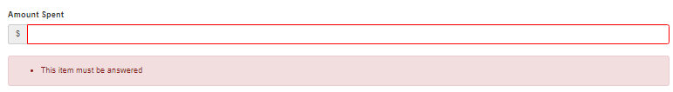

Unspent Reason
Where funds are unspent and a carryover is requested, an ‘Unspent Reason’ must be selected from the drop-down list. Reason Codes advise ONI why funding is being requested to carry over into the next financial year. Reason Codes are described below.
Entering a Reason Code does not replace the need for the submission of a Variation, or a detailed comment in the Justification field

- From the drop-down selection choose the appropriate Unspent Reason(s) and select Add. More than one ‘Unspent Reason’ may be selected from the list provided. If a reason is not listed select Other and include a comment in the ‘Research Office Comments’ field.
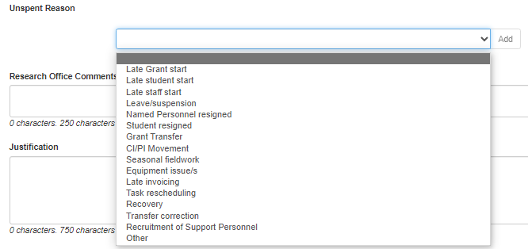
- To add the Unspent Reason click ‘Add’.
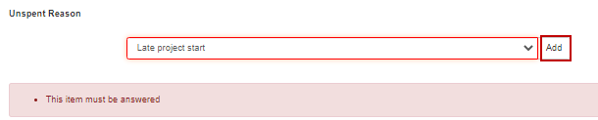
- If the reason has been selected in error, select the ‘x’ button to the right of the reason.
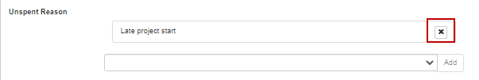
Unspent Reasons
Reason code | Explanation
Late project start | Project started late (e.g. due to late signing of agreement/s, ONI approved deferment)
Late student start | Late commencement of HDR/PGR student funded directly from the grant
Late staff start | Late commencement of staff funded directly from the grant  (that are not named participants or students)
Leave/suspension | Named Participant/s on the grant took a period of leave or suspension during the reporting period
Named Personnel Resigned | Withdrawal of named participants (CIs and PIs only)
Student resigned | Resignation of student funded by the grant
Grant Transfer | Grant transferred during the reporting period
CI/PI Movement | Delays due to movement of named investigators (CIs and PIs only)
Seasonal Fieldwork | Seasonal nature of fieldwork (e.g. wet season, migratory practices, remote community access, natural disaster etc.)
Equipment Issue/s | Equipment Issues (e.g. breakdown of Project equipment, unavailability of new equipment causing delays, delay in new equipment being available from supplier, delay in construction of equipment)
Late Invoicing | Late invoicing for services or equipment that were not paid in the reporting period
Task Rescheduling | Rescheduling of tasks, resulting in expenditure being moved into the following year
Recovery | A recovery occurs when unspent funding is repaid to ONI. When funds have not been spent and there is no approved carryover, funding will be recovered. Only include this reason if there are funds to be recovered by ONI. Please make a reference to the variation number if a recovery has already been entered into RMS.
Transfer Correction | Use this category if there is a need to correct the figures provided at the time of the Transfer of the grant. If this is selected, additional information must be entered into the justification field stating what occurred and the amount that needs to be transferred and/or corrected.
Recruitment of Support Personnel | Use this category if there have been challenges with the recruitment of support personnel, additional information must be entered into the justification field stating what the challenges are and how they will be addressed.
Other  (must specify reason) | If Other is chosen a reason must be entered in the Research Office Comment field

Research Office Comments Only
This field should be used when the unspent reason ‘Other’ is selected to communicate any
additional administrative issues with ONI. For example, if the reason for a delay
in the research progress is not listed in the drop-down selection the reason should be noted in
the ‘Research Office Comments Only’ field.
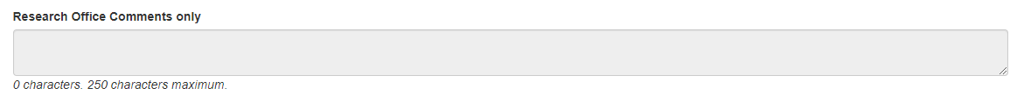

Justification
If the ‘Total Amount Unspent’ (carryover request) is more than 75% of the previous financial year’s allocation, a comment must be entered advising the reason. Where the unspent amount is less than 75%, the justification comment box becomes optional.
However a comment should be included for any funds unspent to advise ONI if there is a delay with aspects of the project, and if a request to change the End date is requested a comment should be included advising the reason for the change.
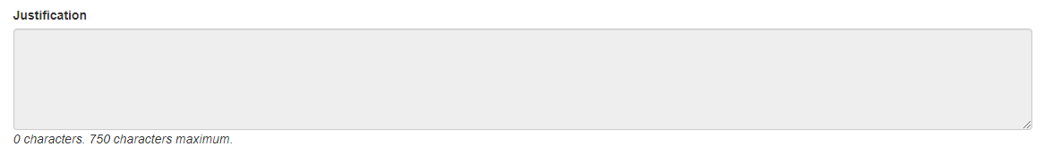

Project Income and expenditure statement
This section of the Report requires the upload of an Income Expenditure Statement from the Administering Organisations finance area, providing the total project expenditure during the reporting period.
- Click on the ‘Choose File’ button, a pop-up window will open where the PDF file can be selected.
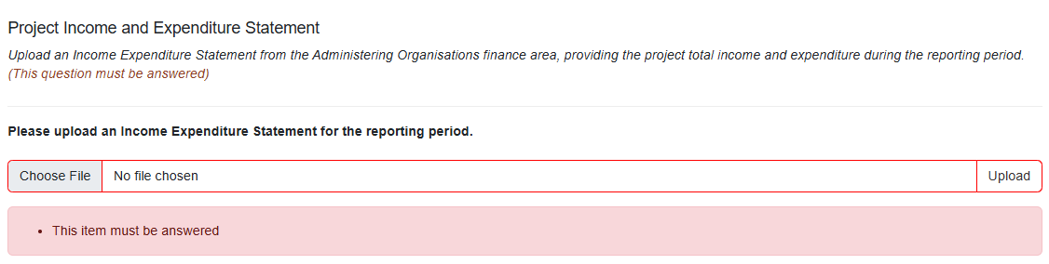
- After choosing the correct PDF file, click on ‘Upload’.
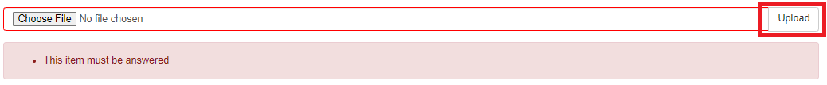
- Once the report is complete select ‘Save’.

PART 3 – Submitting the EoYR to the RO EoYR Delegate
Once all required information has been entered, AO staff must submit reports to the
RO EoYR Delegate for assessment and certification.
- The ‘Ready to Submit’ status will appear against each Report which has been completed.
- Select ‘Submit to RO Delegate’.
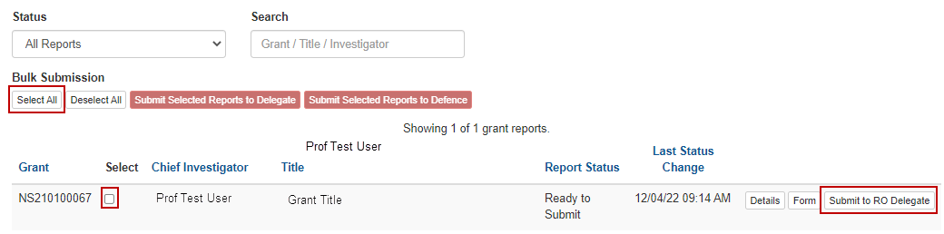
Where there are multiple reports to be submitted you can press Select all from bulk submission.

PART 4 – RO EoYR Delegate Certification and Submission
EoYRs must be checked and certified by the RO EoYR Delegate prior to submitting the reports to ONI. RO EoYR Delegates are required to certify that the Grant has complied with the relevant schemes Grant Guidelines and Grant Agreement and that all information provided within the report is accurate and up to date.
Submission of this report must only be actioned by a person who has the financial delegation to do so on behalf of the AO, as this is a legal document supplied to ONI.
All EoYRs must be submitted in RMS by 30 September for the previous financial year. Extensions will not be allowed unless approved by the RGS team prior to this date.

Edits required – De-submit
If information needs editing or is incorrect prior to submitting the report to ONI, the RO EoYR Delegate can return the report back to RO staff.
- Select ‘Return to Research Office’.

Certify and Submit EoYR to the Funding Entity for assessment
- The ‘Certify’ button will appear against each Report which is ready to be certified and submitted to ONI for assessment. Select Certify.

- A pop-up box will appear, select ‘Agree to Certification’.
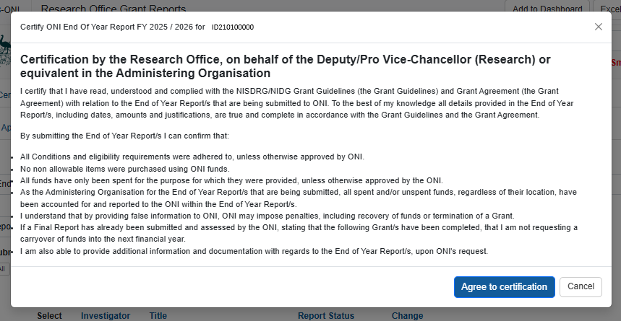
- Once certified, the status of the report will appear as ‘Certified’ and may then be submitted to ONI.
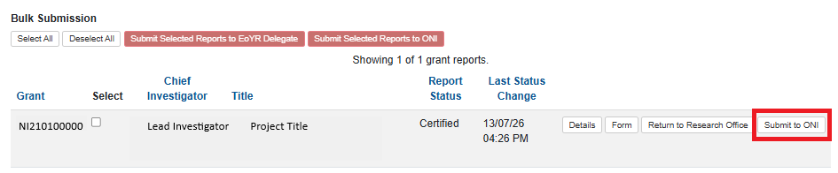
- Once EoYRs are submitted to ONI, the progress of the report can then be tracked using its status in RMS. If further information is required, RGS will return the report to the AO and/or send an email advising the query.

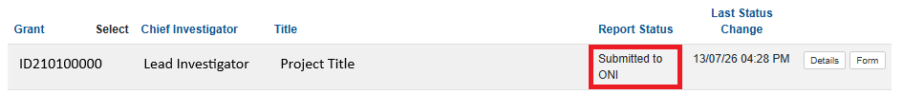
- Once approved, the Report Status will show ‘Accepted’.

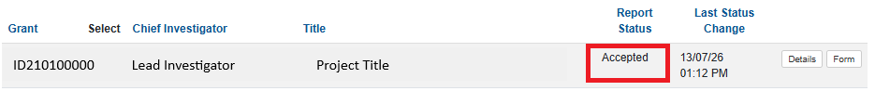
If you have any questions regarding the completion of the End of Year Report, please contact Research Grants Services arc-nidg@arc.gov.au.

Definitions and Glossary

Definitions
Term | Definition
Administering Organisation (AO) | An Eligible Organisation responsible for the administration of the grant.
Australian National Intelligence Community | Comprises the six agencies that formerly made up the Australian Intelligence Community (AIC):  - the Office of National Intelligence (ONI)  - the Australian Signals Directorate (ASD)  - the Australian Geospatial-Intelligence Organisation (AGO)  - the Australian Secret Intelligence Service (ASIS)  - the Australian Security Intelligence Organisation (ASIO)  - the Defence Intelligence Organisation (DIO)  as well as the Australian Criminal Intelligence Commission (ACIC) and the intelligence functions of the Australian Federal Police (AFP), Australian Transaction Reports and Analysis Centre (AUSTRAC) and The Department of Home Affairs.
Australian National Security Community | Comprises the:  - Department of Defence  - Department of Home Affairs  - Office of National Intelligence  - Department of Home Affairs  - Department of Foreign Affairs and Trade  - Prime Minister and Cabinet  - Department of Industry, Science, Energy and Resources.
Intelligence Challenges | Those challenge areas aligned with the National Security Science and Technology Priorities identified by the Australian Government to be funded by the ONI, and available on the RGS website.
Lead Chief Investigator (CI) | The first named investigator of a Project
Project | An application approved by the ONI Delegate to receive funding, may also be referred to as a Grant.
Reporting Period | The period of the report, July to June. A financial year.
Research Office | A business unit within an Eligible Organisation that is responsible for contact with Us regarding applications and projects.
Us/We | The Australian Research Council

Glossary
Acronym | Elaboration
AO | Administering Organisation
ARC | Australian Research Council
CI | Chief Investigator
EoYR | End of Year Report
ONI | Office of National Intelligence
NIDG | National Intelligence Discovery Grants
NISDRG | National Intelligence and Security Discovery Research Grants
RGS | Research Grants Services team
RMS | Research Management System
RO | Research Office

