National Intelligence Discovery Grants
Progress Reporting in RMS
(User Guide)
Updated July 2026

Contents
Introduction 3
Key Points 4
Summary of Workflow 4
Quick Reference 5
PART 1 – Locate the Progress Report within RMS 6
PART 2 – Complete the Progress Report 8
Part A - Project Update 8
A1. Administration 8
A2. Budget Update 9
A3. Performance Measures 9
A4 Performance Measure Update 10
A5. Provide a high-level update on the progress of the research 12
Part B - Grant Personnel 13
B1. Grant Personnel 13
Part C - Grant Outreach 16
C1. Grant Outreach 16
C2. Additional Funding 17
Part D - Research Outputs 19
D1.Output Target High-Level 19
D2. Output Target Detailed 19
D3. Quality of Research Outputs 20
D4. Research Outputs 21
PART 3 – Submit to the Research Office 24
PART 4 – Research Office Certification and Submission 25
Research Office review of the Progress Report 25
Submit the Progress report to ONI 26
Glossary and Definitions 27
Definitions 27
Glossary 28

Introduction
The Australian Research Council (ARC), on behalf of the Office of National Intelligence (ONI) is conducting grant management for the National Intelligence and Security Discovery Research Grants (NISDRG) program. In 2025, the Office of National Intelligence (ONI) rebranded the NISDRG Program to National Intelligence Discovery Grants (NIDG) program to reflect a refined focus on the Intelligence Challenges.
The NIDG program continues the aims of NISDRG to enhance systematic engagement between Australia’s National Intelligence Community and Australia’s research and technology community.
To ensure that the NIDG program achieves the objectives and intended outcomes, all awarded grants are required to provide periodic progress updates against set Program focused Key Performance Indicators (KPIs) as well as performance measures that help demonstrate how a Project is progressing. KPIs must be set for each Project against the standard Program KPIs, and performance measures when the grant commences using a KPI form (KPI Report) in RMS.
Following the acceptance of the KPI Report by RGS, Progress Reports will be submitted twice yearly to advise the progress of the Project against the performance goals set in the KPI Report to reflect the grants achievements. It is important to note that KPIs and progress reporting are only one measure of progress and will be reviewed in context with other reports, outreach, and engagement activities.
All grant management activities, including the submission of variations and grant reporting, must be completed within the ONI RMS Portal - https://rmsoni.researchgrants.gov.au unless otherwise advised by RGS.
Upon submission of a Progress Report by an Administering Organisation (AO), the Research Grants Services (RGS) team will review the submitted report against the targets in the KPI Report. The progress of the Project should reflect the aims, activities and anticipated outcomes as outlined in the original application. Progress Reports will also be made available to ONI.
Note: The KPIs submitted in the original KPI report will not continue past the original grant period. If your grant is extended, or there is a gap in project activity, please respond to the relevant questions in the Progress Report to note significant variances to the original targets.
The following instructions provide information for the entry and submission of Progress Reports into the available RMS report.

Key Points
- The target audience for this user guide is Lead Chief Investigators (CI) and Research Office (RO) staff for NISDRG and NIDG awarded grants
- KPI’s are established by Project teams at the beginning of the Project
- Progress Reports are only one measure used to monitor project progress
- Progress reports will be opened each year for the Lead CI to complete in:
  - February (reporting period for previous July – December)
  - August (reporting period for previous January – June)
- An AO RO Delegate is required to certify and submit the Progress Report by the due date. Extensions will not be allowed unless approved by the RGS team prior to the due date.
- The RGS team will review the submitted report against the targets in the KPI Report. Progress Reports will also be made available to ONI.

Summary of Workflow

*The RGS team may request clarification or amendments prior to acceptance on behalf of ONI.

Quick Reference
PART 1 – Locate the Progress Report within RMS
Progress Reports are available within the ONI RMS Portal - https://rmsoni.researchgrants.gov.au
PART 2 – Complete the Progress Report
The Progress Report must be completed by the Lead CI. All Progress Report details for the Project should reflect the aims, activities and anticipated outcomes as outlined in the original application.
The form will display with form part (headings) coloured Red as there are mandatory questions requiring a response. Mandatory questions will have a red outline, some questions will be optional and will not include a red outline. Please ensure these questions are reviewed and answered if they apply to your projects progress.
- Part A – Research Outputs Project Update
This section is designed to provide ONI a snapshot of the Projects administrative activities including any changes to the project team, recruitment of personnel, an estimate of the projects current expenditure and the current research findings.
- Part B – Grant Personnel
This section will advise ONI of the personnel engaged to work on the project including a statistical table noting the total number of personnel engaged to the project, and the name and role of the engaged personnel.
- Part C – Grant Outreach
This category includes a statistical table noting the total number of engagements the project team has presented to the Australian Government, industry and business, and Australia’s National Intelligence and Security Communities, and any funding received to advance the research.
- Part D – Research Outputs
This section of the report includes a statistical table noting the total number of outputs produced by the project, the quality of those outputs and a copy of outputs submitted for publication.
PART 3 – Submit to the RO
Once all mandatory fields have been completed, and the CI is satisfied that all details have been accurately entered, the report will be submitted to the RO Delegate for review.
PART 4 – RO Certification and Submission
The Research Office will review the report prior to certifying and submitting the report to ONI.

If edits are required after submission to ONI, a request to de-submit the Progress Report must be made to the RGS team by emailing arc-nisdrg@arc.gov.au.
Note: For further information and guidance regarding a question, hover over this icon in the Progress Report form

PART 1 – Locate the Progress Report within RMS
The projects Lead Chief Investigator (CI) listed in RMS will complete the Progress Report, in the ONI RMS Portal - https://rmsoni.researchgrants.gov.au.
From the Action Centre select the ‘Grant Reports’ link from the Grant Management module.
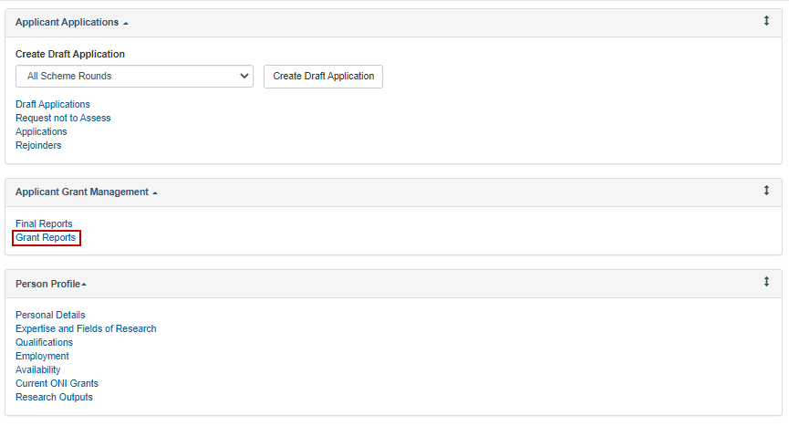
From the report drop down menu locate the report for the current period (ONI Progress Report Year January – June or July – December). The progress report reporting period will be the six months prior to the report completion period.
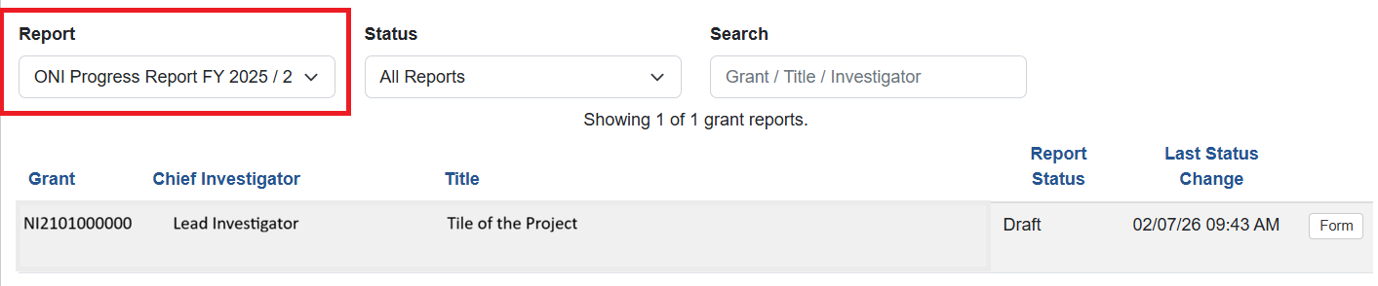
Once the current, open report has been selected, press the ‘Form’ button to begin completing the report.
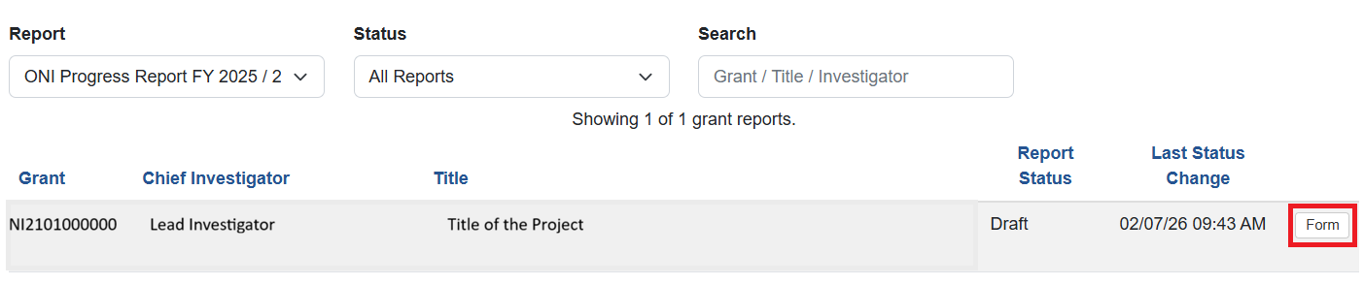

The form will display with form parts (headings) coloured Red as there are mandatory questions requiring a response.
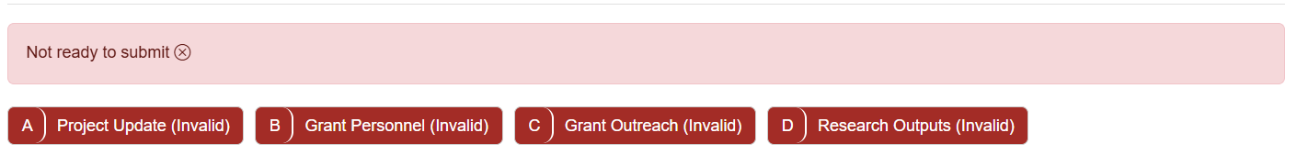
Mandatory questions will have a red outline and a message This item must be answered, some questions may be optional and will not include a red outline. Please ensure these questions are reviewed and answered if they apply to your projects progress.
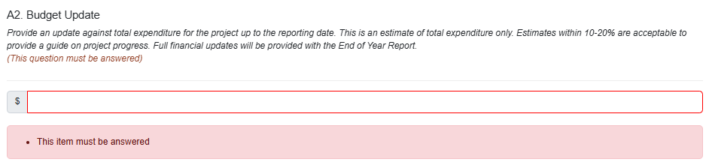
As you Progress through the Report don’t forget to save the form. RMS will time-out after a period of time, if you do not select Save the information you have entered may be lost. The save button is located at the top of the form. We recommend saving the form as each Form Part is completed at a minimum.

Once all mandatory questions within a form part are completed the Form Parts (headings) will turn Green. Once all form parts are green and the report has been reviewed it can be submitted to the Research Office for review.
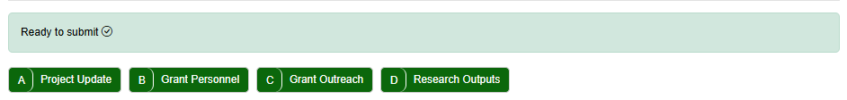

PART 2 – Complete the Progress Report
The Progress Report is intended to capture the current progress against the specified categories. Sections of the Progress Report will populate with the targets previously submitted
in the KPI Report. The current Progress Report tables will demonstrate the progress of the Project against those KPI targets since the commencement of the project.
Mandatory fields within the report will be flagged with a red outline. A response is required in each mandatory field to validate the form, a zero (‘0’) must be entered in the statistical tables if an item has not been produced for the category.
Select ‘Save’ at the top of the form regularly during the completion of the report.

Part A - Project Update
This section is designed to provide ONI a snapshot of the Projects administrative activities including any changes to the project team, recruitment of personnel, an estimate of the projects current expenditure and the current research findings.

A1. Administrative Update
This is a free text box to enable you to provide ONI an update on the administration of the project. Including but not limited to:
- Progress against administrative arrangements (e.g. ethics approvals, governance arrangements, MIAs etc.);
- Details of any security incidents encountered (e.g. data breach from hackers, unsolicited request for project information, cyber security incident);
- Progress against recruitment activities, including any personnel commencing or leaving the project;
- Any anticipated changes to personnel (e.g. named CIs or PIs moving to another university or retiring);
- Any anticipated requests for project variations (e.g. end date extensions, project completing earlier than expected, change to Partner Organisation contributions);
- Unforeseen events that could cause project delays
- Anything else regarding your project that you would like to discuss with ONI or the ARC.
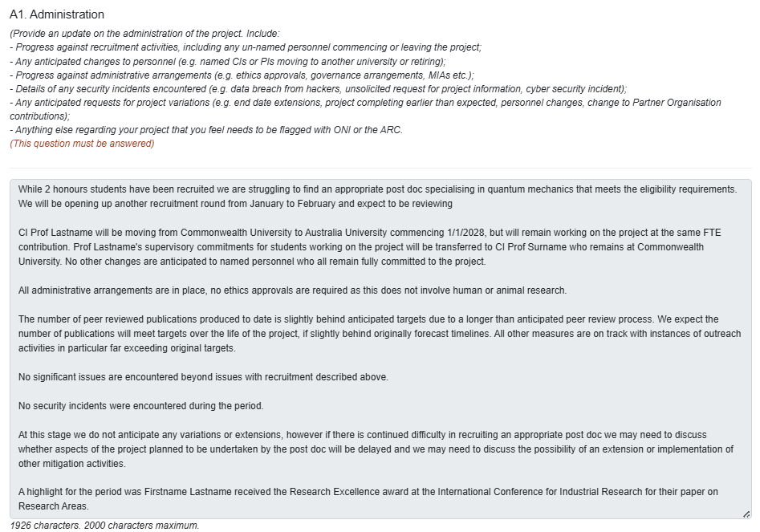
Sample Administrative update

A2. Budget Update
ONI have requested Projects provide an indicative update of Grant expenditure in each Progress Report. This should be an estimate of the projects total expenditure from project commencement to the end of the reporting period. Estimates within 10-20% are acceptable as this update is to provide ONI a guide on project progress only.
Note: The Administering Organisations Research Office Finance area will provide an actual update of the expenditure annually in the End of Year report.
This is a currency field. Enter the total estimated project expenditure from project commencement to the end of the reporting period.
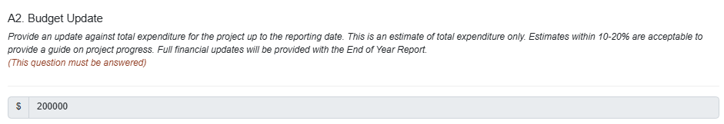
Sample Project expenditure

A3. Provide a high-level update on the progress of the research
This question will provide ONI an update on your research activities, progress and results. Upload a PDF of up to 2-pages of the research, you may include text and images to demonstrate the research findings, this may include progress against work packages and achievements against relevant challenges.
To upload a Pdf select Choose file, select the file from your shared-drive and select Upload. The PDF should be a maximum of two pages.
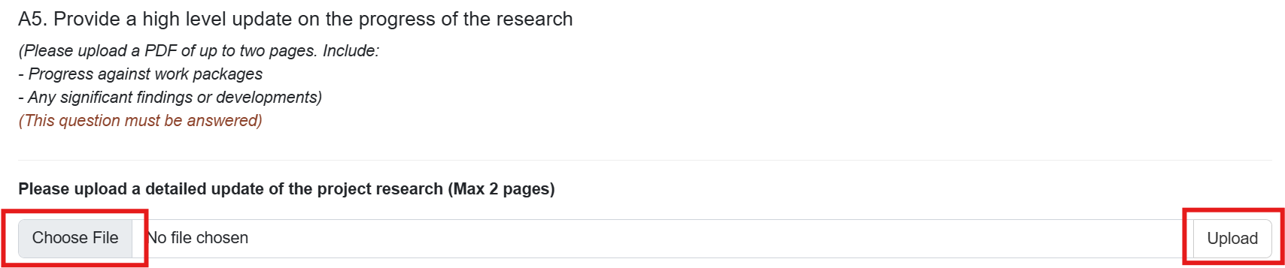
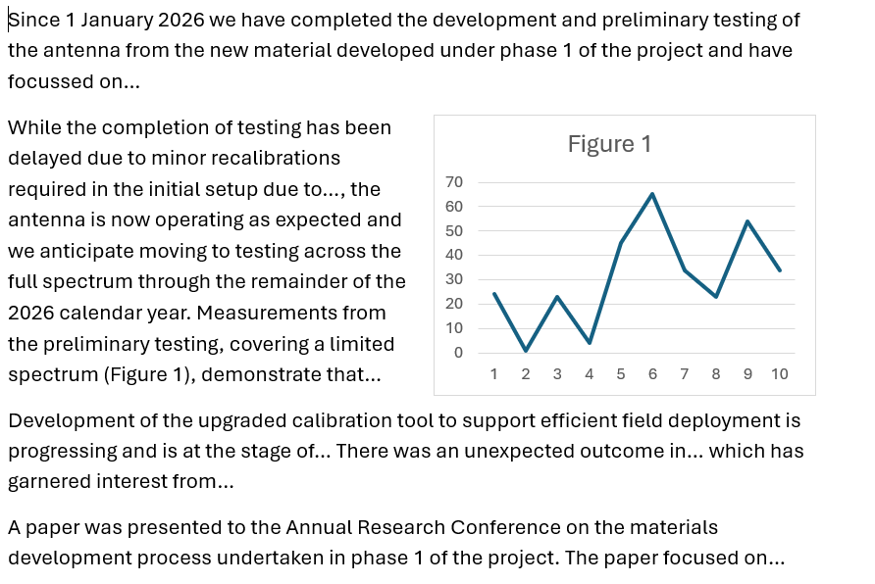
Sample Project Update

A4. Performance Measures
Performance Measures allow the CI to report on the specific Performance measures advised in the KPI Report. This section will import a table of the performance measures specific to the project entered in the KPI Report.
To view the measure type and yearly benchmarks expected to be achieved, select the Show/Hide button.
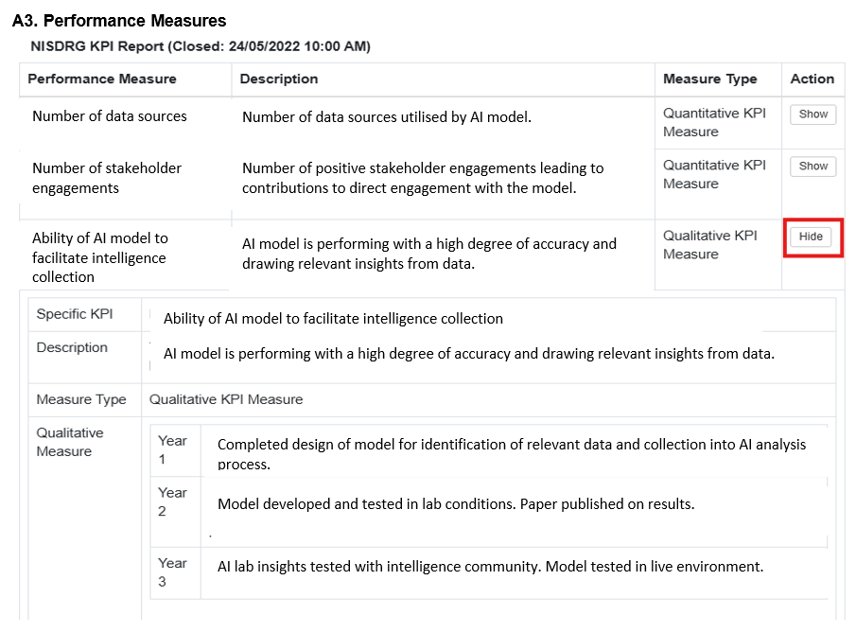
Sample Performance Measures

A4 Performance Measure Update
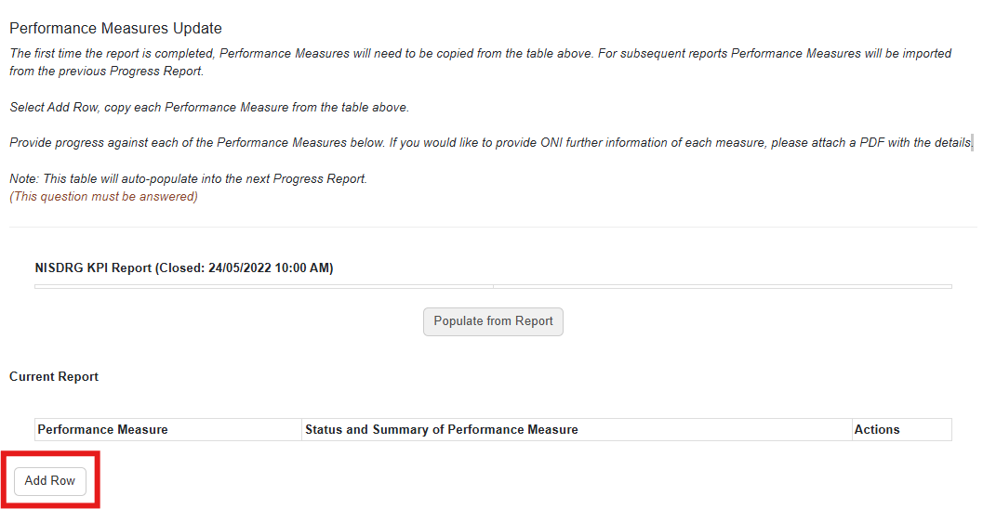
To answer this question for the first time from Current Report select Add Row.
From the Performance Measure table above, copy the first performance measure, and paste the performance measure into the pop-up box, select OK.
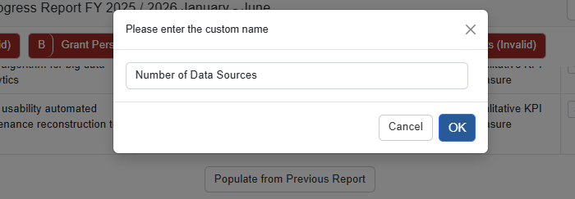
Provide the status and a brief update of the KPI. If further information is available a PDF can be uploaded.
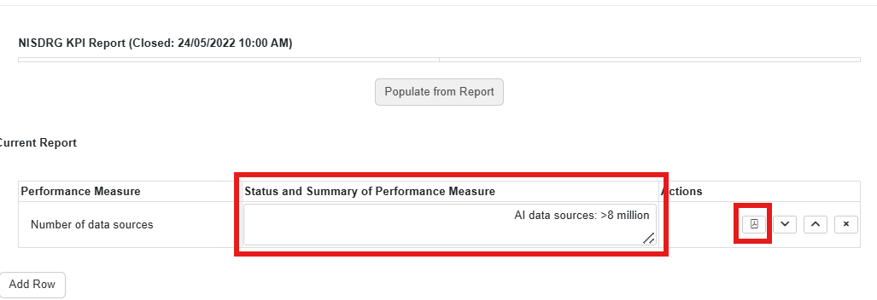
To upload a PDF Select the PDF icon from Actions.
Select Choose file, locate the file and select Upload
Complete these steps for each KPI.
The information contained in this table will copy across to the next progress report.
In subsequent reports, select the activated Populate from Report button.
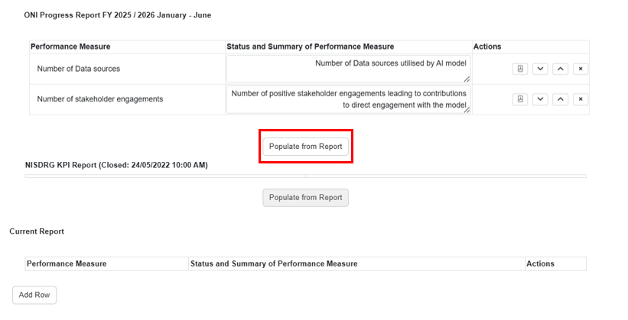
A pop-up box will appear. Select Ok to populate the Current Report table

The Current table will populate with the data saved in the previous report including the PDF if uploaded.
The Status and Summary of Performance Measure field will be editable, where you will be able to update the status and progress of the performance measure as the research progresses. A PDF can be uploaded if required as detailed above.
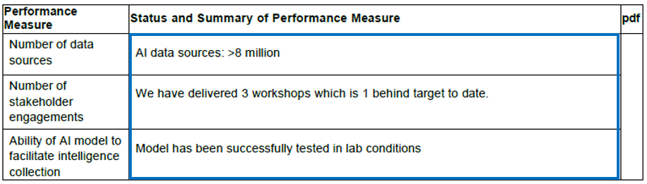

Sample Performance Measure table

Part B - Grant Personnel
This section is intended to show the Project’s ability to build capacity and capability by supporting researchers, fostering research trainees and engaging non-academic participants.

B1. Grant Personnel
The statistical table will import the personnel targets from your KPI Report. In the Current Report table enter the total number of personnel recruited to the project since commencement whether they are engaged/paid by the Grant, the Administering Organisation or a partnering organisation.
To validate the table, a zero should be entered if there are no personnel recruited for the category.
Note: The targets from the KPI Report are not editable. Once all fields in the Current Report table are entered, the red outlined fields of the KPI Report section will clear.
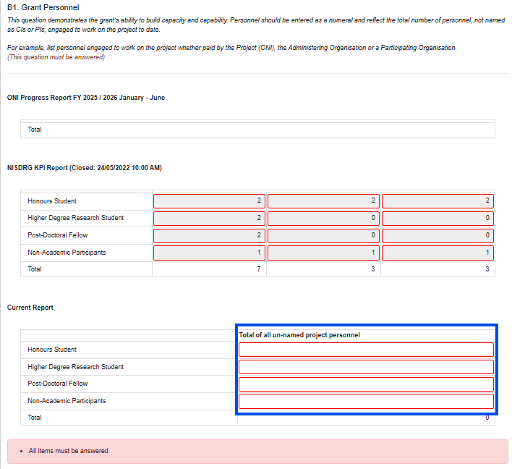

B2. Engaged Personnel
Here you will list all personnel (except named CIs and PIs) recruited to the project from commencement whether they are engaged/paid by the Grant, the administering organisation or participating organisations.
During recruitment the ONI Personnel Declaration form (located on the Grants Services website) and associated documents should have been forwarded to ONI for vetting, therefore they do not need to be uploaded to the Progress Report.

To answer this question for the first time, from Current Report select Add Row.
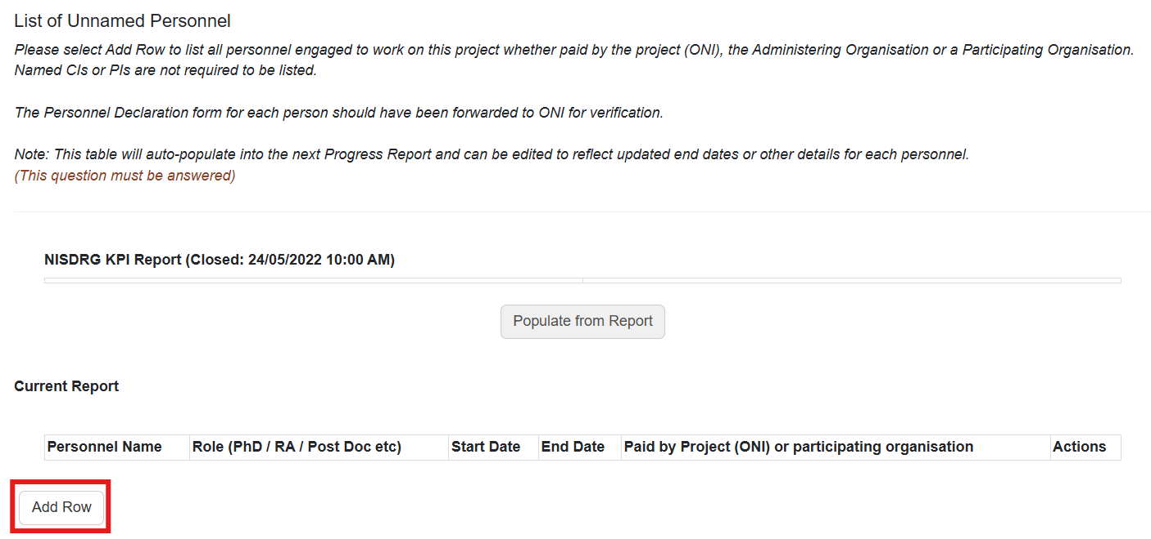
In the pop-up box enter the name of the engaged/recruited personnel.
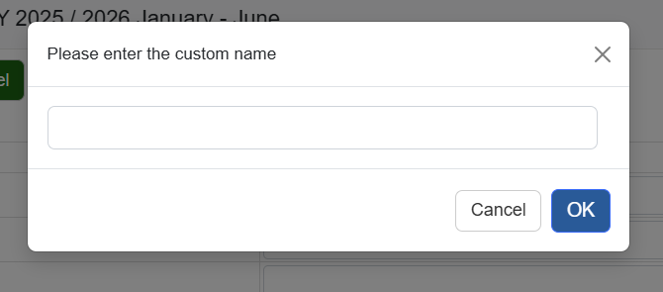
Complete the table with the persons role, start/end date and affiliated organisation. Select Add Row to enter additional personnel recruited to the project.
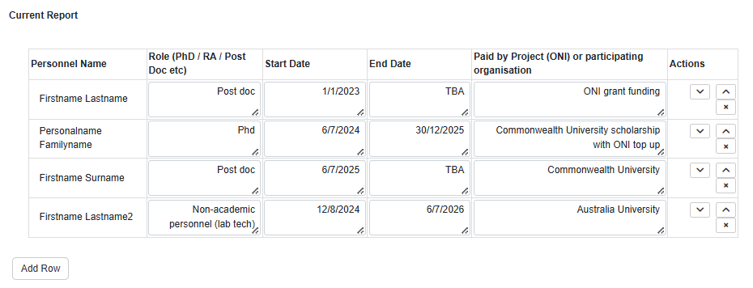
Sample Engaged Personnel
The information contained in this table will copy across to the next progress report.

In subsequent reports, select the activated Populate from Report button.
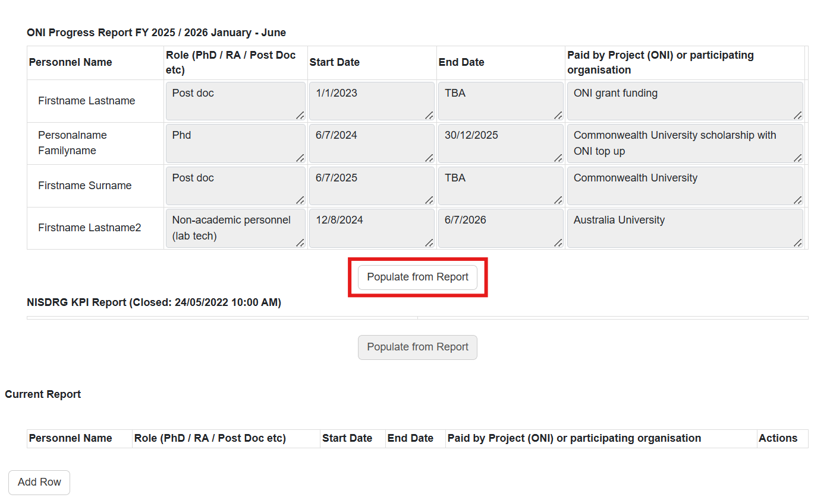
A pop-up box will appear. Select OK to populate the Current Report table.

The Current Report table will populate with the data saved in the previous report.
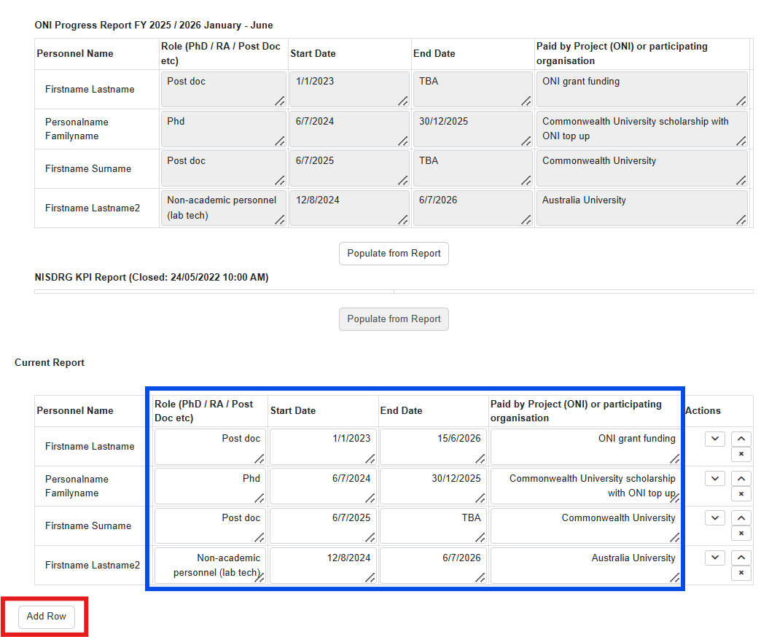
The Role, Start, End date and affiliated organisation fields will be editable, where you will be able to update the status of each person as the Grant progresses.
To enter additional personnel recruited to the project select Add Row and complete the fields as detailed above.

Part C - Grant Outreach
This section will demonstrate the grant’s level of engagement between the research team, the Australian Government, industry and business, and Australia’s National Intelligence and Security Communities.
The second part of this section will provide details on any additional funding that has been applied for or received to enable the enhancement or continuation of the research.

C1. Grant Outreach
This question will import the statistical Outreach targets table from your KPI Report. In the Current Report table enter the total number of outreach activities the team has completed since commencement.
To validate the table, a zero should be entered if there have not been any outreach activities for the category.
Note: The target fields from the KPI Report table are not editable. Once all fields in the Current Report table are entered, the red outlined fields of the KPI Report table will clear.
Briefings to Government may include updates provided during site visits by, or meetings (including phone conversations and video conferences) regarding research progress, with ONI as well as any other correspondence where you have provided ONI an update on the research. If you have a significant breakthrough or output, ONI will be keen to hear about it outside of the normal reporting periods.
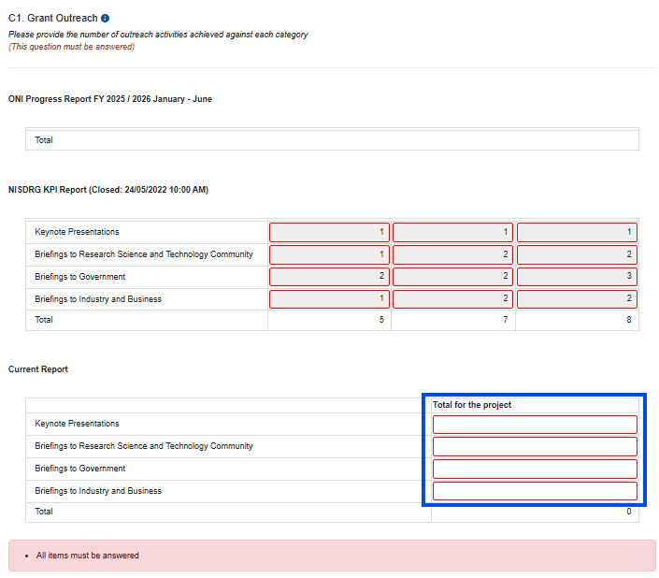

C2. Additional Funding
Please provide information regarding any funding applied for or received as a result of this project including funding to continue or extend the research activities.
If you would like to provide ONI details of the activities to be undertaken with this additional funding, a PDF can be uploaded by selecting the PDF Icon under Actions.
Note: This table and the information entered will auto-populate into the next progress report.
To answer this question for the first time and enter the details of funding applied for select Add Row.
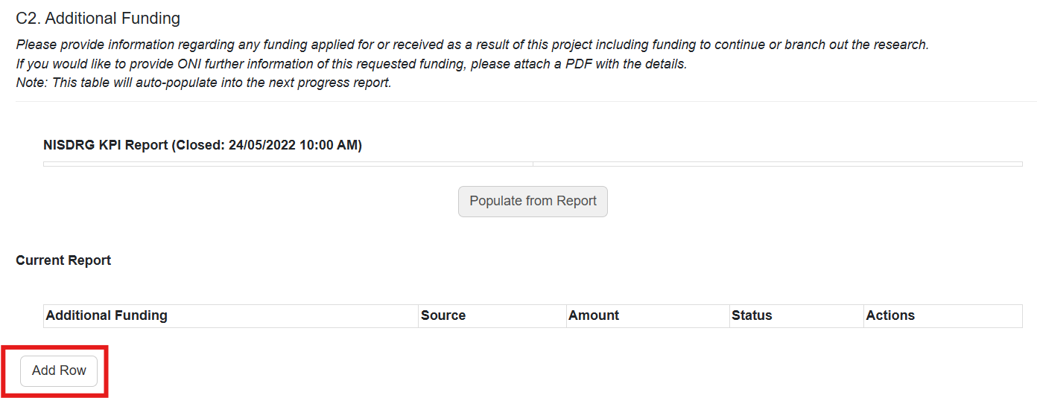
Enter the name of the funder or scheme the funding has been requested through, then select OK.
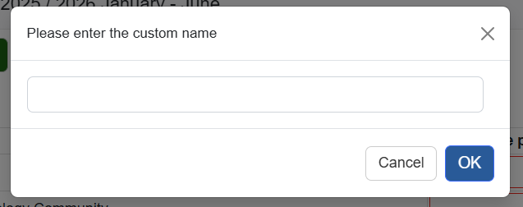
Complete the fields with the details and upload a PDF if required.
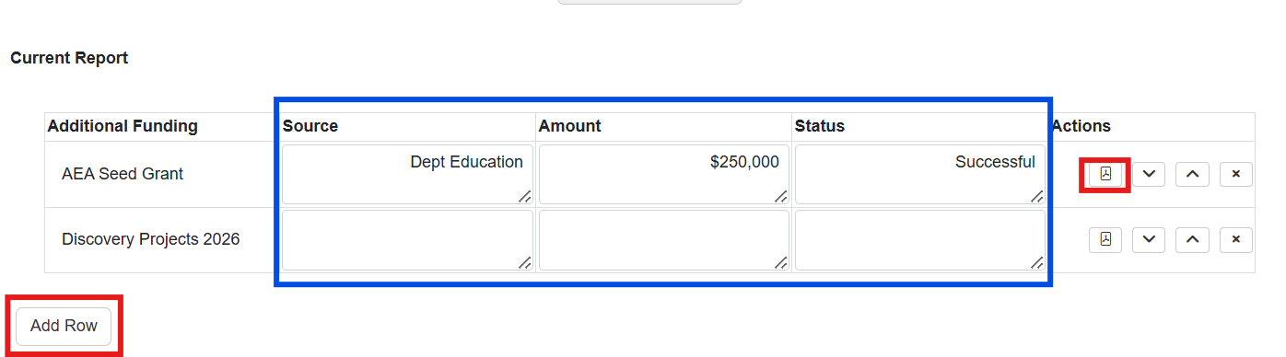
To enter another funding request select Add Row.

This table, the data entered and any PDFs uploaded will copy across to the next Progress Report.
In subsequent reports, to populate the Current Report table select the activated Populate from Report button.
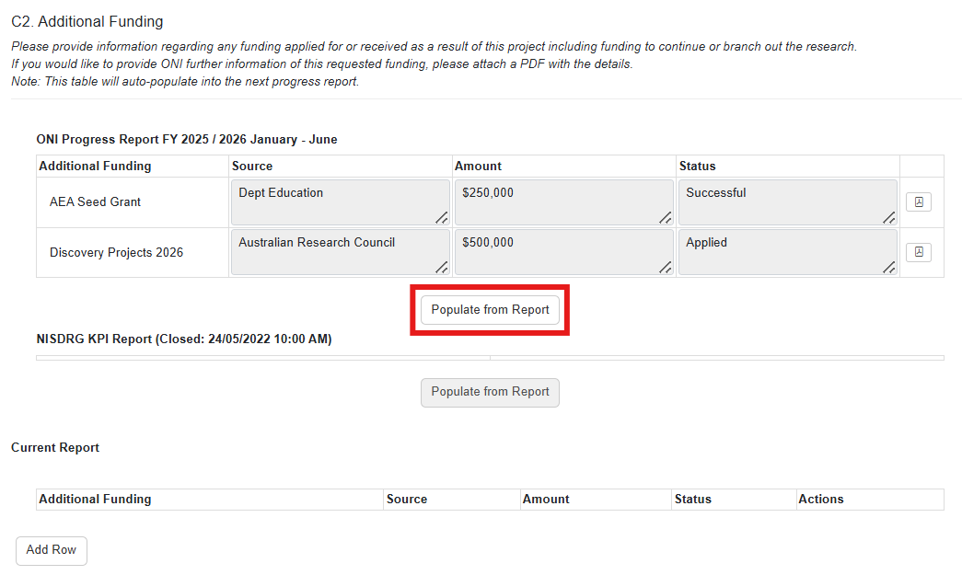
A pop-up box will appear. Select OK to populate the Current Report table.
The Current Report table will populate with the data saved in the previous report.
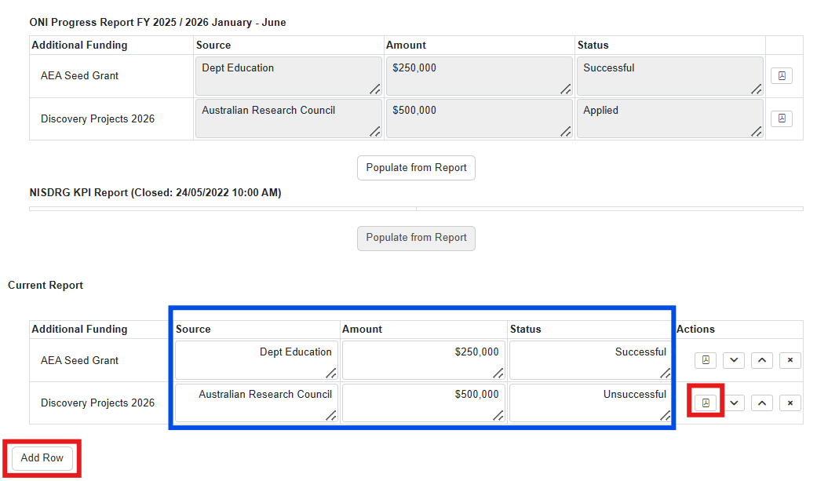
Sample Additional Funding applied or received
The Source, Amount and Status fields will be editable, where you will be able to update the status of the funding request when a update or decision is received.
To enter additional funding applications related to the research select Add Row and complete the fields as detailed above.

Part D - Research Outputs
This section will capture the total number of outputs the projects has produced. A statistical table will capture the total number of outputs, you will provide a comment on the quality of the outputs and upload a copy of each output published by the project

D1.Output Target High-Level
The Output targets entered into the KPI Report will be imported into the report. In the statistical table enter the total number of outputs produced in each category since the project commenced.
The Output Target High-Level Current Report table will capture each output as peer reviewed, non-peer reviewed or as a Data set, each output should only be counted once in this table.
To validate the table, a zero should be entered if there have not been any outputs produced for the category.
Note: The targets from the KPI Report are not editable. Once all fields in the Current Report table are entered, the red outlined fields of the KPI Report section will clear.
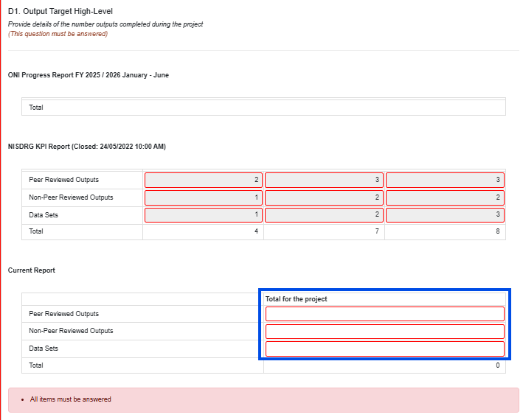

D2. Output Target Detailed
This question will provide a statistical table to capture the projects total specific output categories. Each output produced by the project, counted in question D1, can be categorised into one or all of the output categories as been collaborative, directed at the intelligence community or openly accessible.
To validate the table, a zero should be entered if there are outputs that have not been developed or made available to a category.
Note: The target fields from the KPI Report table are not editable. Once all fields in the Current Report table are entered, the red outlined fields of the KPI Report table will clear.
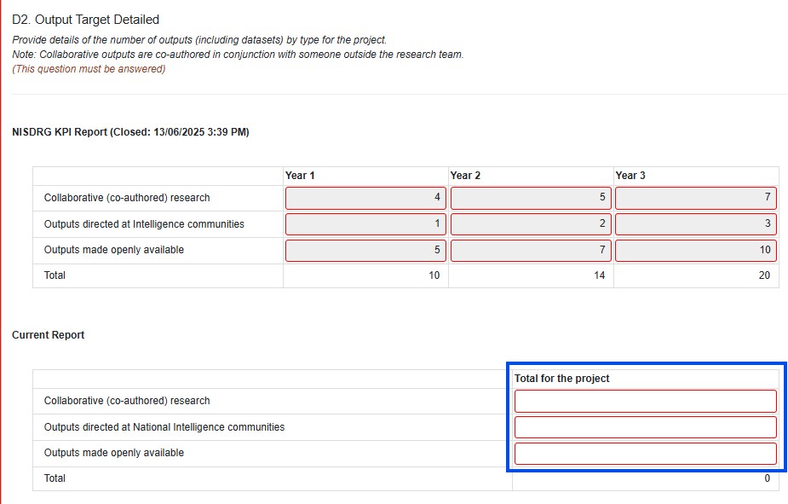

D3. Quality of Research Outputs
The details of how you intended to measure the quality of your research outputs will be populated from the KPI report.
In the text box provided enter a brief update on the quality of Research Outputs produced. The indicators provided in your KPI Report can guide this response, however any indicators of quality or impact can be reported on where your Research Outputs have achieved outcomes outside the scope of the KPIs.
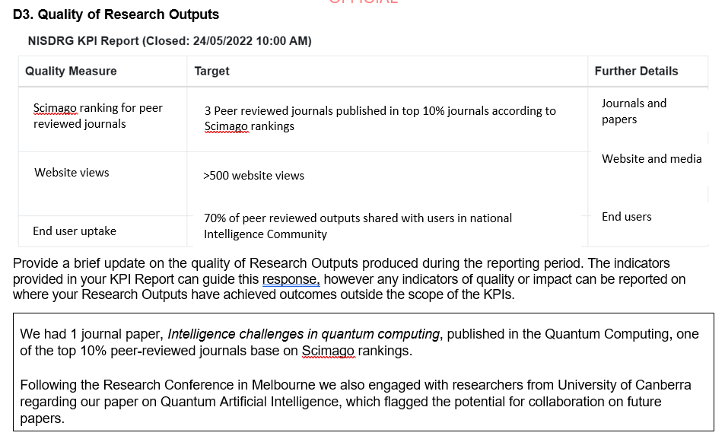
Sample Output Quality Update

D4. Research Outputs
ONI has requested a copy of all outputs developed by the project and submitted for publication.
To answer this question for the first time, from Current Report select Add Row.
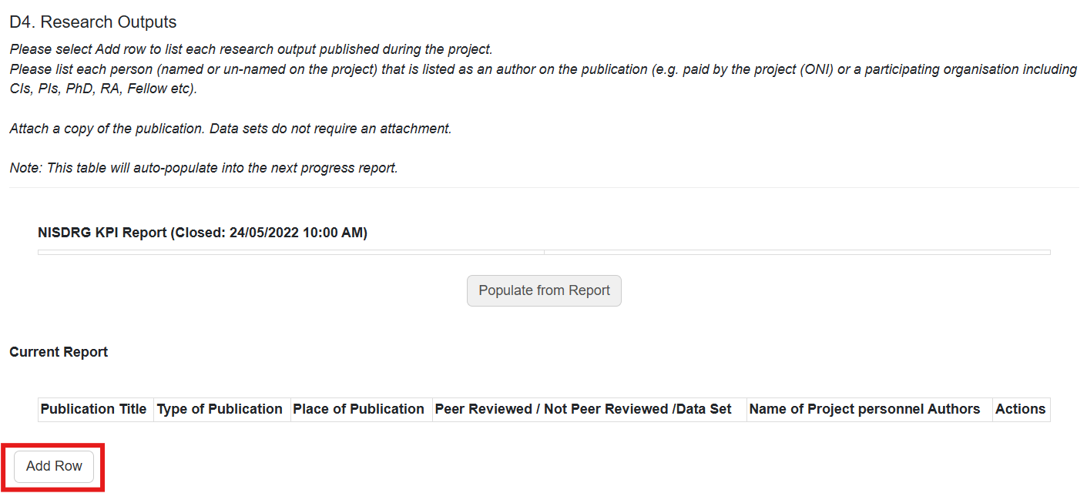
I the pop-up box enter the name of the publication, then select OK.
Complete the fields with the details.
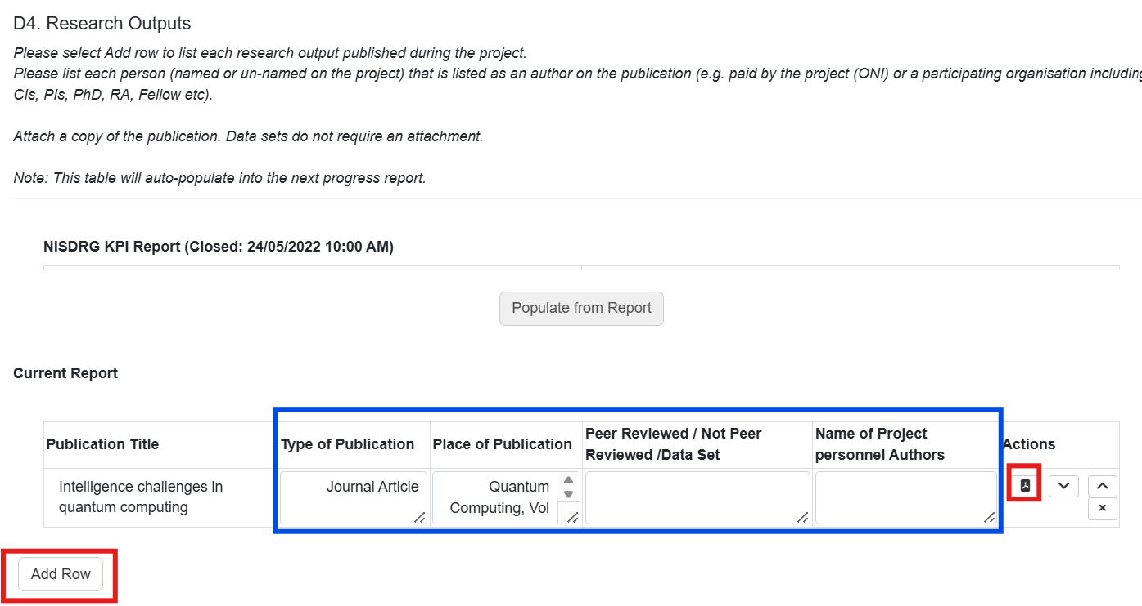
Upload the publication as a PDF by selecting the PDF Icon in the Actions field. Select Choose file, locate the document and select Upload.
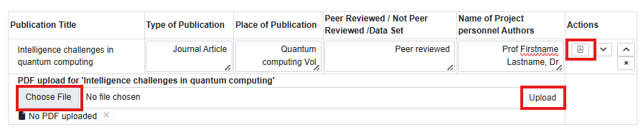
To enter another publication select Add Row.
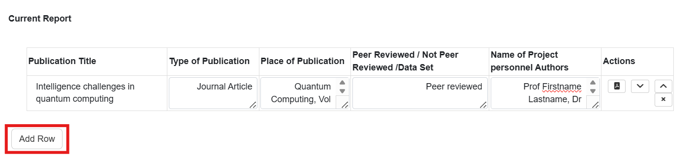
This table, the data entered and the PDFs uploaded will copy across to the next Progress Report.
In subsequent reports, to populate the Current Report table select the activated Populate from Report Button.
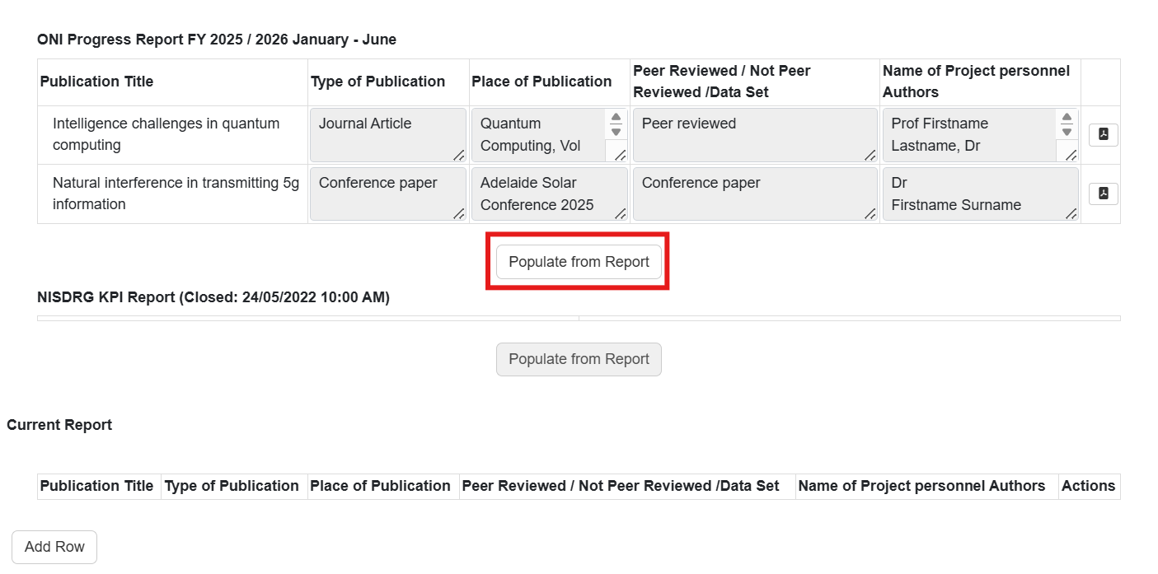
A pop-up box will appear. Select OK to populate the Current Report table.

The Current Report table will populate with the data saved in the previous report.
The type of publication, place of publication, peer review and author fields will be editable, where you will be able to update the status of the publication as required.
To enter additional publications select Add Row and complete the fields as detailed above.
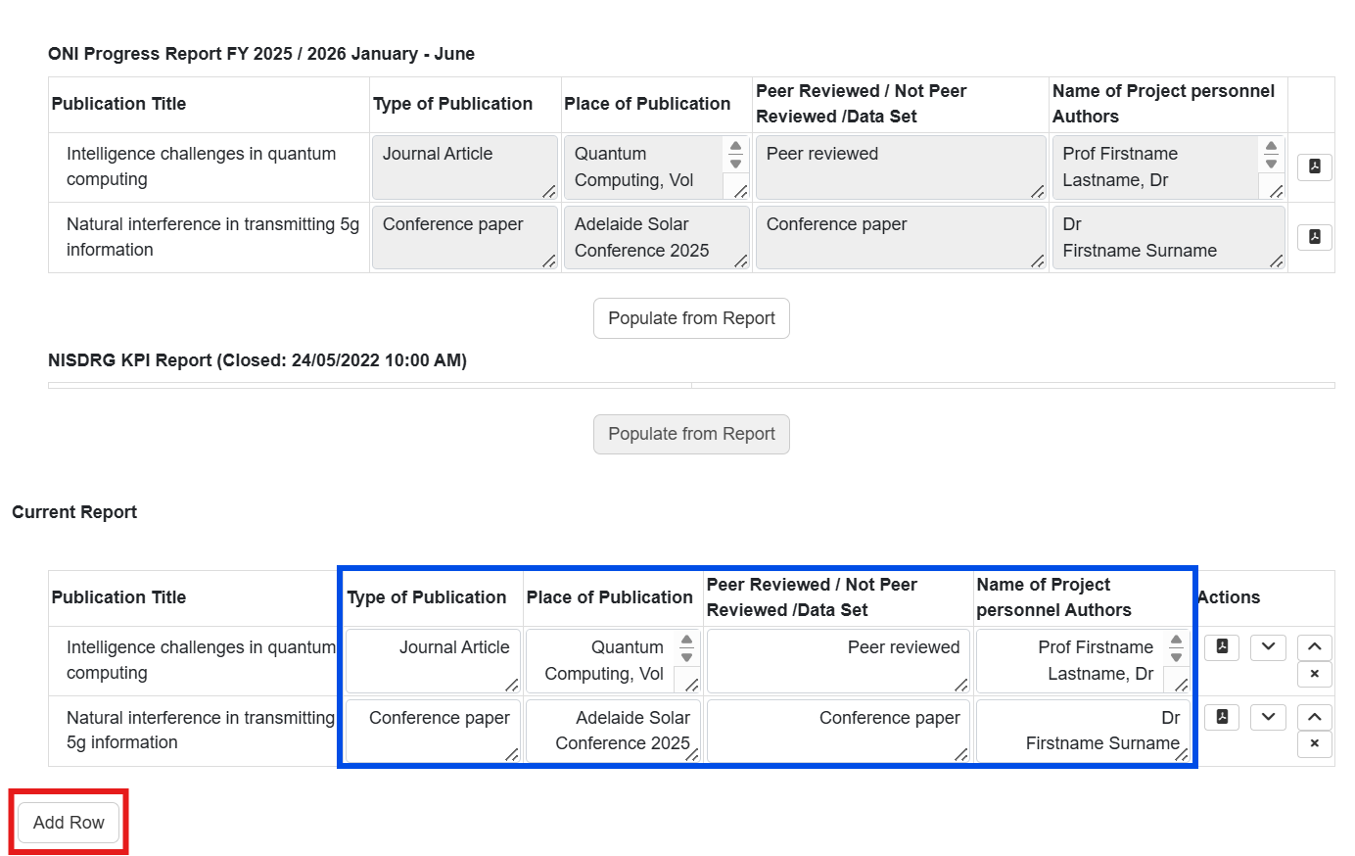
Sample Publications

PART 3 – Submit to the Research Office
Once all form parts are green, and the lead CI of the grant is satisfied that all details have been entered, the report must be submitted to the grant AO Research Office (RO) for review.
To submit a completed report to the RO ensure the ‘Ready to Submit’ message appears at the top of the report.
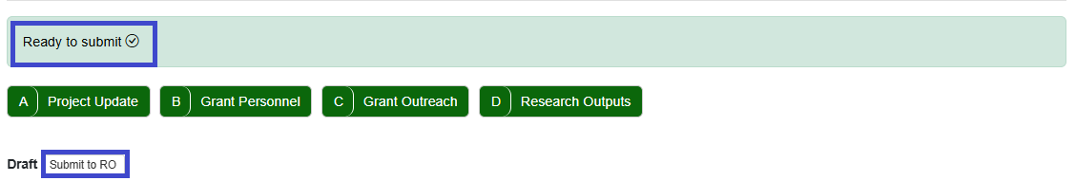
The Submit to RO Button is available in the Report or the Grant Reports summary page.
If the form parts are green but the Ready to submit message or button is not visible. Save the form and the button should appear.
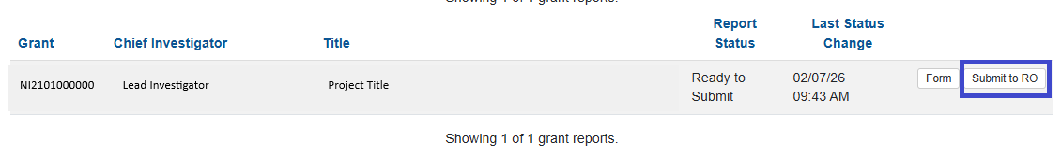
Locate the relevant report and select the ‘Submit to RO’ button.
Confirm submission of the Progress Report by selecting ‘Submit to RO’ in the pop-up message.
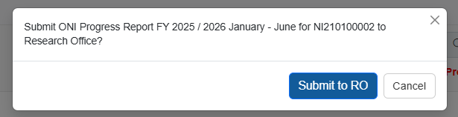

Once the report has been submitted to the Research Office for review, you will not be able to edit the report. If you would like to include or amend additional information, contact your research Office to request the report be returned to you.

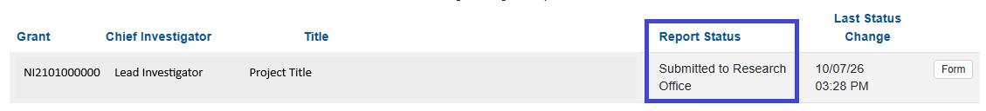

PART 4 – Research Office Certification and Submission
The submission of the Progress Report forms part of the Agreement between the AO and ONI to provide periodic progress updates against set KPIs and Performance Measures. Therefore, each answer should be reviewed to ensure the reported progress aligns with the key benefits identified in the Project Plan, and the aims, activities and anticipated outcomes as outlined in the original application. Upon confirmation that the entered details are agreeable to the AO, the Progress Report must be certified by an RO Delegate and submitted to ONI for review.

Research Office review of the Progress Report
To locate the Progress Report navigate to the ONI RMS portal https://rmsoni.researchgrants.gov.au, locate the Research Office Grant Management module on the Action Centre.
Select the ‘Research Office Grant Reports’ link.
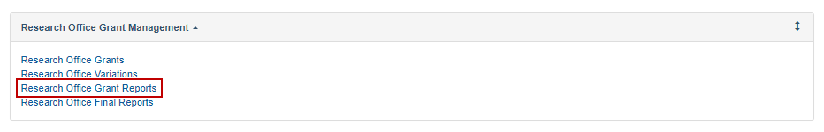
From the report drop down menu locate the report for the current period (ONI Progress Report Year January – June or July – December). The progress report reporting period will be the six months prior to the report completion period.
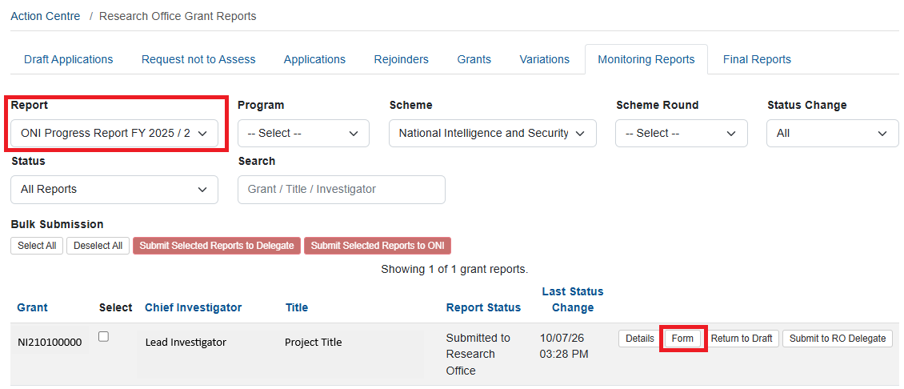
To review the details entered in the Progress Report select Form. If edits are required, return the Progress Report to the lead CI by selecting Return to Draft.

Submit the Progress report to ONI
When the Progress Report is acceptable, submit the Report to the RO Delegate by selecting the Submit to RO Delegate Button.
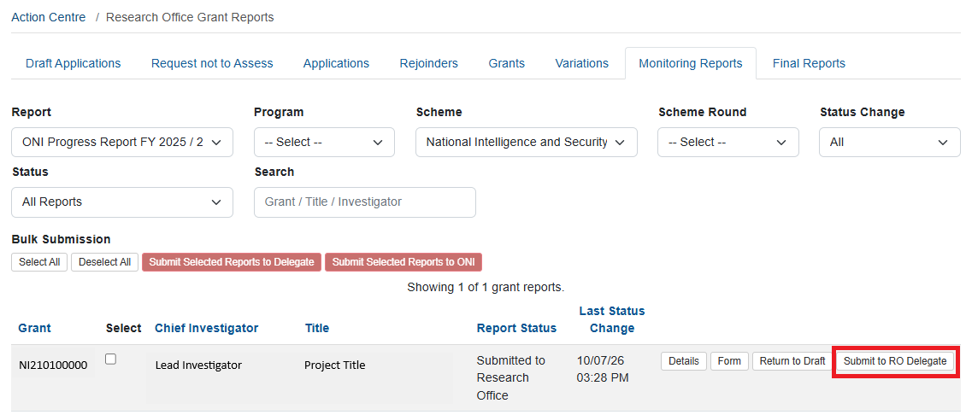
Confirm submission to the RO Delegate by selecting the ‘Submit to RO Delegate’ button from the pop-up box.
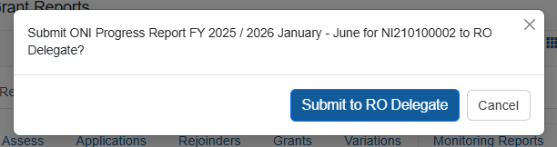
The report must be certified by the RO Delegate. Select the ‘Certify’ button.
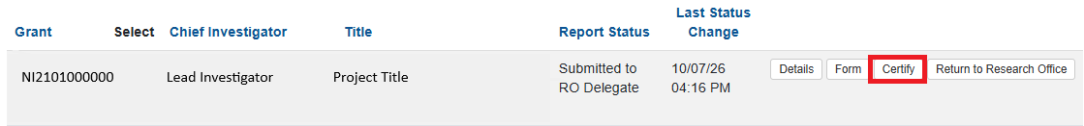
Confirm RO Delegate certification by selecting ‘Agree to Certification’.
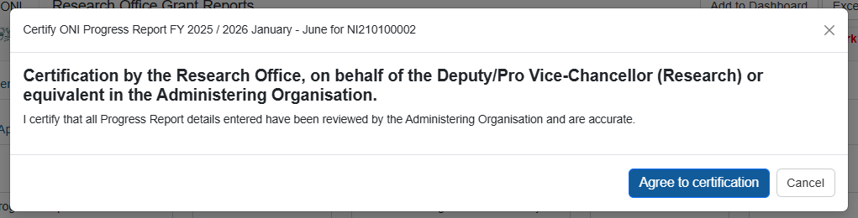
Finalise submission by selecting the ‘Submit to ONI’ button.
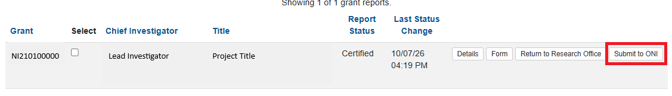
If additional edits are required once the progress report has been submitted to ONI, the RO must contact the RGS team at arc-nidg@arc.gov.au to request the return of the report.
Once the report has been reviewed by RGS and ONI and it is deemed acceptable it will be accepted in RMS. If additional information is required, the RGS team will contact the RO.

Glossary and Definitions

Definitions
Term | Definition
Administering Organisation (AO) | An Eligible Organisation responsible for the administration of the grant.
Australian National Intelligence Community | Comprises the six agencies that formerly made up the Australian Intelligence Community (AIC):  - ONA  - the Australian Signals Directorate (ASD)  - the Australian Geospatial-Intelligence Organisation (AGO)  - the Australian Secret Intelligence Service (ASIS)  - the Australian Security Intelligence Organisation (ASIO)  - the Defence Intelligence Organisation (DIO)  as well as the Australian Criminal Intelligence Commission (ACIC) and the intelligence functions of the Australian Federal Police (AFP), Australian Transaction Reports and Analysis Centre (AUSTRAC) and The Department  of Home Affairs.
Australian National Security Community | Comprises the:  - Department of Defence  - Department of Home Affairs  - Office of National Intelligence  - Department of Home Affairs  - Department of Foreign Affairs and Trade  - Prime Minister and Cabinet  - Department of Industry, Science, Energy and Resources.
Intelligence Challenges | Those challenge areas aligned with the National Security Science and Technology Priorities identified by the Australian Government to be funded by the ONI, and available on the RGS website.
Key Performance Indicators (KPIs) and/or Performance Measures | A set of quantitative and/or qualitative measures that We use to monitor and report on progress of research outcomes.
Lead Chief Investigator (CI) | The first named investigator of a Project.
Progress Report | A report submitted in RMS advising the progress of the grant against Key Performance Indicators (KPIs).
Project | An application approved by the ONI Delegate to receive funding, may also be referred to as a Grant.
POACR | Participating Organisation Agreed Contribution Report
Reporting Period | The period of the report, January to June or July to December.
Research Office (RO) | A business unit within an Eligible Organisation that is responsible for contact with Us regarding applications and projects.
Research output | All products of a research project.
Us/We | The Australian Research Council.

Glossary
Acronym | Elaboration
AO | Administering Organisation
ARC | Australian Research Council
CI | Chief Investigator
KPI | Key Performance Indicator
ONI | Office of National Intelligence
NIDG | National Intelligence Discovery Grants
NISDRG | National Intelligence and Security Discovery Research Grants
RGS | Research Grants Services team
RMS | Research Management System
RO | Research Office

